MAPUA MALAYAN DIGITAL COLLEGE
Academic Year 2025-2026

KaBarangayConnect: An Integrated Web-Based Management and Real-Time Incident Reporting System

Roxane Myles A. Andrade
Rick C. Cabugnason
Monina Angela D. Patiño
Alex S. Resurreccion

Glenn Baluyot

A Capstone Project Proposal Submitted
In Partial Fulfillment of the Requirements for the Degree of

Bachelor of Science in Information Technology
Major in Software Development

APPROVAL SHEET

This is to certify that the capstone project proposal entitled:

“KaBarangayConnect: An Integrated Web-Based Management and Real-Time Incident Reporting System”

Prepared and submitted by:

Roxane Myles A. Andrade
Jiullano Pepito B. Baldeo
Rick C. Cabugnason
Monina Angela D. Patiño
Alex S. Resurreccion

in partial fulfillment of the requirements for the degree of Bachelor of Science in Information Technology Major in Software Development, has been examined and is hereby recommended for approval and acceptance.

Panel Evaluators:

Aldrin John Tamayo John Ray Hernani
_______________________ _______________________ _______________________
Panel Chair Panel Member Panel Member

APPROVED:

Accepted and approved in partial fulfillment of the requirements for the degree of Bachelor of Science in Information Technology Major in Software Development.

Glenn Baluyot
_______________________
Mentor/Adviser

Mario Pison Jr.
_______________________
Program Head

Date of Project Proposal Oral Defense: <Insert Date>

DECLARATION OF ORIGINAL WORK

We, the undersigned from Section A3101, enrolled in MO-IT200D1 - Capstone 1 for Term 3, under the supervision of our adviser, Glenn Baluyot, hereby affirm that this paper, titled KaBarangayConnect: An Integrated Web-Based Management and Real-Time Incident Reporting System, is an original product of our research investigation.

To the best of our knowledge, this work neither contains any material that is previously published, built, or written by another person or by any of the authors nor does it contain falsified, fabricated, or plagiarized content.

The use of graphs, images, text, and/or frameworks is with the permission of the copyright owner.

We agree that should Mapua-Malayan Digital College, through its faculty and/or administrators, eventually prove fault, regardless of our intent, or anything contrary to this attestation, the college has the right to impose reasonable sanctions including the cancellation of the degree conferred to us.

Signed:

Alex S. Resurreccion

Roxane Myles A. Andrade

Jiullano Pepito B. Baldeo

Rick C. Cabugnason

Monina Angela D. Patiño

Conforme:

Glenn Baluyot

ACKNOWLEDGEMENT

The researchers would like to convey their sincere appreciation to everyone who, in one way or another, contributed to the completion of this capstone project proposal, KaBarangayConnect: An Integrated Web-Based Management and Real-Time Incident Reporting System.

We are grateful to our panel evaluators and faculty members for their time, guidance, and constructive recommendations. Their insights helped us improve the organization, feasibility, and technical consistency of this paper.

We also extend our appreciation to the Mapúa Malayan Digital College community for providing the learning environment and academic support that enabled us to complete this study.

We would like to thank the respondents and stakeholders who participated in our surveys and consultations. Their honest feedback and shared experiences provided essential input in understanding current barangay workflows and in shaping the direction of our proposed solution.

Lastly, we thank our families and friends for their continued encouragement, patience, and support throughout this academic journey

LIST OF TABLES

Table 1. Functional Requirement Table...…………………………………………… page 48
Table 2. Non-functional Requirement Table………………………………………… page 49
Table 3. ISO/IEC 25010 Mapping of Evaluation Criteria …..……………………… page 151
Table 4. Detailed Test Cases by Testing Level …..……………………………..…… page 151
Table 5. User Acceptance Testing Respondent Breakdown (Planning Target)……… page 153
Table 6. Standardized Test Scenarios for User Acceptance Testing………………… page 153
Table 7. Defect Severity Classification and Resolution Policy……………………… page 155
Table 8. Success Criteria for System Readiness …………………………………… page 155
Table 9. Likert Scale Interpretation for Evaluation Results………………………… page 157

LIST OF FIGURES

Figure 1. Bayan 911 Mobile Interface ………………………………………….. …… page 28
Figure 2. BarangayOS Web Portal …………………………………………….……… page 29
Figure 3. eGovPH Mobile Dashboard………………………………………………… page 30
Figure 4. EBARANGAY Web Homepage…………………………………….….…… page 31
Figure 5. One Barangay Management System (OBMS) Web Homepage…….….…… page 33
Figure 6. Frequency of Internet Usage Among Respondents….……………………… page 54
Figure 7. Number of Barangay Document Requests During the Past 12 Months..…… page 55
Figure 8. Average Processing Time of Barangay Documents………………………… page 56
Figure 9. Respondents' Experience in Reporting Incidents to the Barangay….… …… page 56
Figure 10. Respondents' Decision to Proceed with Filing an Incident Report……… .. page 57
Figure 11. Estimated Number of Documents Processed per Week…………………… page 58
Figure 12. Estimated Number of Incident Reports Received per Month……….…..… page 59
Figure 13. Current Method of Recording Document Requests……………….….…… page 59
Figure 14. Current Method of Recording Incident Reports…………………………… page 60
Figure 15. KaBarangayConnect High-Level Architecture Diagram …………….…… page 66
Figure 16. .KaBarangayConnect NoSQL Document Schema Architecture……..…… page 72
Figure 17. KaBarangayConnect DFD Level 0 …………………………...…………… page 77
Figure 18. KaBarangayConnect DFD Level 1 ………………………...…………… page 78
Figure 19. Resident Portal Login Interface (Mobile Browser)…...…………………… page 77
Figure 20. Data Privacy Compliance and User Consent Interface (Mobile Browser)... page 78
Figure 21. Resident Registration and Address Verification Interface ………………... page 79
Figure 22. Resident Dashboard and Centralized Civic Hub…………...……………… page 81
Figure 23. Global Navigation and Resident Profile Drawer Interface……...………… page 82
Figure 24. Document Request Workflow and Status Tracking Interface…...………… page 83
Figure 25. Incident Reporting and Emergency Triage Interface……………………… page 85
Figure 26. Synchronous Emergency Triage Chat Interface ………………..….……… page 86
Figure 27. Centralized Civic Information and Announcements Interface………..…… page 88
Figure 28. Barangay Officials Directory and Civic Leadership Interface………..…… page 89
Figure 29. Persistent Notification History and Alert Routing Interface………….…… page 90
Figure 30. System Accessibility and Inclusive Design Configuration Interface……… page 91
Figure 31. Constituent Support and Knowledge Base Interface………………….…… page 93
Figure 32. Admin Login Interface (Desktop Browser) …………………………..…… page 94
Figure 33. Secure Administrative Portal Authentication and MFA Verification …… page 95
Figure 34. Centralized Administrative Dashboard and Real-Time Telemetry……...… page 96
Figure 35. Resident Records Management and Demographic Database……………… page 97
Figure 36. Digital Document Queue and Administrative Workflow………..………… page 98
Figure 37. Location-Based Incident Command and Automated Triage Interface…..… page 99
Figure 38. Centralized Civic Broadcasting and Content Management Interface …… page 100
Figure 39. Administrative Personnel Roster and Directory Management Interface … page 101
Figure 40. System Notification History and Administrative Audit Log Interface ..… page 102
Figure 41. Synchronous Emergency Triage and Multi-Session Command Interface .. page 103
Figure 42. Global System Configuration and Data Privacy Compliance Interface …. page 104
Figure 43. KaBarangayConnect Navigation Flow: Authentication and Onboarding .. page 107
Figure 44. KaBarangayConnect Navigation Flow: Resident Constituent ...………… page 108
Figure 45. KaBarangayConnect Navigation Flow: Administrative Personnel ……… page 110
Figure 46. Use Case for Emergency Incident Reporting & Triage ………………..… page 120
Figure 47. Use Case for Document Clearance Processing ………………………..… page 121
Figure 48. KaBarangayConnect Testing Workflow …..……….…………………..… page 157
Figure 49. Implementation Plan Diagram …………………….…………………..… page 159

LIST OF APPENDICES

Appendix A. Link to Prototype ……………………………………………….…… page 170
Appendix B. Disclosure of Artificial Intelligence Tools Used in Research .……….. page 171
Appendix C. Evaluation Questionnaires……………………………………….…… page 172
Appendix D. Informed Consent Form ………………………………………….…… page 173
Appendix E. Data Privacy Form …………………………………….……….…… page 174
Appendix F. Letter of Request to Barangay………………………….……….…… page 175
Appendix G. Weekly Progress Report……………………………….……….…… page 176

TABLE OF CONTENTS

APPROVAL SHEET 1
DECLARATION OF ORIGINAL WORK 2
ACKNOWLEDGEMENT 3
LIST OF TABLES 4
LIST OF FIGURES 5
LIST OF APPENDICES 6
TABLE OF CONTENTS 7
INTRODUCTION 8
A. Background of the Study 8
B. Statement of the Problem 9
C. Research Objectives 10
D. Research Questions 11
E. Significance of the Study 12
F. Scope and Limitations 13
REVIEW OF RELATED LITERATURE 15
Modernizing Incident Reporting and Emergency Response 35
Synthesis and Gap Analysis 46
METHODOLOGY 48
A. Requirement Analysis 48
B. System Design / Design 61
C. Development Plan 131
D. Testing Plan 137
E. Implementation Plan 146
REFERENCES 150
APPENDICES 158

CHAPTER I

INTRODUCTION

Background of the Study

Barangay serves as the most fundamental unit of local government in the Philippines, functioning as the primary point of contact between the state and its citizens. As mandated by Republic Act No. 7160, also known as the Local Government Code 11, barangays are responsible for delivering essential public services, maintaining peace and order, managing community records, and facilitating the resolution of local disputes. Despite the critical nature of these responsibilities, a significant number of barangays across the country continue to rely on manual, paper-based processes for carrying out their day-to-day operations (Carpio, 2020). Records are maintained through handwritten logbooks, document requests are processed through physical visits to the barangay hall, and incident reports are filed using paper forms - methods that are increasingly inadequate given the growing complexity and population of Philippine communities.
This reliance on manual, paper-based processes is not merely narrative- it reflects a documented, nationwide pattern. As early as 2020, the DILG itself acknowledged that only around 30 percent of Local Government Units nationwide had taken any measurable steps to digitize their operations (Ibañez, 2020). Five years later, the gap has narrowed only modestly: as of late 2025, DILG data shows that just 23 percent of the country’s more than 42,000 barangays were actively using its Barangay Information Management System (BIMS), with roughly a third having merely completed orientation on the platform without yet operating it (Department of the Interior and Local Government [DILG], 2025). A parallel push by the Department of Information and Communications Technology reported that its eLGU platform had reached 838 LGUs nationwide by late 2024 - 375 in Luzon, 238 in the Visayas, and 225 in Mindanao automating services such as business permit and barangay clearance issuance (Department of Information and Communications Technology [DICT], 2024). While this reflects real progress, it still leaves the majority of the country's LGUs, and by extension most barangays under their jurisdiction, dependent on some form of manual processing.

Where barangays and LGUs have made the shift, the reported gains are concrete. Davao City's Sangguniang Panlungsod, for instance, digitized its legislative processes and cut paper consumption from close to 70 reams per session to about five (Philippine News Agency [PNA], 2023), illustrating the kind of operational waste that manual, paper-heavy systems can generate at scale. This pattern is echoed in this study's own point of reference, eDokumento, a web-based barangay document request system evaluated in Barangay Maranding, which recorded an overall System Usability Scale score of 86.75 rated "excellent" after digitizing what had previously been a manual, in-person request process (Bacus et al., 2025). Taken together, these figures reinforce the same gap this study has observed on the ground: barangays still running on manual systems continue to report slower processing and weaker monitoring, while those that have automated report measurable gains in speed, accuracy, and usability further substantiating the need for a localized system like KaBarangayConnect.

The limitations of these manual systems in barangays have been well documented in existing literature. Studies have shown that barangays relying on manual processes struggle with inefficient data management and fragmented systems, which hinder effective governance and timely service delivery (WebYu Research Team, 2025). As discussed with the related study on web-based barangay document systems, it was found that digitizing document requests significantly reduced processing times and minimized errors compared to manual methods. Similarly, Carpio (2020) found that manual record-keeping in barangay management systems frequently results in data duplication, loss of records, and difficulty in retrieving accurate information - issues that directly compromise the security, accessibility, and centralization of community records. These findings collectively suggest that a unified digital solution is necessary to address the systemic inefficiencies inherent in manual barangay operations, a recommendation echoed across multiple studies on local government digitalization in the Philippines (Bautista et al., 2023; Reyes & Cabalag, 2021).

The absence of a centralized incident reporting mechanism poses a particularly serious challenge for community safety. Without a structured digital system, incident reports are typically filed through informal channels - physical visits to the barangay hall, personal calls to officials, or posts on unmoderated social media group chats - resulting in delayed documentation, incomplete records, and inconsistent follow-through on community concerns (Bautista et al. 2023). These manual reporting methods contribute to specific, observable problems: reports that go unrecorded due to the unavailability of the officer on duty, incidents that cannot be tracked or escalated properly due to the absence of a centralized log, and response times that are prolonged because officials have no real-time visibility over community safety concerns. Incident reporting is mandated under RA 7160 as part of the Katarungang Pambarangay or the barangay justice system, which aims to harmoniously settle disputes within the community to promote peace, justice, and harmonious relationships - a mandate that is difficult to fulfill effectively without proper digital infrastructure in place.

Statement of the Problem
Despite the advancements in digital governance, many local barangay units continue to struggle with fragmented administrative processes and inefficient communication channels brought by manual systems. This study aims to address the following specific gaps, which establish the foundation for the system’s development and evaluation:
- Inefficiencies and Limitations in Existing Manual Processes. The barangay heavily depends on handwritten logbooks for documenting an estimated 50 to 400 document requests per week and 20 to 70 incident reports per month. This reliance results in lengthy procedures, misplaced records, and deterred reporting. This operational gap prompts the need to identify and analyze the specific limitations characterizing current manual workflows .
- Lack of Defined System Requirements and Unified Architecture. There is a distinct absence of a centralized digital infrastructure that bridges the gap between residents and local officials, resulting in fragmented services. Consequently, there is a critical need to determine the specific functional and non-functional requirements, as well as the optimal database design, necessary to construct an integrated web-based architecture.
- Vulnerabilities in Data Security and Privacy. Transitioning from physical logbooks to a centralized digital platform introduces risks regarding the handling of sensitive resident data and incident evidence. It is a significant challenge to establish what specific multi-level authentication and encryption protocols are required to safeguard this information and ensure Data Privacy Act compliance.
- Absence of Real-Time Tracking and Centralized Monitoring. Residents currently lack mechanisms to track document request statuses, and barangay officials experience severe bottlenecks in monitoring active community threats. This gap necessitates an investigation into how real-time dashboard analytics, automated notifications, and digital integration can enhance monitoring capabilities and overall operational efficiency.
- Need for Standardized Evaluation of System Acceptability. Even with a community exhibiting 100% daily internet accessibility, the success of a digital transition depends heavily on user adoption. There is a need to systematically evaluate how barangay officials and residents perceive the implemented system's usability, performance efficiency, and security to ensure it meets actual community needs .

Research Objectives

The general objective of this study is to design and develop KaBarangayConnect, a web-based barangay management and incident reporting system that provides a streamlined and efficient way for barangay officials to manage records and for residents to report community concerns. Specifically, this study aims to:
- To identify and understand the document management and incident reporting processes of the barangay.
- To analyze the current challenges encountered in manual barangay document processing and incident reporting.
- To design a centralized web-based system architecture for managing barangay records, document requests, and incident reports.
- To develop a functional KaBarangayConnect platform that includes user registration, online document requests, real-time incident reporting, and administrative management features (including real-time dashboard analytics and automated notifications).
- To implement robust system security and intelligent response mechanisms, specifically incorporating role-based access control (RBAC), data encryption for privacy compliance, and a rule-based incident prioritization engine.
- To evaluate the usability, functionality, and performance of the developed system among authorized barangay personnel and selected residents of Barangay Labuin, Pila, Laguna.

Research Questions
The following research questions were developed to guide the design, implementation, and evaluation of KaBarangayConnect as a web-based barangay management and incident reporting system:
- What specific processes, limitations and inefficiencies characterize the current manual processes for resident record management, document requests, and incident reporting in Barangay Labuin, Pila, Laguna?
- How do traditional manual methods affect the operational efficiency, accuracy, and reliability of barangay record management and incident tracking compared to automated systems?
- What functional, non-functional requirements, database schemas and system architecture design are necessary to establish a web-based barangay management and incident reporting system for KaBarangayConnect?
- How do features such as online document requests, real-time incident tracking, administrative dashboards, and automated notifications support daily operations for residents and officials?
- What security measures (RBAC, data encryption) and automated algorithms will be needed to ensure privacy of data and prioritize responses?
- What are the considerations in the assessment of the acceptability and efficiency of KaBarangayConnect in terms of functionality, usability, accessibility, reliability, performance efficiency, and security?

Significance of the Study

The significance of this study lies in its potential to modernize and improve the efficiency of local governance at the barangay level through the implementation of a centralized digital platform. The project addresses long-standing issues in administrative management, communication, and public service delivery that many barangays still experience due to outdated manual processes and fragmented communication methods. Specifically, this study will be highly beneficial to the following groups:
- For Barangay Officials - The system significantly reduces the burden of manual paperwork, minimizes data redundancy, and improves record accuracy and accessibility. By digitizing incident reporting, complaint management, document requests, and information dissemination, the platform helps barangay officials manage operations more efficiently. The integration of real-time reporting and centralized record management ensures that community concerns are properly documented, monitored, and resolved in a timely manner. Additionally, it enhances the ability of officials to generate reports and comply with government documentation requirements.
- For Barangay Residents - The platform gives residents easier, remote access to essential barangay services without the immediate need for physical visits. By providing a structured and accessible digital channel, the system promotes faster response times during emergencies and strengthens communication and transparency between residents and local authorities.
- For Future Researchers - This study serves as a valuable baseline and foundational reference for future researchers aiming to explore or expand upon localized e-governance systems. The integration of serverless cloud architectures (like AWS Lambda and API Gateway), NoSQL databases, and rule-based triage engines into a grassroots government setting provides a proven technical framework that future scholars can adopt, critique, or enhance for similar digital transformation initiatives.

Scope and Limitations

F. Scope and Limitations

This study covers the development and pilot implementation of KaBarangayConnect, a web-based barangay management and incident reporting system for Barangay Labuin, Pila, Laguna. The system is designed for three user roles: residents, barangay staff, and administrators. The scope includes registration and login, document request submission and status tracking, incident report submission and updates, an administrative dashboard for monitoring and managing request and report statuses, basic notifications, and record archiving/search.

The pilot evaluation will involve authorized barangay personnel, such as the secretary, clerk, or assigned staff, and selected residents who will use the system for document requests and incident reporting. The evaluation will focus on the implemented core modules and selected quality criteria, specifically functionality, usability, reliability, performance efficiency, and security.

This study is limited to a web-based pilot implementation and does not include a native mobile application. Although the system is intended to be mobile-responsive, its performance strictly depends on internet connectivity and device availability. Crucially, the system does not claim to replace traditional emergency response mechanisms during severe weather conditions (e.g., typhoons) when telecommunication infrastructures are totally down. In such scenarios where internet access is completely severed, the system relies on a manual fallback and transition plan rather than forcing an online-only operation. The study also does not include predictive artificial intelligence—any prioritization in incident handling is limited to rule-based incident prioritization based on predefined criteria. In addition, the system does not include direct emergency dispatch integration, live GPS-based field response, or integration with national government databases.

For the pilot evaluation, the study targets a total of 7 purposely selected participants from Barangay Labuin, Pila, Laguna. This respondent pool is composed of 2 authorized barangay personnel (including the Punong Barangay, barangay secretary, assigned clerks, and administrative staff who directly process document requests and incident reports) and 5 registered residents aged 18 and above who have previously requested barangay documents or reported community incidents within the past 12 months. The target sample size is purposive and site-specific; final participant counts may be adjusted depending on the actual availability of respondents and coordination outcomes with the barangay office. All pilot respondents will be covered by individual informed consent and data privacy notices.

The testing and evaluation period for the pilot implementation is scheduled from October 5, 2026 to October 16, 2026. The first week (October 5–9, 2026) covers the pilot deployment, on-site user training for barangay staff, and User Acceptance Testing (UAT) with both resident and personnel respondents. The second week (October 12–16, 2026) is allocated for the organization, coding, and statistical analysis of collected Likert-scale and qualitative data, as well as the drafting of Chapter IV results. This evaluation timeline is anchored on the project's overall 12-week Gantt Chart covering August 17, 2026 to November 6, 2026.

CHAPTER II

REVIEW OF RELATED LITERATURE

This chapter presents a review of existing studies, technological frameworks, and digital platforms related to local public administration, electronic governance, and emergency management systems. The purpose of this review is to analyze current trends, methodologies, and established practices that can serve as the foundation for the development of KaBarangayConnect: An Integrated Web-Based Management and Real-Time Incident Reporting System. With the increasing shift toward electronic governance, numerous solutions have been developed to handle community requirements, ranging from online certificate generation to active incident monitoring. Evaluating these existing platforms provides practical guidance on how to optimize digital service delivery for local communities.

Through this evaluation, the review identifies effective technological approaches while also pointing out the prevailing inefficiencies in traditional barangay operations. The insights gathered from related studies and systems will guide the design, architecture, and functionality of the proposed platform to ensure that it effectively addresses the needs of both barangay residents and administrators. Emphasis is placed on usability, accessibility, real-time communication, and secure data management to support reliable and efficient public service delivery.

E-Governance and Digital Transformation
The United Nations E-Government Survey explains that digital government is moving toward integrated, people-centered services, with emphasis on accessibility, inclusion, and service experience rather than isolated online features (United Nations Department of Economic and Social Affairs, 2024). This supports KaBarangayConnect’s direction as a resident-facing platform that should be simple to use and practical for real community transactions.

In the Philippine context, the Development Academy of the Philippines discussed DICT’s initiatives that support government digital transformation, including platforms and programs that aim to streamline service delivery and improve interoperability across government services (Development Academy of the Philippines, 2024). This provides national-level context for why barangay systems should align with the broader direction of digital governance.

Local government adoption of electronic systems has also accelerated. DILG reported that many LGUs have adopted electronic systems, including the eLGU platform, to improve processing speed and reduce red tape in frontline transactions (Department of the Interior and Local Government, 2024). Similarly, GMA News reported that over 800 LGUs have integrated into the eLGU system and that the platform supports processing of common transactions, including barangay-level services, through digital channels (Bajo, 2024). These reports support the feasibility of digitizing routine transactions and the relevance of systems like KaBarangayConnect.

Beyond adoption rates, research highlights recurring barriers that affect digital governance outcomes. Andaya, Orlina, and Ilustre (2025) synthesized recent literature and emphasized persistent gaps in ICT infrastructure, digital literacy, and institutional capacity. These issues are relevant to KaBarangayConnect because they affect usability, accessibility, and the realistic scope of implementation for a student-developed system.

Sunandha (2025) reviewed Philippine digital transformation efforts and described the “digital paradox,” where progress exists but remains uneven because of infrastructure gaps, cybersecurity concerns, and the digital divide. This supports the need for KaBarangayConnect to be lightweight, user-friendly, and realistic for the conditions of barangay operations.

Citizen Engagement and Acceptance of E-Government

Brucal et al. (2024) examined e-governance and social media in the Philippines and noted that digital tools can reduce cost, errors, and delays in service delivery, but infrastructure limits and privacy concerns can hinder full adoption. These insights support KaBarangayConnect’s focus on transparency and tracking, while also reinforcing the need for privacy-aware design.

Valle et al. (2024) explored citizen perspectives on a local e-government platform and reported that user interface satisfaction and trust in privacy and security measures influence acceptance. Their findings are relevant to KaBarangayConnect because residents will adopt the platform only if it feels safe and easy to use.

Jou et al. (2024) studied accessibility factors affecting the eGov PH mobile application and used the Technology Acceptance Model (TAM) to examine relationships among perceived ease of use, usefulness, and user attitude. While KaBarangayConnect is a barangay-focused platform, the study reinforces that user awareness, ease of use, and readiness affect adoption of digital government tools.

Barangay Service Systems and Document Requesting Platforms

Taruc et al. (2023) developed and assessed Docu-Go, a web-based barangay document requesting system, and evaluated it using ISO 25010. The study reported generally acceptable quality ratings from both experts and residents, supporting the idea that online document requesting can be practical and acceptable in barangay settings. KaBarangayConnect follows a similar direction by supporting document requests with tracking and status updates.

Dela Cruz et al. (2024) examined an office procedure for document transactions in a Quezon City barangay and identified operational issues such as limited service points and manpower, which can slow down processing. This supports KaBarangayConnect’s goal of reducing repeated follow-ups by providing organized request logging and status monitoring.

Enaño et al. (2025) developed BarangayConnect, a web-based portal for resident data and administrative services, and evaluated it using ISO 25010. Their study supports the value of centralizing services and records through a web platform and reinforces KaBarangayConnect’s goal of simplifying resident transactions.

Gasmido Jr. et al. (2025) described a web-based barangay management and information system evaluated using ISO 25010 and TAM. Their results show that usability and perceived usefulness can strongly drive adoption, which supports KaBarangayConnect’s need to be understandable for residents and manageable for staff.

Aliling et al. (2025) presented the development and evaluation of an e-Barangay Information Management System (E-BIMS), emphasizing improvements in transaction speed, record accessibility, and administrative efficiency. This supports KaBarangayConnect’s plan to centralize records and streamline request handling.

Siay et al. (2025) developed eDali Deborok, a web-based barangay system that supports transactions, announcements, and notifications, with features that promote transparency and community engagement. This aligns with KaBarangayConnect’s tracking, notification, and dashboard features.

However, systems like eDali Deborok still have practical limitations that are common in barangay digital platforms. For example, they may focus more on transaction handling and announcements than on a structured end‑to‑end workflow for incident reporting, including consistent status tracking, evidence handling, and centralized monitoring for follow‑up. In addition, adoption in barangay settings may be affected by internet availability, varying staff capacity, and the need for simple interfaces for residents. These limitations support the need for KaBarangayConnect to provide a more integrated workflow that combines document requests and incident reporting in one dashboard, with clear status updates, basic notifications, and organized record archiving to reduce missed reports and repeated follow-ups.

Incident Reporting and Community Response Systems

Laurena et al. (2022) developed AidPack, a web-based incident report management system that connects civilians with barangay officials and related agencies. The study emphasized that incident reporting systems should prioritize ease of use, clear instructions, and evidence attachments to support legitimacy and response workflow. These points directly support KaBarangayConnect’s incident reporting module and attachment functionality.

Duco et al. (2023) proposed a mobile and web platform for barangay remote services and disaster response, including support for document requests and an emergency module. Their work supports KaBarangayConnect’s concept of integrating administrative services with incident handling to improve responsiveness.

The Department of Science and Technology highlighted Project SIGNAL as an incident reporting and monitoring system for LGUs that supports geo-tagged reporting and builds a database used for planning and risk analysis (Department of Science and Technology, 2025). This supports KaBarangayConnect’s emphasis on maintaining organized incident records that can be reviewed and analyzed.

Amora and Khan (2025) evaluated reliability and user satisfaction in a mobile incident reporting system using Firebase connectivity. While KaBarangayConnect uses a different stack, the study supports the importance of stable data handling and clear reporting workflows to improve user confidence.

While these systems show that web/mobile reporting platforms can improve documentation and coordination, they also highlight recurring limitations. Many solutions are designed for a single purpose (incident reporting only or administrative services only), which can lead to fragmented workflows when barangay offices still process document requests separately. Other common constraints include dependence on internet connectivity, varying staff capacity, and the need for simple reporting forms to avoid incomplete submissions. These limitations support the need for KaBarangayConnect as an integrated platform that combines document requests and incident reporting in one workflow, with clear status tracking, basic notifications, and centralized record archiving to reduce missed reports and repeated follow-ups.

Location Data, GIS, and Data-Informed Governance

Del Pilar et al. (2024) developed B-GIS, a web-based barangay geographic information system evaluated using ISO 25010, and showed that combining record management with location-based information can support planning and decision-making. While KaBarangayConnect focuses on requests and reports, the study supports future enhancements such as mapping incident locations or visualizing service demand patterns.

Enaño et al. (2025) integrated data analytics into their barangay portal for forecasting and planning. This suggests that once barangay data are centralized, the barangay can use records for evidence-based decisions, which KaBarangayConnect can support through searchable and filterable digital records.

Records Management and Document Management Readiness

Ziemba et al. (2022) discussed critical success factors for adopting electronic document management systems in public administration, emphasizing readiness, training, and process alignment. These factors are relevant to KaBarangayConnect because successful use depends not only on technology but also on how well the workflow fits the barangay’s daily process.

Kashaija (2022) assessed e-records management readiness in a local authority setting and identified barriers such as lack of systems, limited trained personnel, and insufficient policies. These findings support KaBarangayConnect’s limitations and highlight the importance of designing a system that is feasible for the barangay environment.

However, these findings also imply practical constraints that may affect the implementation and adoption of KaBarangayConnect. Limited trained personnel can slow down system use if staff members are unfamiliar with digital workflows, while insufficient policies can lead to inconsistent data handling and weak standardization in record management. For this study, we will consider these constraints by ensuring the system remains simple and workflow-based, and by identifying operational requirements such as role-based access and basic procedures for record handling. This also supports the research focus on: What operational and organizational constraints (e.g., staff capacity and existing policies) may affect system adoption and consistent use in the pilot barangay?

Software Quality Evaluation and User-Centered Measurement

ISO/IEC 25010 provides a standardized model for assessing software product quality attributes such as functional suitability, performance efficiency, usability, reliability, security, maintainability, and portability (International Organization for Standardization, 2023). Since many barangay system studies use ISO 25010, it is an appropriate framework for evaluating KaBarangayConnect.

Alannsary (2025) proposed a model for evaluating e-government solutions using ISO/IEC 25010 quality-in-use and emphasized user-centered outcomes such as satisfaction, effectiveness, and risk reduction. This supports evaluating KaBarangayConnect not only by feature completeness but also by real user experience.

Batoon and Piad (2023) demonstrated the application of ISO 25010 in assessing a web-based system with geo-tagging and decision support. Their work provides an example of how ISO 25010 can be applied to web platforms designed for local community services.

Despite its usefulness, ISO/IEC 25010 also has limitations when applied to a student-developed, barangay-focused system. First, quality attributes such as usability, security, and reliability can be rated differently depending on the evaluator’s experience, which means results may be subjective if based only on expert judgment. Second, ISO/IEC 25010 does not automatically capture operational constraints such as internet stability, device availability, and staff readiness that can strongly affect real deployment in barangay settings. To address these limitations, this study will combine ISO/IEC 25010-based evaluation with user testing among authorized barangay personnel and selected residents in the pilot site, and will include simple performance checks and workflow-based tasks (e.g., request submission, status updates, report logging, and record retrieval) to ensure that measured quality reflects actual system use.

Data Privacy and Security for LGU Systems

The National Privacy Commission (NPC) continues to emphasize that organizations must establish privacy management programs and implement reasonable measures to protect personal data, which includes government agencies that collect and process citizen information (National Privacy Commission, 2024a). This is relevant to KaBarangayConnect because the system processes resident accounts and incident reports that may contain sensitive details.

NPC also issued updates and circulars to strengthen personal data protection measures (National Privacy Commission, 2024b). In addition, NPC commended DILG Memorandum Circular No. 2024-135 for strengthening data privacy compliance among LGUs and emphasized registration of data processing systems and data protection measures within LGU operations (National Privacy Commission, 2024c). These provide a governance and compliance context for incorporating role-based access control, privacy notices, and proper handling of attachments in KaBarangayConnect. NPC Circular 16-01 also outlines security measures for personal data in government agencies, including access controls and safeguards, which further supports secure handling of resident records (National Privacy Commission, 2022).

To operationalize these privacy requirements in KaBarangayConnect, the system will apply basic security and data protection techniques appropriate for barangay-level implementation. These include role-based access control (separating resident, staff, and administrator permissions), secure authentication, input validation to reduce malicious or invalid submissions, and controlled file handling for attachments to prevent unsafe uploads. The study will also consider data minimization (collecting only necessary information), audit-friendly logging of status changes for accountability, and secure storage practices for sensitive records. These measures translate NPC guidance into implementable controls that help protect resident information while keeping the system practical for the pilot barangay.

Related Systems

KaBarangayConnect is positioned within a broader digital governance environment where local public service platforms are increasingly used to improve administrative efficiency, monitoring, and citizen access to services. Existing systems show that digital tools can support either document-related transactions, incident reporting, or general records management. However, many of these systems still operate as separate or single-purpose solutions, which can lead to fragmented workflows at the barangay level.

One example is Bayan 911 , a mobile-based incident reporting tool that allows users to report emergencies and community incidents. Its strength lies in incident submission and reporting visibility. However, its coverage is focused primarily on incident-related concerns and does not extend to routine barangay administrative services such as document requests and request monitoring. This limitation is relevant to the present study because barangay operations often require both administrative processing and incident-related coordination within the same office workflow.

Another example is BarangayOS , which emphasizes digital processing of barangay records and document-related transactions. Systems of this type support administrative organization, tracking, and digital documentation. However, incident reporting is not always a primary or deeply integrated component. This suggests that while records management tools can improve clerical efficiency, they may still leave barangay incident handling in separate channels if reporting functions are not fully integrated.

The eGovPH platform reflects a broader government-wide direction toward digital service integration. Its value lies in its national-scale approach to service accessibility and digital transactions. However, the complexity of a large-scale platform may make it less focused on the localized and specific workflows of a single barangay. For the present study, this highlights the importance of designing a system that remains simple, localized, and directly aligned with the operational needs of barangay personnel and residents.

Document-request platforms such as Docu-Go demonstrate that web-based document request systems can be acceptable and practical in barangay settings (Taruc et al., 2023). Their strength is in streamlining request processing and improving tracking for document-related transactions. However, these systems do not always address incident reporting and response monitoring in the same platform. This supports the need for a more integrated workflow in the proposed study.

Related literature and system comparisons also show that digital service platforms are more effective when they are usable, trustworthy, and aligned with actual work practices. Trust, usability, workflow clarity, and privacy protection are recurring factors that influence whether citizens and government staff will adopt digital public service tools (Belanger & Carter, 2008; Gupta & Chauhan, 2024; Winckler et al., 2016). These findings are important for KaBarangayConnect because the proposed system is intended not only to digitize submission processes but also to support actual day-to-day barangay operations through centralized monitoring, role-based access, and structured status updates.

Overall, the reviewed systems show that current platforms offer useful models for document processing, incident reporting, and public service digitization, but they also reveal a recurring gap: the lack of a single localized platform that combines document requests and incident reporting in one manageable workflow. This gap supports the design of KaBarangayConnect as an integrated web-based pilot system for Barangay Labuin, Pila, Laguna.

Existing Local Governance and Management Platforms

The digital systems discussed in this section share a common goal with the proposed web application. They are designed to link residents directly with local authorities, facilitating essential public services such as issuing barangay certificates, managing administrative records, and tracking community incidents.

Bayan 911 - Barangay App

Bayan 911 is a mobile emergency and incident reporting tool designed specifically for barangay leaders and citizens in the Philippines. It allows residents to submit incident reports using specific categories, descriptions, photo attachments, and GPS location data. The platform enables local government units to track incidents in real-time and send push notifications to update users on the status of their reports (Microbiz One, 2025).
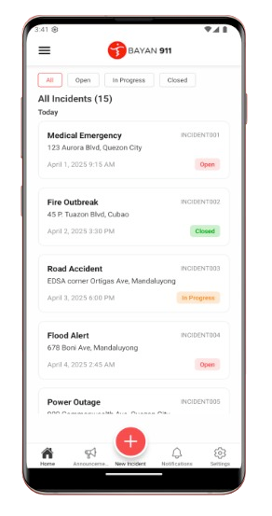
Figure 1.Bayan 911 Mobile Interface

While Bayan 911 is highly effective for emergency dispatch and incident monitoring, its functionality is strictly limited to incident reporting. Users have noted that the app does not provide tools for daily administrative barangay tasks, meaning residents still have to visit the barangay hall or use a different system to request official documents.
KaBarangayConnect, by comparison, integrates both real-time incident reporting and administrative document processing into a single unified platform. Instead of forcing residents to download one app for emergencies and use another method for paperwork, KaBarangayConnect provides a centralized dashboard where both critical incidents and routine clearance requests can be managed simultaneously by barangay staff.

BarangayOS

BarangayOS is a comprehensive digital governance platform built specifically for Philippine barangays. It focuses heavily on digitizing administrative workflows, allowing residents to request documents like Barangay Clearances and Certificates of Indigency online. A key feature of this system is its use of QR-based verification, which embeds a scannable code on issued documents to prevent tampering and fraud (Zentech Inc., 2026).
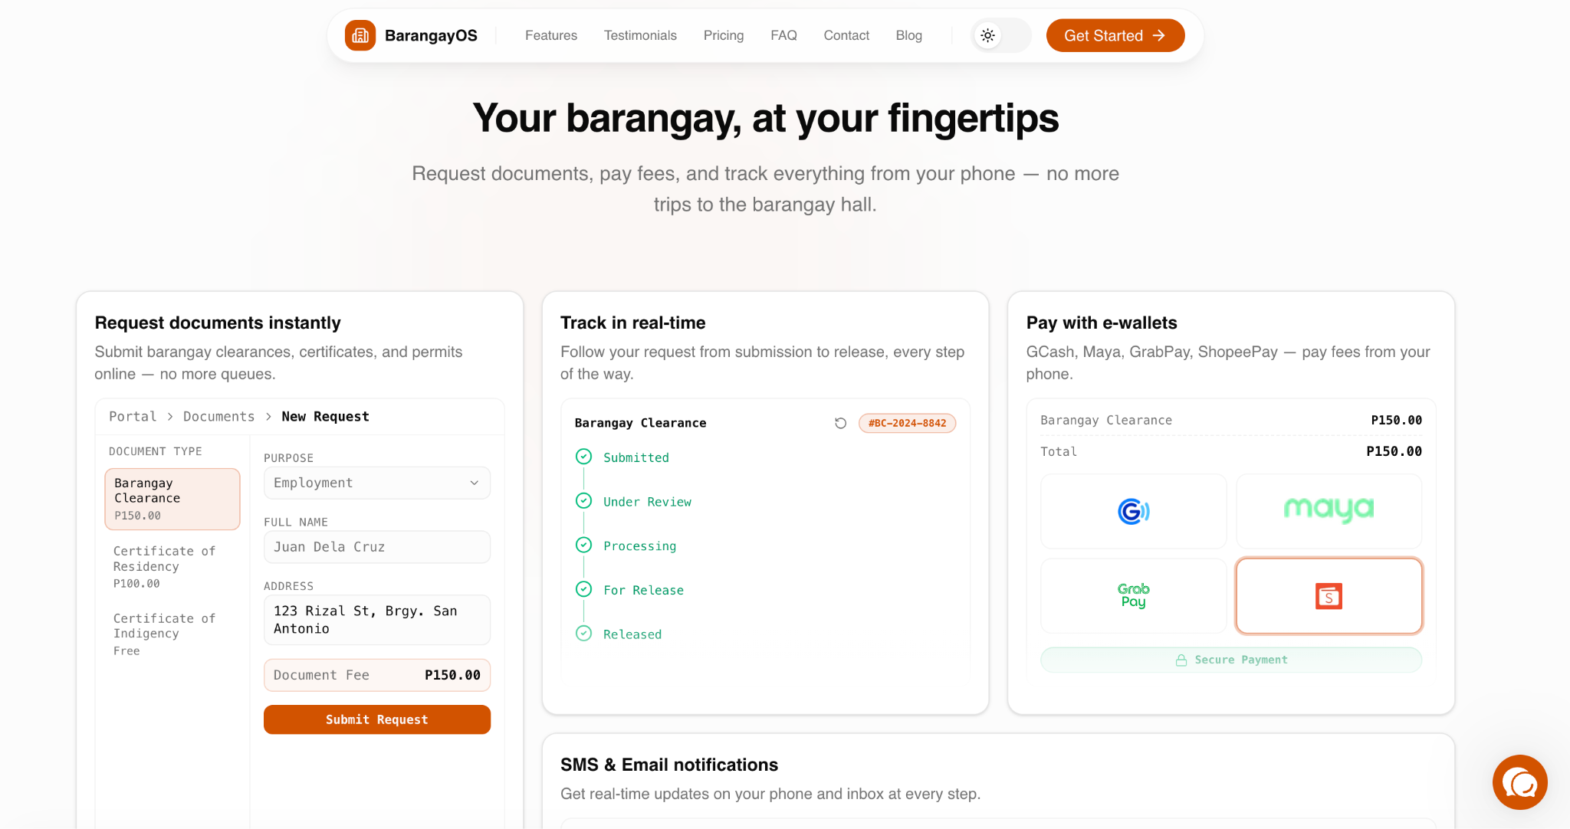
Figure 2.BarangayOS Web Portal

Although BarangayOS excels in document tracking and secure digital records, it functions primarily as a clerical tool. The platform lacks a dedicated emergency module for active community threats, meaning it cannot process or prioritize urgent, life-threatening incident reports from residents.
KaBarangayConnect adopts the secure administrative features of platforms like BarangayOS, specifically the QR code verification for documents—but expands upon it by introducing an Emergency Quick Button and Rule-Based Incident Prioritization. This ensures that the barangay system is not just a digital filing cabinet but a centralized monitoring platform capable of sorting high-priority emergencies from routine requests.

eGovPH App

The eGovPH App is the Philippine government’s official single operating system designed to unify all national and local government services into one application. It provides a centralized hub for digital IDs, national agency transactions, and localized reporting integrations like the PNP LERIS for crime reporting (Department of Information and Communications Technology, 2026).
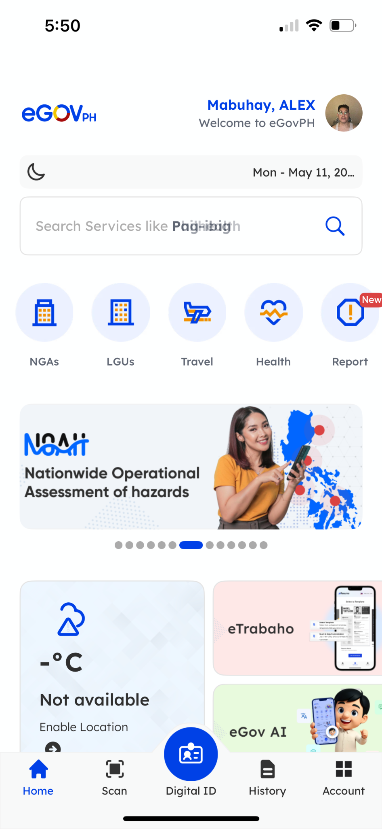
Figure 3.eGovPH Mobile Dashboard

As of recent updates in 2026, user feedback indicates that while the app is ambitious, its national scale makes it heavy and sometimes prone to technical bugs regarding local ID generation and loading times. Because it caters to the entire country, navigating to specific, localized barangay concerns can be overly complex for standard users.
KaBarangayConnect, by contrast, offers a localized, community-focused model. By narrowing the scope exclusively to the jurisdiction of a single barangay, the system avoids the clutter of a massive national app. This localized approach promotes neighbor-to-neighbor connectivity, ensures faster loading times, and allows barangay officials to have a dedicated, uninterrupted view of their specific community’s needs.

EBARANGAY

EBARANGAY is a digital governance platform designed to digitize standard barangay services. Residents can use the application to request official documents such as clearances, business permits, and certificates of indigency. It also includes a blotter module where citizens can formally file complaints or community disputes for barangay mediation (EBARANGAY, 2026).
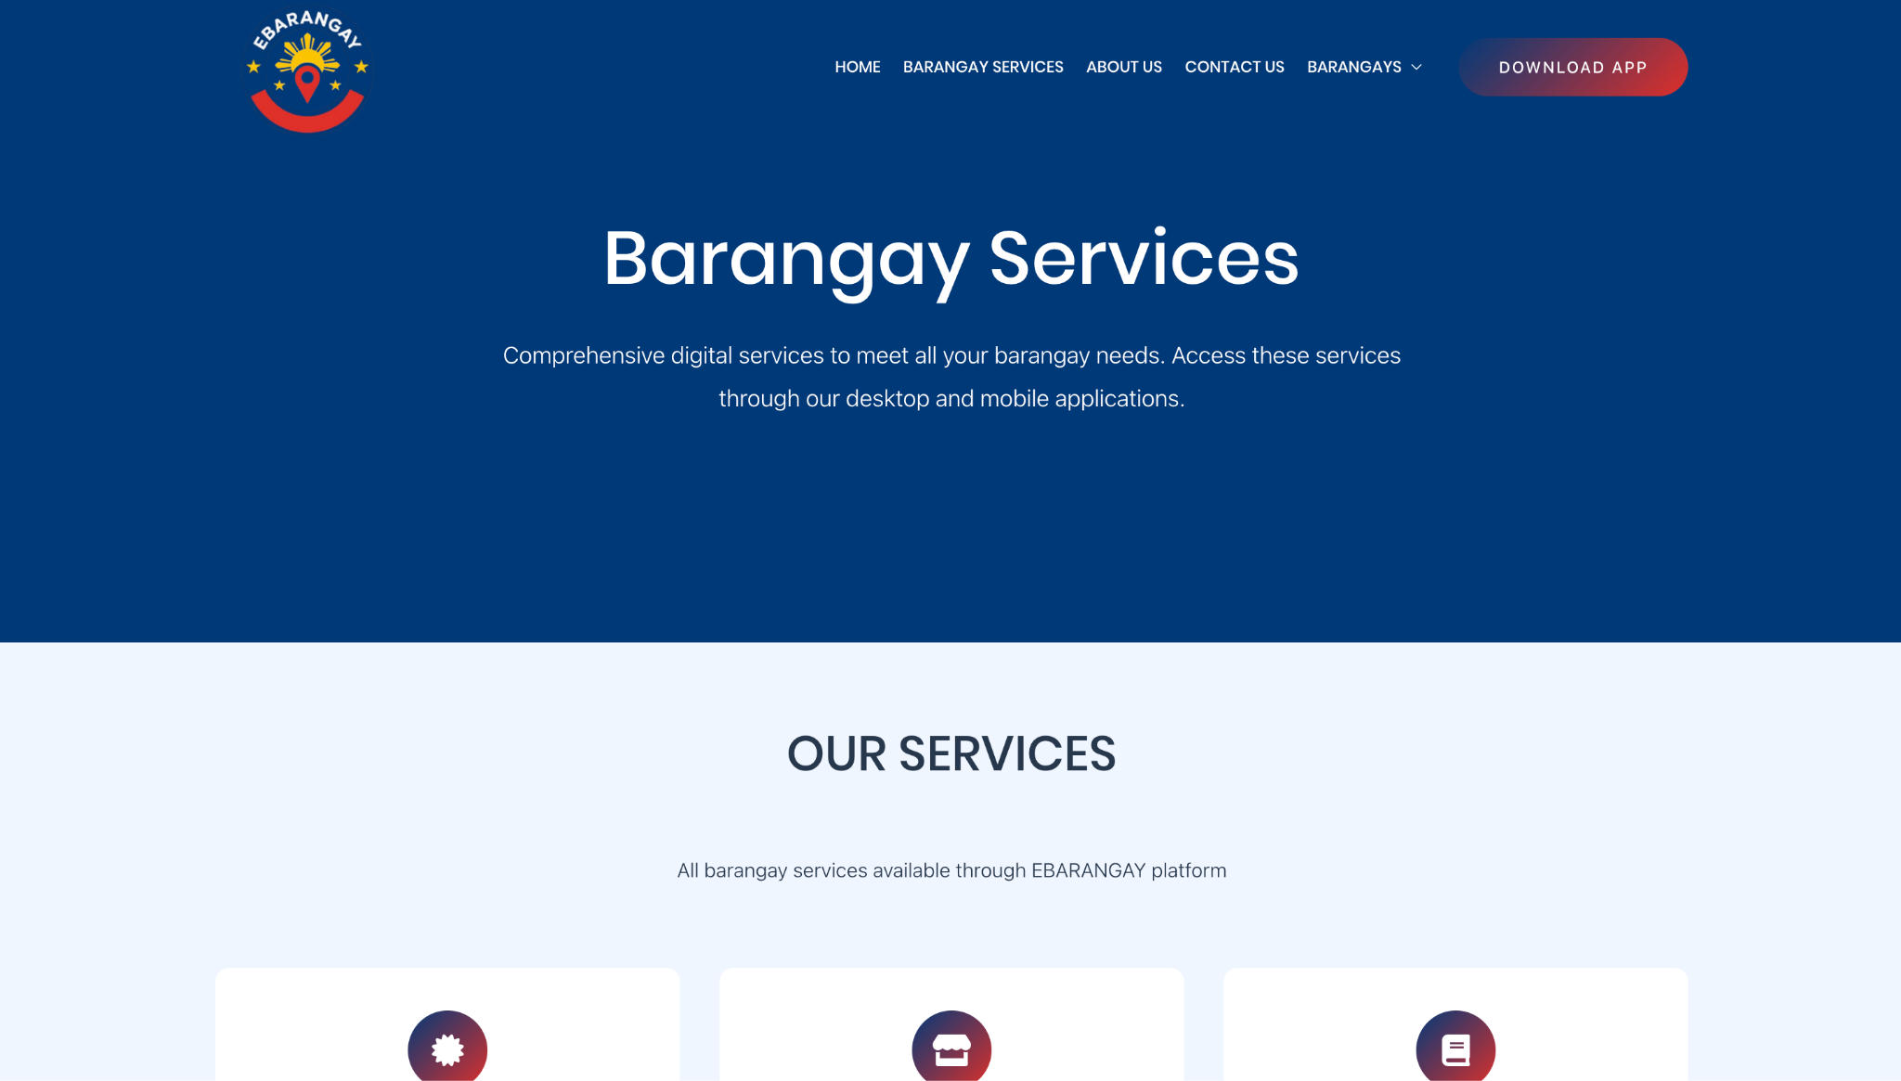
Figure 4.EBARANGAY Web Homepage

While EBARANGAY is highly useful for processing formal paperwork and documentation, its blotter feature is designed strictly for standard, non-urgent dispute filing. It lacks a specialized module for urgent, real-time emergency dispatch.
KaBarangayConnect, by comparison, integrates an Emergency Quick Button directly into the resident dashboard. Instead of forcing a resident to fill out a lengthy formal blotter form during a crisis, KaBarangayConnect allows them to instantly alert barangay officials of an active threat, bridging the gap between clerical management and immediate disaster response.

One Barangay Management System (OBMS)

OBMS is a comprehensive digital management solution aimed at automating the internal administrative operations of a barangay. It serves as an extensive backend database for barangay officials, featuring modules for resident profiling, asset management, treasury, and document issuance. The system is built to help local leaders make data-driven decisions based on community demographics (RAG IT Solutions, 2026).
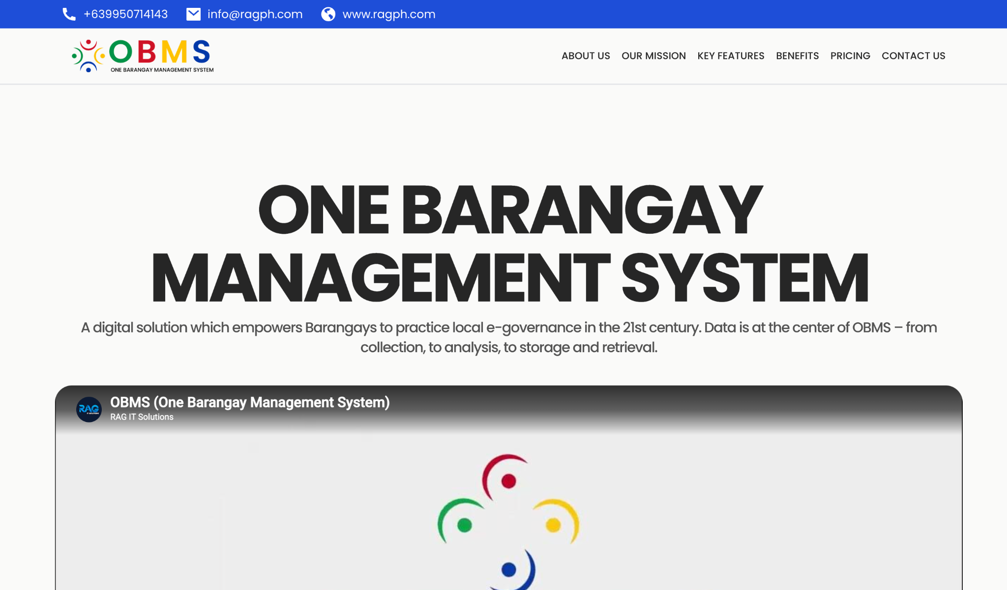
Figure 5.One Barangay Management System (OBMS) Web Homepage

Although OBMS provides robust tools for data collection and internal administration, it is heavily geared toward the operational side of the barangay staff rather than the active, daily engagement of the residents.
KaBarangayConnect adopts the centralized database approach of OBMS but places a stronger emphasis on two-way resident accessibility. By providing a resident-facing dashboard with real-time status tracking for both document requests and incident reports, KaBarangayConnect ensures transparency, allowing citizens to see exactly how and when their local government is addressing their concerns.

Related Studies

The following section explores published academic research and institutional reports that provide the theoretical foundation for KaBarangayConnect. By examining recent literature focused on local e-governance, automated document processing, real-time emergency tracking, and secure public record management, this review identifies prevailing operational bottlenecks as well as proven technological solutions. Gathering these insights is necessary to establish the technical and design requirements for a unified, web-based management system intended to improve response monitoring.

Transition to E-Governance in Local Government Units

The modernization of barangay operations is a primary focus of recent local governance research. Historically, the smallest administrative units in the Philippines have relied heavily on manual, paper-based workflows for record-keeping and document issuance. A 2025 study on the BarangayConnect information portal highlights that this reliance on physical logs often results in delayed essential services, such as the issuance of clearances and residency certificates. The study demonstrates that migrating to a web-based information system centralizes resident data, automates document requests, and significantly reduces the processing time required by barangay staff (Enaño et al., 2025). However, a critical limitation of this system is its passive operational design; it functions predominantly as a digital ledger for clerical tasks. Because it lacks a real-time community engagement module, the system fails to address urgent, life-threatening concerns. During community crises, residents using this platform still had to resort to traditional, offline methods—such as phone calls or physical visits—to alert authorities, proving that administrative digitization alone does not equate to a fully responsive local government.
Similarly, research published in the Philippine E-Journals regarding the “Digital Barangay” system emphasizes the inefficiencies of fragmented data systems. By implementing a centralized web platform, the researchers recorded a measurable improvement in administrative task turnaround and data accessibility for both officials and residents (Gasmido et al., 2025). Despite these administrative improvements, researchers noted severe limitations regarding the system's scalability and architectural resilience. During instances of internet instability or sudden spikes in user traffic, the centralized system experienced significant downtime, rendering the document services completely inaccessible to the public. Furthermore, the platform's scope was strictly limited to records management, offering no automated triage features to prioritize incoming community complaints.
These documented limitations highlight a significant gap in current local e-governance solutions: existing platforms are built merely to replace filing cabinets rather than to serve as active community command centers. This gap provides strong academic backing for the implementation of KaBarangayConnect. By integrating a scalable Document Request Management module with an active, real-time incident reporting dashboard and an Rule-Based Incident Prioritization system, KaBarangayConnect differentiates itself from previous iterations of barangay systems. It ensures that both routine administrative requests and critical emergencies are managed within a unified, highly available framework that actively responds to the community's immediate needs.

Modernizing Incident Reporting and Emergency Response
Beyond clerical management, effective local governance requires immediate coordination during community emergencies. Traditional methods of incident reporting at the barangay level, such as phone calls, text messages, or physical visits to the barangay hall—frequently suffer from delayed responses and poor documentation. A 2026 study examining an IoT-enabled “Barangay Panic Button” system identified that conventional communication methods often fail during critical situations due to high stress and network reliability issues. The research advocates for push-button emergency triggers that allow residents to rapidly transmit alerts and exact geographical coordinates to local officials, minimizing response times (IJRSI, 2026). However, a significant limitation of this hardware-centric approach is its lack of contextual data. While a physical panic button transmits a location ping instantly, it cannot inform officials about the nature of the emergency (e.g., whether it is a fire, a medical crisis, or an active crime), leaving responders blind until they arrive on the scene. Additionally, distributing and maintaining physical IoT devices for every household is highly cost-prohibitive for standard barangays. KaBarangayConnect addresses this limitation by utilizing a web-based Emergency Quick Button on the residents' existing personal devices, eliminating external hardware costs while allowing users to instantly categorize the emergency type with a single tap, providing critical context prior to dispatch.
Furthermore, a 2024 study on the "Guardian Insight" platform illustrates the necessity of centralized data analytics in emergency monitoring. The researchers found that relying on fragmented short messaging systems (SMS) for incident reporting is prone to errors and misinterpretations. By utilizing a centralized communication dashboard, barangay officials can process real-time alerts, spot patterns in emergency incidents, and allocate their response teams more accurately (Guardian Insight, 2024). Despite its analytical capabilities, the study noted a critical operational limitation: the system relied entirely on manual sorting by the receiving staff. During peak reporting times, human operators experienced "alert fatigue," resulting in severe emergencies occasionally getting buried under a high volume of low-priority community reports (such as noise complaints or minor neighbor disputes). KaBarangayConnect directly resolves this bottleneck by expanding upon the centralized dashboard concept with an integrated Rule-Based Incident Prioritization component. Instead of depending exclusively on staff to manually read and rank incoming alerts, the proposed system automatically evaluates the selected emergency category and text, instantly flagging life-threatening reports as "HIGH PRIORITY" so they bypass routine administrative requests in the admin queue.
Mobile Application for Incident Reporting
Ignaco (2021) developed an app which enabled the reporting and communication of incidents in real-time among the citizens and the barangay officials. The app provided the ability for users to submit their report with descriptions and GPS location as well as photos and was delivered directly to the responders and law enforcers.
It is pertinent to KaBarangayConnect in the sense that the system being proposed similarly concentrates on incident reporting, monitoring, and record keeping. It should be noted that, contrary to the study, the application KaBarangayConnect can only be used in web-based prototyping with only incident reporting and monitoring capabilities without emergency dispatching and GPS technology.
Crime Incidence and Responsiveness of Police-Barangay Joint Operations in Barangay Buenavista and Barangay Sta. Lucia, Sablayan, Occidental Mindoro
In Dacayanan's (2026) study, police and barangay officers worked together in their respective communities on responding to crimes that were reported to them. Effective communication, structured monitoring, and quick responses to crime reports are among some of the things that should be done in order to achieve effective crime management in communities.
The study contributes to the objective of KaBarangayConnect since this system also seeks to improve communication and collaboration between barangay officials and residents. Nevertheless, the scope of the proposed KaBarangayConnect is confined to online crime reporting, monitoring, and management of the records, and it excludes any activities in law enforcement response management.
Development and Evaluation of a Digital Barangay Management System
Osman (2026) designed and analyzed a digital barangay management system, which enhanced the functioning of the local government through centralized documentation, office automation, and digitization. It was found that a digital system enhances the efficiency and reliability of services within a barangay.

The study is relevant to the research on the KaBarangayConnect System since both systems use digitized methods to enhance barangay processes. The only difference is that KaBarangayConnect only focuses on document request processing, incident reporting, alerts, and documentation archiving while other barangay processes fall outside the scope of this research.
Strategies and Mechanisms of Local Government Units for E-Governance
According to Correa et al. (2022), the adoption of e-governance systems in local government organizations in the Philippines was examined. In their findings, the use of digital technology like websites and portals can enhance communication, transparency, citizen participation, and service delivery.
The research is pertinent to KaBarangayConnect because KaBarangayConnect also embraces digital governance by enabling online document requests and incident reporting. But unlike the research, the KaBarangayConnect application only applies to the pilot project at Barangay Labuin, Pila, Laguna.
Barangay Constituents Information and Services Management System
Villones (2021) developed the Barangay Constituents Information and Services Management System (BCISMS) to improve barangay transactions, service management, and record retrieval through a centralized digital platform. The study found that manual processing of barangay certificates, permits, and records often resulted in delays and inefficient data management.
The system included features such as record searching, report generation, graphical presentation of census data, and digital records management. Evaluations using McCall’s Software Quality Model and ISO/IEC 9126-1:2000 showed high ratings in functionality, usability, reliability, efficiency, maintainability, and portability. The findings are related to KaBarangayConnect because both systems focus on centralized records management, efficient information retrieval, and improved barangay services through web-based technologies.
Real-Time Incident Alert Dashboard
Khan et al. developed a Real-Time Incident Alert Dashboard capable of detecting emergencies such as accidents, fires, assaults, and thefts using a centralized web-based dashboard. The researchers explained that traditional reporting systems often depend on manual processes, which can result in delayed reporting, and poor coordination among responders.
The proposed system utilized real-time monitoring, centralized dashboards, automated notifications, and database management to improve emergency response and incident monitoring. This study is relevant to KaBarangayConnect because both systems aim to strengthen incident reporting and public safety through centralized digital platforms and real-time monitoring features.

Real-time incident reporting and intelligence framework: Data architecture strategies for secure and compliant decision support
Shaffi and Sidhick (2025) introduced a real-time incident reporting and intelligence framework that improved incident management through automation, artificial intelligence, and real-time analytics. The study emphasized that traditional reporting systems are often affected by delayed responses, incomplete information, and human error, which can negatively affect decision-making and incident resolution.
The framework integrated centralized databases, automated incident detection, dashboards, notifications, and intelligent analytics to improve incident reporting and management. The study is relevant to KaBarangayConnect because both systems focus on centralized digital platforms, secure data management, interoperability, and real-time monitoring to improve efficiency and responsiveness.

Yaneza et al. (2025) - Online Emergency Response Management System (OERMS)
This study developed an Online Emergency Response Management System (OERMS) evaluated using ISO 25010 and the Technology Acceptance Model. The ISO evaluation yielded an overall mean score of 4.61, with Compatibility at 4.61, Security at 4.56, and Reliability at 4.53 receiving the highest marks. The TAM results indicated high user satisfaction, with Perceived Usefulness at 6.69 and Ease of Use at 6.68. The findings confirm the system's effectiveness in improving resource coordination, user engagement, and emergency limitations..
This study is relevant to KaBarangayConnect as it validates the technical feasibility and user acceptance of web-based emergency management systems within the Philippine context. The OERMS, however, focuses on resource coordination and multi-agency emergency logistics rather than community-level, resident-initiated reporting. It also does not integrate routine administrative services such as document requests. KaBarangayConnect improves upon this by unifying emergency response with day-to-day barangay service delivery in a single platform - eliminating the need for residents to navigate separate systems for routine requests and urgent situations. The strong ISO 25010 ratings achieved by OERMS also validate that the evaluation framework KaBarangayConnect intends to use is well-suited and widely accepted for assessing systems of this nature.

Da'Costa et al. (2025) - AI-Driven Triage in Emergency Departments: A Review of Benefits, Challenges, and Future Directions
This narrative review analyzed peer-reviewed articles published between 2015 and 2024 and identified substantial benefits of AI-driven triage, including improved patient prioritization, reduced wait times, and optimized resource allocation. However, challenges such as data quality issues, algorithmic bias, clinician trust, and ethical concerns are significant barriers to widespread adoption.
While this study focuses on AI triage within hospital emergency departments, its findings provide a strong theoretical foundation for KaBarangayConnect's Rule-Based Incident Prioritization feature. The core principle - that AI-driven prioritization of incoming reports significantly reduces response delays and improves resource allocation - is directly applicable to the barangay context. KaBarangayConnect adapts this established concept from the clinical setting to community-level emergency response: when a resident activates the Emergency Quick Button and selects an incident category (e.g., Fire, Medical, Flood), the system automatically classifies severity and presents suggested response actions to the barangay official on duty. Unlike hospital-grade AI triage systems that require complex machine learning infrastructure, KaBarangayConnect implements a practical, rule-based triage layer that is feasible for student development and realistic for barangay deployment - demonstrating how AI-assisted prioritization can be effectively scaled down to the grassroots level of local governance.

Tolentino et al. (2025) - Smart Crime Informatics and Decision Support for Police-Community Partnerships
This study developed a Digital Crime Informatics and Community Relationship Management System with Decision Support for Police Provincial Offices in the Philippines. Using the Agile SDLC and evaluated under ISO/IEC 25010, the system met key quality standards including usability, performance efficiency, security, and functional suitability. The decision support feature enabled the Philippine National Police to effectively monitor crime data and location-based information to improve resource allocation and patrol planning.
This study demonstrates the value of digitizing community safety systems and integrating decision support tools for law enforcement in the Philippine context. However, its scope is limited to police-level operations and is designed for provincial police offices rather than the barangay level where first-contact community response actually occurs. The system also requires PNP personnel to operate and manage reports, excluding residents from the reporting process entirely. KaBarangayConnect addresses this gap by empowering residents directly — allowing them to submit structured incident reports from their own devices without relying on law enforcement intermediaries. Moreover, KaBarangayConnect's Rule-Based Incident Prioritization component provides barangay officials with automated severity classification and suggested response actions for each incident type, bringing intelligent decision support to the most local and accessible level of government.

Enaño et al. (2025) - BarangayConnect: A Web-Based Information Portal for Resident Data, Administrative Services, and Community Records Using Data Analytics
This study developed a web-based application called BarangayConnect, designed to streamline barangay operations through digital transformation. The system provides a centralized platform allowing residents to request services such as barangay clearances, certificates of residency, and identification cards without physically visiting the barangay hall, and includes an interactive dashboard displaying real-time demographic data and household information to support data-driven decision-making.
This study shares a similar title and concept with KaBarangayConnect, making the distinction particularly important. While BarangayConnect by Enaño et al. successfully addresses document request digitization and incorporates data analytics for internal barangay planning, it remains bounded to a single barangay in Pasig City with no integration with external government systems and no emergency management feature. KaBarangayConnect distinguishes itself by going beyond administrative digitization — it introduces an Emergency Quick Button that auto-fills incident reports using the resident's registered profile, automatically tags the submission as High Priority, and triggers immediate notification to all active barangay staff. This real-time emergency response capability addresses a critical gap that BarangayConnect and similar systems leave unresolved: the absence of a structured, digital, and time-sensitive channel for reporting life-threatening community incidents.

Tosper et al. (2025) - WebYu: A Barangay Yuson Web-Based Information Management System Initiatives
This study developed WebYu, a web-based Barangay Information Management System for Barangay Yuson, Guimba, Nueva Ecija, using a mixed-methods approach and the Scrum methodology. The system was evaluated by 75 participants using ISO 25010 standards, yielding an overall mean of 4.62, particularly excelling in maintainability and security. The study specifically addressed fragmented data management, delays in record retrieval, and inconsistencies in the issuance of clearances and certificates that arise from manual paper-based barangay systems. The researchers found that centralizing resident data into a digital platform significantly improved the speed and accuracy of document issuance.significantly improved the speed and accuracy of document issuance. However, the WebYu study was limited to document and records management and did not examine incident reporting, real-time community safety concerns, or two-way communication between residents and barangay officials.
This study is directly relevant to KaBarangayConnect as both systems target the same core operational inefficiency — the reliance of barangay offices on manual record-keeping. However, WebYu is limited exclusively to information management and does not include any incident reporting, community safety, or emergency response capabilities. KaBarangayConnect advances beyond this scope by integrating document request management with a real-time incident reporting module, an Emergency Quick Button for urgent situations, and an Rule-Based Incident Prioritization System — features entirely absent from WebYu. Furthermore, while WebYu serves only the administrative side of barangay operations, KaBarangayConnect is designed as a resident-facing platform that gives community members direct access to both service requests and safety reporting from a single dashboard.

Culi et al. (2025) - S.A.F.E.R.: A Community Disaster Resilience Mobile Application
This study created S.A.F.E.R., a community resilience application with direct communication channels for residents and responders via a secure chat system, safety guidance alerts that provide actionable instructions based on location and incident degree, and community resilience tools like offline emergency contacts and a dynamic news feed. Usability, usefulness, dependability, and overall performance were all systematically evaluated based on the Mobile App Rating Scale (MARS) and ISO/IEC 25010 standards.
S.A.F.E.R. shares KaBarangayConnect's focus on enabling locals to take an active role in community safety as opposed to being passive users of public services. S.A.F.E.R., on the other hand, is a stand-alone mobile emergency application that functions without reference to any governance or administrative platform. Document request management, formal barangay record-keeping, and organized incident reporting that local government entities can examine and take action on are not supported. KaBarangayConnect is appropriate for barangays that do not have the resources to maintain separate specialized applications because it combines these features into a single web-based platform that is accessible across devices. Furthermore, S.A.F.E.R. does not address the informal social media group chats that many barangays now use; instead, KaBarangayConnect's Official Announcement Feed offers a validated, government-controlled communication route.

Synthesis and Gap Analysis
In summary, the reviewed literature shows that the adoption of digital tools, reporting mechanisms, centralized databases, and real-time monitoring systems would help to increase the efficiency, communication, and effectiveness of services provided by the barangays and local government units. The reviewed studies revealed that online tools would help in processing document requests, incident reports, records, and administrative tasks, among other benefits. In addition, the literature showed that it is crucial to consider aspects such as usability, system readiness, human capability, ease of workflow, and ensuring privacy and security, for example, using role-based access controls.
Even as effective as the current solutions were, most research efforts had centered on either administrative management or incident reporting separately. Many existing solutions had been developed merely for handling documents, managing records, or incident responses, thus creating an inefficiency of disjoined workflow and disconnected service provision. Moreover, some of the existing solutions did not even have monitoring, coordination, and dashboard functions that could be used to improve their efficiency. It is, therefore, apparent from the existing literature and solutions that there was a need to develop KaBarangayConnect in order to combine document request management, record management, incident reporting, and monitoring functionalities under one solution. Also, user-centered evaluation techniques such as ISO/IEC 25010 and pilot user testing are supported by the literature to measure functionality, usability, reliability, performance efficiency, and security of the solution.

CHAPTER III

METHODOLOGY

Requirement Analysis

The present section discusses the functionality and non-functionality requirements of KaBarangayConnect, which is a comprehensive web-based system for managing the operations of a barangay, and reporting incidents in real time. Requirements have been specified in consideration of the needs of the officials and people living within a barangay, as well as the goals of the research and relevant literature.

Needs Assessment and Problem Analysis
The barangays are the basic units of local governance that provide for essential public services, maintenance of records of residents, processing of documents, and handling of incidents in the community. Being the front-liners in the provision of government services, the barangays deal with many administrative transactions daily for the effective delivery of their services to the people.

Based on the initial interview and survey conducted among the barangay residents and the barangay officials in Barangay Labuin, Pila, Laguna, the barangay still makes use of the traditional method in dealing with document processing, record keeping, and incident reports. From the survey responses, the processing of documents and incident reports is done through the use of handwritten logbooks and documents, and the barangay staff deals with many document and incident requests weekly.

Moreover, the results show that all respondents have constant access to the internet, implying that the web-based system will be accessible to the targeted users. Respondents stated the presence of repeated transactions concerning barangay document request, while one of them admitted that he was discouraged by the long procedure of reporting incidents. All of these issues imply the necessity of implementing an efficient system that could simplify the administrative procedures and increase the level of communication between residents and the barangay staff.

Based on the discovered needs, the researchers suggest implementing KaBarangayConnect, which is a web-based system for managing the process of document request, incident reporting, and records management. It is suggested to integrate all of these processes in one place so that they could become easier, transparent, and improved in terms of the level of communication between the resident and barangay officials. It is expected that the implementation of the suggested system would promote the digital transformation of the government services according to the requirements of the Data Privacy Act of 2012 (Republic Act No. 10173).

Functional and Non-Functional Requirements Matrix
- Functional Requirement
Functional requirements define the specific features, services, and processes that KaBarangayConnect must perform to meet the needs of its users. These requirements describe how the system will support residents, barangay staff, and administrators in managing document requests, incident reports, notifications, and records. They serve as the foundation for the system's core operations and functionalities.
Table 1 presents the functional requirements identified for KaBarangayConnect.
Req. ID No. | Requirement | Description
FR-01 | User Registration and Login | The system shall facilitate the creation and authentication of resident accounts using either standard email credentials or Google Single Sign-On (SSO). Google SSO enables a streamlined, one-click onboarding experience while securely validating user identity. Resident account creation is contingent upon accepting the Data Privacy Act (RA 10173) consent agreements.
FR-02 | Administrator Authentication | Multi-Factor Authentication (MFA) is strictly enforced for all administrative accounts. The system utilizes Time-Based One-Time Passwords (TOTP) generated via the Google Authenticator application. Following primary credential validation, administrators must provide a dynamic 6-digit verification code from their physical mobile device to gain access, effectively mitigating unauthorized entry from compromised passwords and protecting sensitive civic data.
FR-03 | Role-Based Access Control | The system shall categorize users into user roles (Resident, Barangay Staff, and Administrator) and provide access to system modules and information according to the privileges of users.
FR-04 | User Profile Management | The system must allow residents to create, view, and update their profile information, while the administrators will handle the resident accounts such as account activation, suspension, and updating.
FR-05 | Online Document Request Submission | The system should enable residents to apply for barangay documents (for example, Barangay Clearance, Certificate of Residency) through an online application form.
FR-06 | Identify Verification Upload | The system should enable residents to submit their ID and other documents as proof for document verification.
FR-07 | Document Processing Workflow | The system should enable barangay officials to check submitted applications, verify submitted documents, approve or deny the applications, ask for more documents if necessary, and make approved documents ready for pickup.
FR-08 | Real-Time Document Tracking | The system will enable residents to track the process flow of document requests by checking their approval status and processing timeline.
FR-09 | Incident Report Submission | The system will enable residents to report incidents that include relevant information like incident description, category, date and time of incident, as well as its location.
FR-10 | Interactive Geospatial Mapping | The system will enable residents to identify the exact location of the incident on an interactive map prior to making an incident report.
FR-11 | Multimedia Evidence Upload | The system will enable residents to attach pictures/videos to support their incident report.
FR-12 | Incident Prioritization and Management | The system shall enable barangay officials to be able to view incident reports, classify incident based on level of severity, update the status of an incident, set priorities and resolve incidents.
FR-13 | Live Emergency Communication | The system shall enable residents and barangay officials to engage in real time chat regarding active incidents.
FR-14 | Automated Notification System | The system shall automatically notify user of any changes in documents requests, incidents statuses, announcements and system activities.
FR-15 | Dashboard Monitoring | There shall be dashboards for pending document requests, active incident reports, emergency statistics, notification summary, and system activities according to the roles of users.
FR-16 | Barangay Announcement Management | There shall be capability of creating, editing, publishing, archiving, and deleting of barangay announcements by the administrator and viewing the same by residents.
FR-17 | Barangay Officials Directory | There shall be availability of the barangay officials' directory, where there will be details such as names, positions, offices, and contacts of the barangay officials.
FR-18 | Help and Support Module | There shall be provision of FAQs, help files, and supporting information for residents to use the platform.
FR-19 | Accessibility Settings | The system will support the customization of access settings such as adjusting text size, high-contrast view, and reading the Data Privacy Policy.
FR-20 | Records Archiving and Retrieval | The system will support archiving and retrieval of all documents requests, resident records, incident reports, announcements, and communications.
FR-21 | Administrative Audit Logging | The system will support the logging of all actions taken by the administrator including but not limited to logging of login, document approval, incidents reporting, announcement management and so forth.

Table 1. Functional Requirement Table
- Non-functional Requirement
Non-functional requirements define the quality standards and performance expectations that KaBarangayConnect must satisfy. These requirements focus on how the system operates rather than what it does, covering aspects such as security, reliability, usability, accessibility, performance efficiency, and compliance with data privacy regulations. These requirements ensure that the system remains effective, secure, and user-friendly for all stakeholders.
Table 2 presents the non-functional requirements identified for KaBarangayConnect.
Req. ID No. | Requirement | Description
NFR-01 | Performance Efficiency | The system is expected to respond quickly and handle transactions efficiently.
NFR-02 | Security | The system will ensure authentication, role-based access control, and secure data management.
NFR-03 | Reliability | The system is expected to reliably carry out its intended functions with few downtimes.
NFR-04 | Scalability | Increasing the number of residents, administrators, document requesters, report filers, file uploads, and notifications will not compromise the performance of the whole system.
NFR-05 | Availability | The system should function and be accessible through current web browsers in desktop and mobile versions excluding maintenance windows.
NFR-06 | Usability | The interface design should be easy to learn and easy to use by residents and Barangay officials.
NFR-07 | Accessibility | The system should be accessible through web browsers in desktop and mobile versions.
NFR-08 | Maintainability | The system must be easily upgraded, maintained, and enhanced.
NFR-09 | Data Privacy Compliance | The system shall comply with the Data Privacy Act of 2012 and protect resident information..
NFR-10 | Data Security | The system will ensure that resident information, identification papers, multimedia evidence, and system information are all stored safely using encryption and controlled access methods.
NFR-11 | Auditability | The system must ensure comprehensive and secure audit logging for all activities such as user authentication, administrative actions, and any other system transactions that are considered important.
NFR-12 | Data Retention and Recovery | The system must put in place a system of automatic backup and archiving in order to comply with the relevant government requirements regarding data retention policies.
Table 2. Non-functional Requirement Table
Requirements Gathering Techniques
The requirements for KaBarangayConnect have been determined by means of reviewing existing literature, conducting interviews, analyzing the existing system, and performing user analysis. The purpose of these approaches was to determine the requirements that would help make sure that the developed system will satisfy the real needs of barangay officials and citizens.

Literature Review - A detailed review of various related literature studies, journals, conference proceedings, government documents, and existing management systems of barangays has been done in order to find out what is currently being done in the areas of e-governance, records management, and incident reporting systems. The results showed that some of the important requirements include having centralized databases, automation of workflows, real-time monitoring capability, notifications systems, role-based access, and compliance with data privacy. These findings were used as inputs in formulating the requirements for the proposed system.

Interviews - During the survey and requirements gathering process, one of the researchers, who previously completed an On-the-Job Training (OJT) in the Accounting and Administrative Department of Barangay Labuin, Pila, Laguna, was able to observe the barangay's daily operations. During the internship, it was observed that administrative processes, including document requests, record keeping, and incident recording, were primarily conducted through manual, paper-based procedures. The researcher also observed inconsistencies in the recording and management of barangay documents due to the absence of a centralized digital system.
During the survey, the researcher interviewed both barangay residents and personnel regarding their experiences with document processing, incident reporting, and records management. The responses consistently highlighted challenges such as lengthy manual procedures, difficulty in tracking requests and reports, delays in retrieving records, and the lack of a digital platform for managing barangay services. These findings reinforced the need for an integrated web-based system that would digitize administrative processes, improve record management, facilitate online document requests and incident reporting, and provide a centralized platform for both residents and barangay officials.
Surveys - To verify the gathered requirements for the system and get insights from the target users of the suggested KaBarangayConnect system, a preliminary needs assessment survey was conducted. This initial assessment was participated in by a small sample of six (6) residents and five (5) barangay officials from Barangay Labuin, Pila, Laguna. One of the researchers went to the barangay personally to conduct the survey and gather baseline responses. The residents shared their preliminary experiences on requesting barangay documents, filing incidents, and communicating with officials, while the barangay staff provided initial insights into their administrative tasks.

The survey was one of the main sources of data in relation to testing the functional and non-functional requirements of the proposed system. This is because the information acquired from the residents and barangay staff gave great insights on what needed to be improved in terms of the current workflow and the requirements of the users. This data was utilized in fine tuning the requirements of the system so as to fit the actual needs of the users.
Survey Results and Analysis - In order to provide more validation to the system requirements, a survey was performed involving six (6) residents and five (5) barangay officials of Barangay Labuin, Pila, Laguna. The survey sought to find out about the experiences of the respondents regarding their dealing with barangay services, documents, incident reporting procedures, record keeping practices, and communication with barangay officials. These were useful in terms of finding out the process that is being currently implemented and was used as evidence for the system requirements of KaBarangayConnect.
- Internet Accessibility
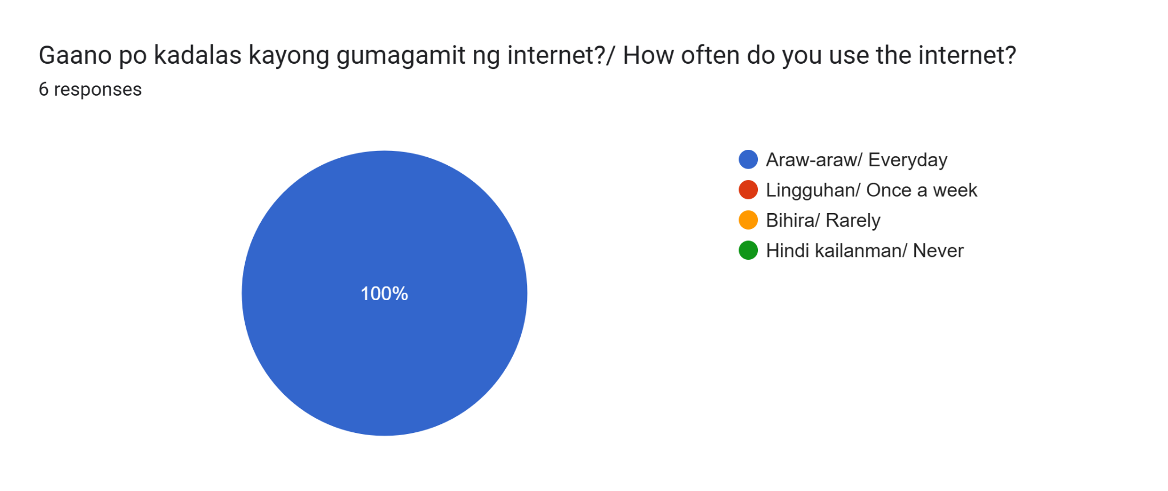
Figure 6. Frequency of Internet Usage Among Respondents

The survey reveals that 100% of the participants access the internet daily. This clearly shows that the residents as well as the barangay staff have daily access to internet services, thus a web-based system will definitely be a viable and convenient solution. The survey findings reveal that the deployment of KaBarangayConnect as a browser-based system will be convenient to access via internet facilities.

- Frequency of Barangay Document Requests
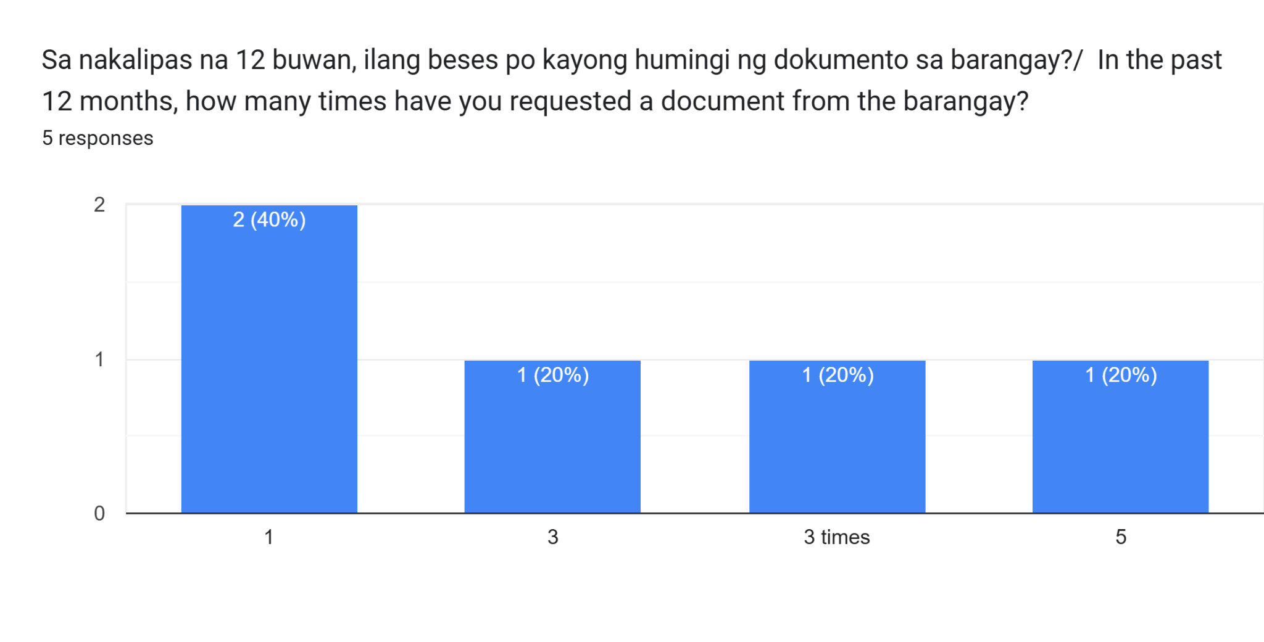
Figure 7. Number of Barangay Document Requests During the Past 12 Months
Based on the results, it can be concluded that there was a difference in the frequency at which the residents requested documents from the barangay in the past year. Although most of the respondents only requested for the document once, some of the respondents made multiple requests from the barangay. The process of requesting documents is therefore a recurring process that needs an effective system.

- Processing Time for Barangay Documents
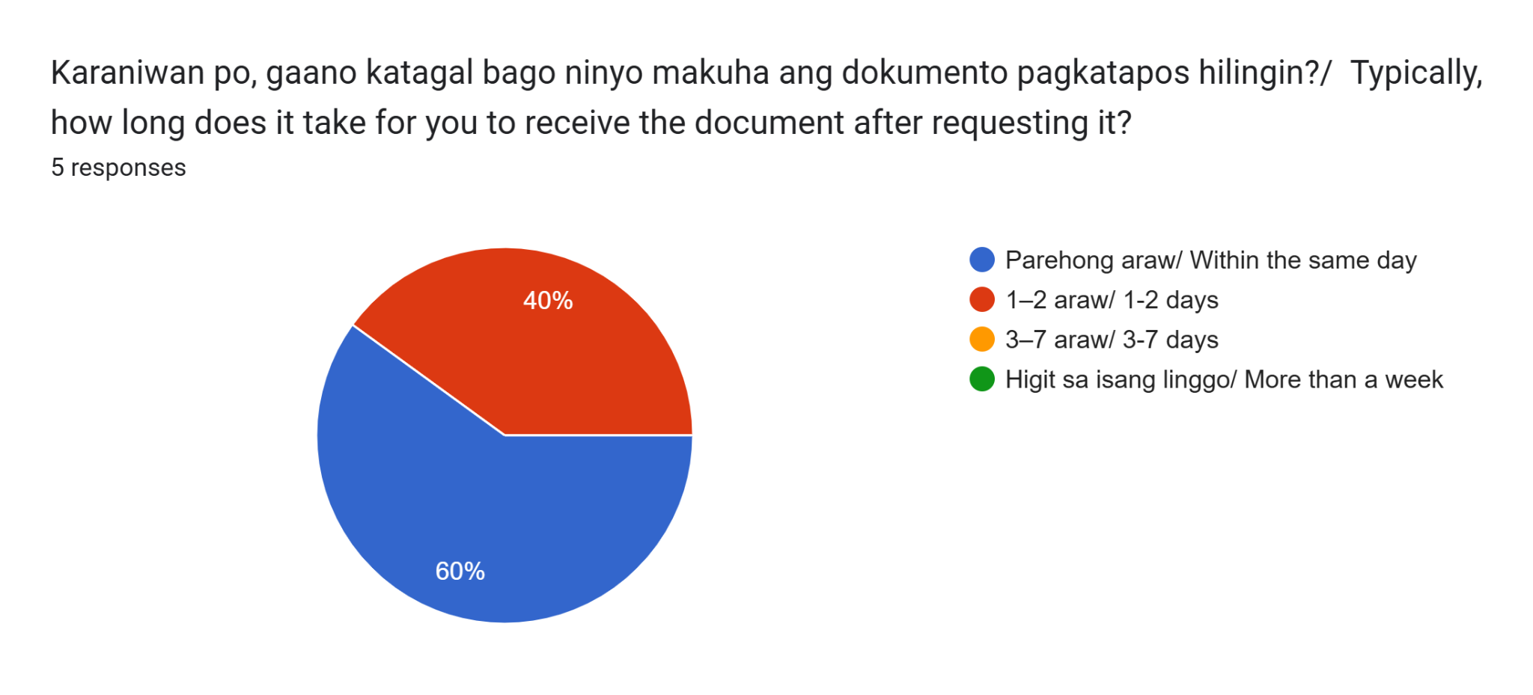
Figure 8. Average Processing Time of Barangay Documents
For the majority of the respondents, the delivery of their requests happened on the same day, while for others it took from one to three days. However, despite the fact that the current period of time is satisfactory, the respondents have expressed their desire to be able to track the progress of their requests.

- Experience in Incident Reporting
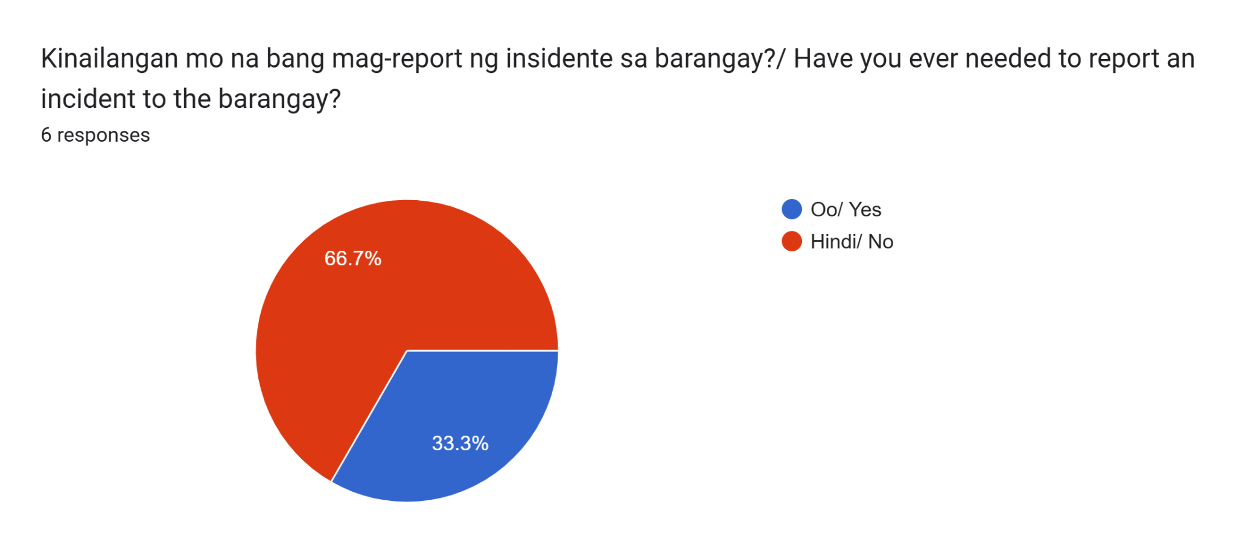
Figure 9. Respondents' Experience in Reporting Incidents to the Barangay
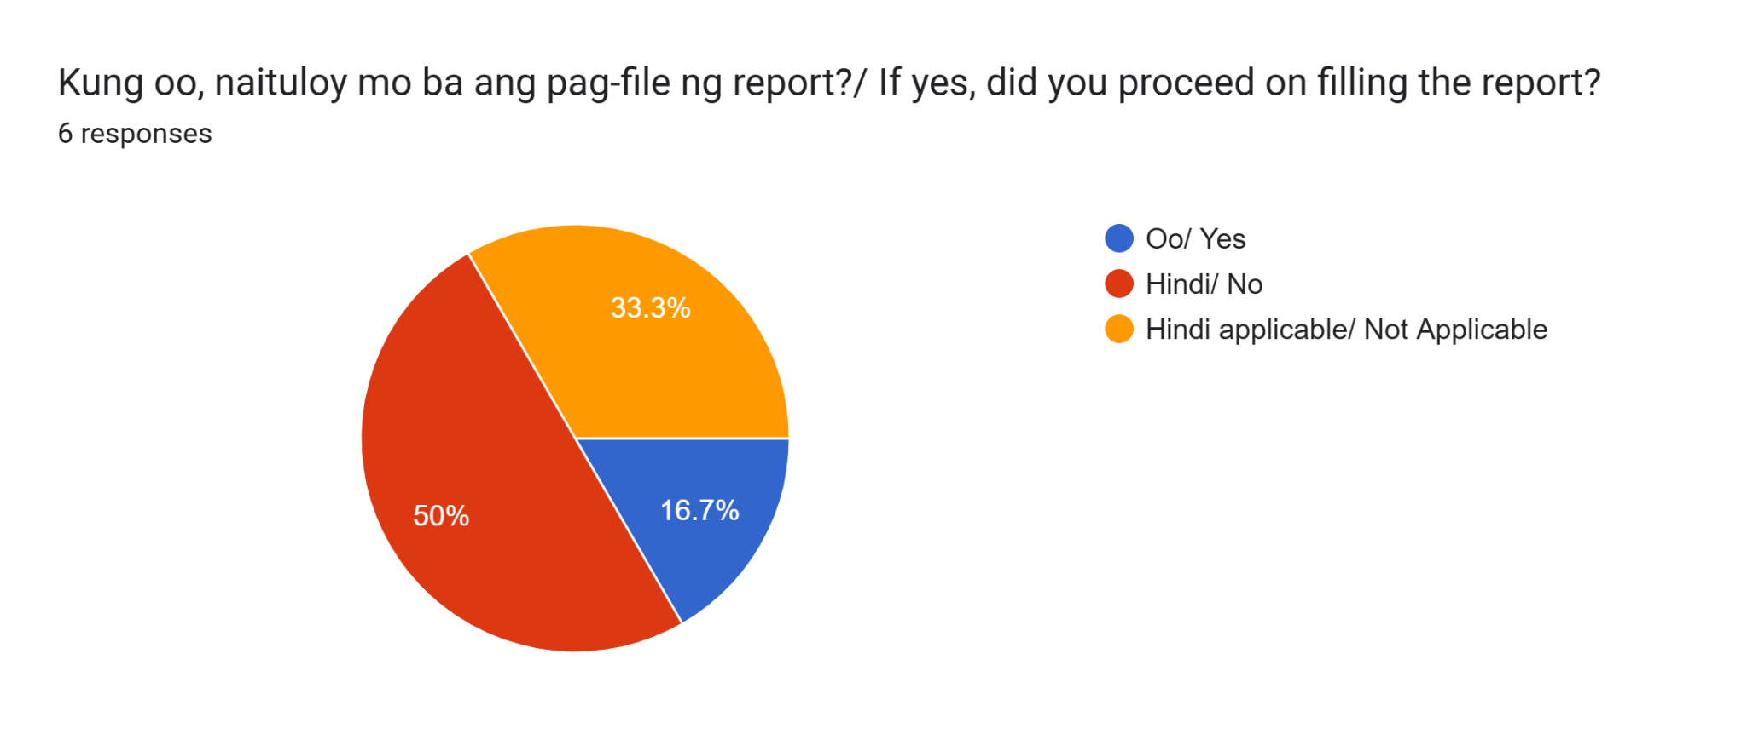
Figure 10. Respondents' Decision to Proceed with Filing an Incident Report
The results of the survey show that the majority of respondents have not made any incident report yet, whereas some of them have prior experience of making an incident report. Of those respondents who have never made an incident report, one respondent expressed his opinion regarding the lengthy nature of the process, which deterred him from filing a report. The findings indicate that the existing system might pose certain obstacles in the way of timely incident reporting. However, even though making incident reports might not be a common practice among all residents, the existence of a centralized system for making incident reports is still very significant.

- Current Incident Reporting Process
According to the respondents who were familiar with incident reporting, incidents are mainly logged manually through logbooks. Logbooks serve as a standardized means of recording incidents; however, such an approach might hamper the process of searching for records, monitoring the status of reports, and compiling reports. Thus, there is a need for having an incident reporting module incorporated into KaBarangayConnect, which will help keep the records safe, track them and access them conveniently.

- Weekly Document Processing
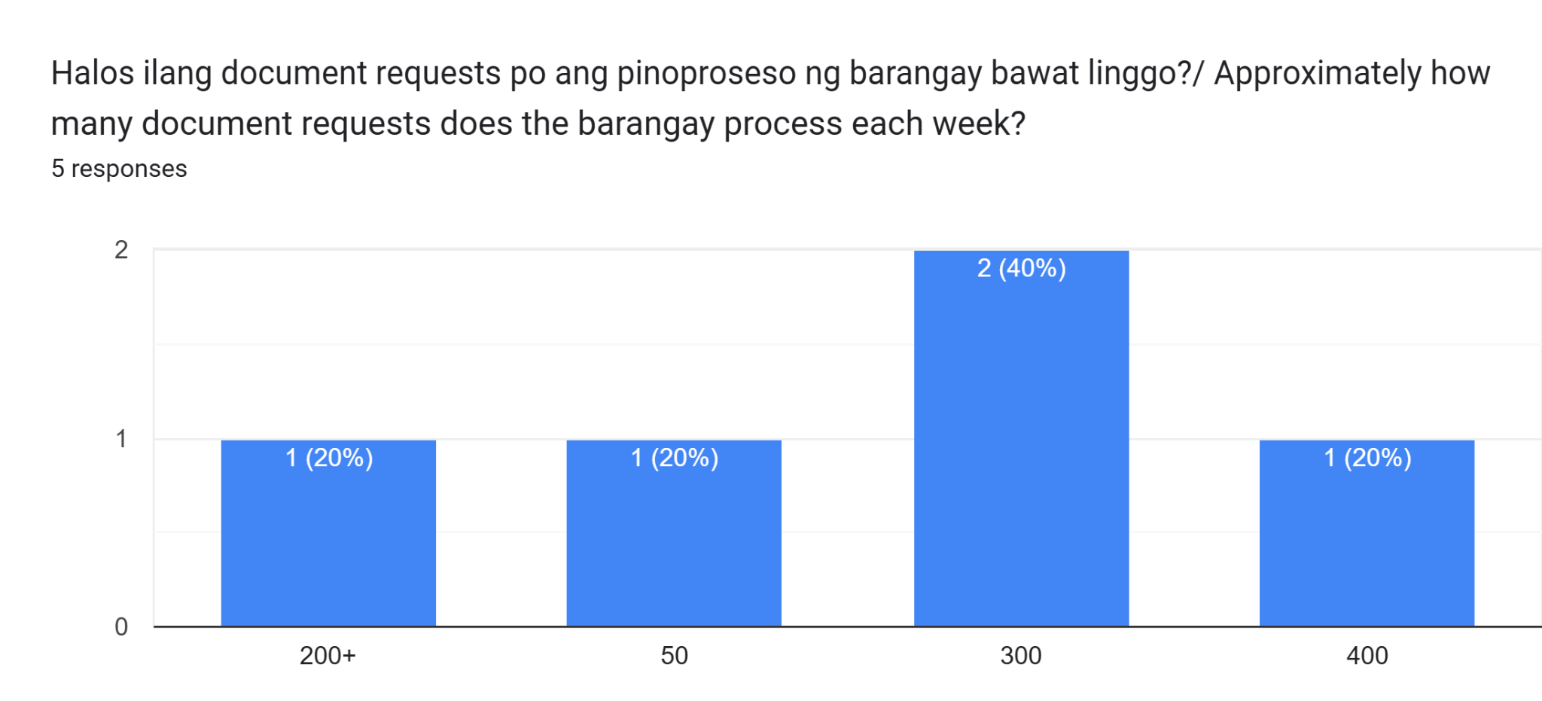
Figure 11. Estimated Number of Documents Processed per Week
Barangay personnel estimated that approximately 50 to 400 document requests are processed each week. Even though the estimated values may differ from one respondent to another, based on their respective roles, it seems clear that document processing is a very important task within the administration.

- Monthly Incident Reports
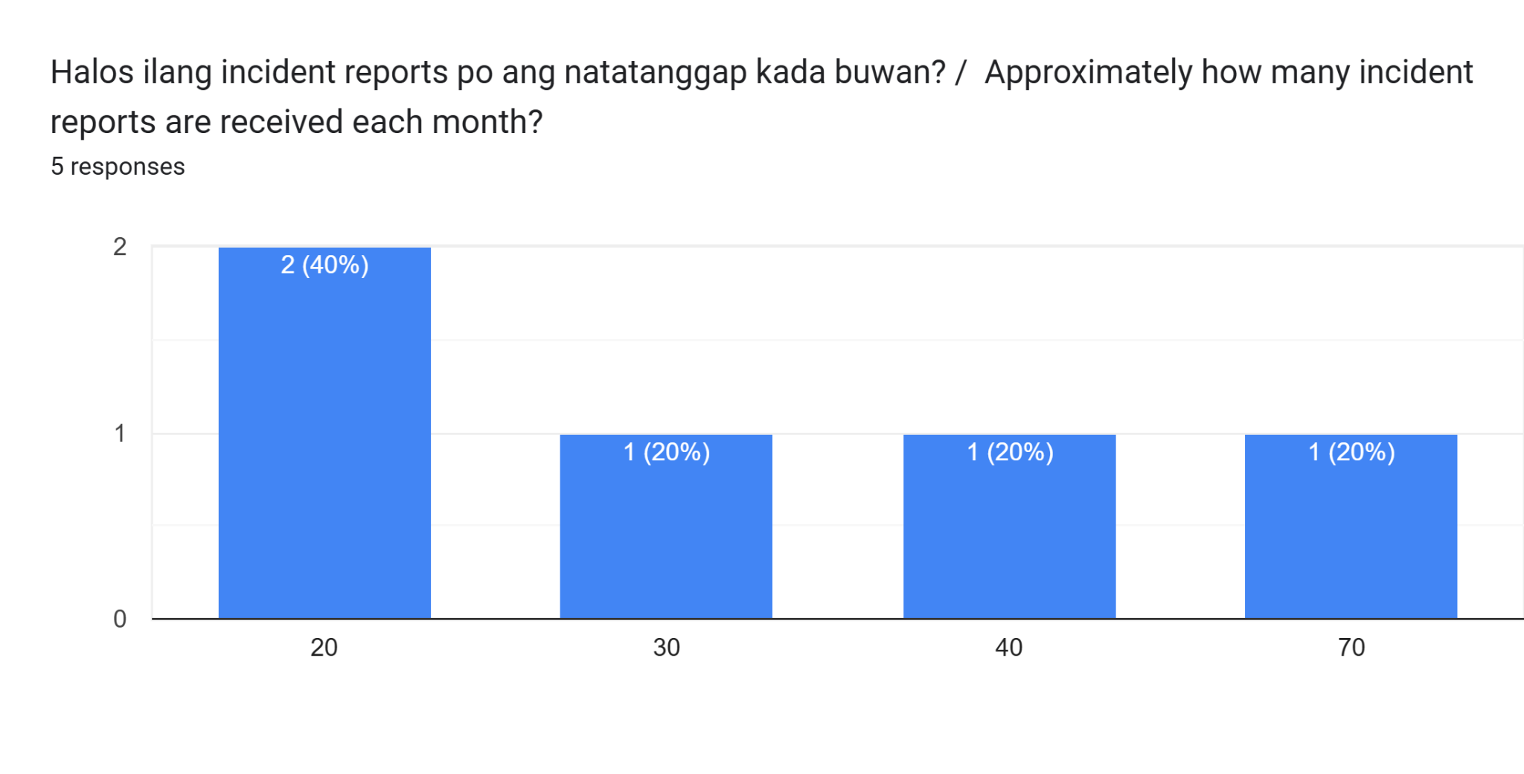
Figure 12. Estimated Number of Incident Reports Received per Month
Barangay personnel projected to receive incident reports amounting to 20 to 70 per month. Such responses imply that the management of incidents is an everyday task of the barangay organization. A central monitoring system will help them manage their reports effectively.

- Existing Record Management Practices
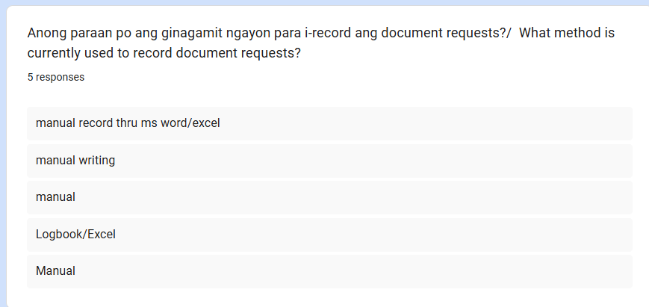
Figure 13. Current Method of Recording Document Requests
According to the report of the barangay officials, the document requests are usually documented manually through record books and logbooks.

In the same way,
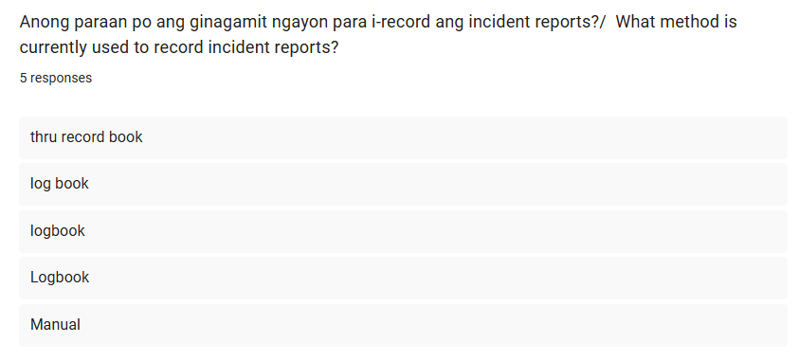
Figure 14. Current Method of Recording Incident Reports
revealed that incident reports are also documented through manual logbooks and handwritten documentation.
These show that the barangay is still using manual or paper-based documentation, thus there will be more chances for delays in retrieving information, and there is a tendency to misplace or damage records.

User-centered analysis - A user-centered approach was implemented during the requirements analysis and design of KaBarangayConnect to ensure that the proposed system aligns with the needs and expectations of its intended users. Information gathered through interviews and surveys with residents and barangay personnel of Barangay Labuin, Pila, Laguna identified challenges related to document requests, incident reporting, record management, and communication. These findings served as the basis for identifying the system's functional and non-functional requirements, ensuring that the proposed solution supports efficient workflows, usability, accessibility, security, and transparency. Applying a user-centered design approach enables the development of systems that are more effective, usable, and responsive to user needs (ISO, 2019; Pressman & Maxim, 2020).

The requirements of KaBarangayConnect have been identified through a combination of literature research, preliminary interviews, surveys, and user analysis. The preliminary survey involving six (6) residents and five (5) barangay officials served as an initial needs assessment to establish baseline operational gaps and system features. To address these needs, the recommended system includes core functionalities such as online document request processing, digital incident reporting, real-time status tracking, automated notifications, records archiving, dashboard monitoring, and role-based access control. While the preliminary assessment guided early design, the total sample size will be expanded during the final evaluation phase to comprehensively measure system usability, reliability, performance efficiency, and security among a broader group of residents and staff.

In order to respond to the aforementioned requirements, the recommended system should include basic functionalities such as online document request processing, digital incident reporting, status tracking in real time, automated notifications, records management, monitoring using dashboards, user authentication, and role-based access control. Also, the system should be designed to meet the non-functional requirements of usability, reliability, performance efficiency, accessibility, security, maintainability, and compliance with the Data Privacy Act of 2012 (RA 10173).

The identified requirements will act as the starting point of subsequent phases of the project that will involve design, database design, implementation, testing, and evaluation of KaBarangayConnect. Through meeting the identified operational requirements of the process of requirement gathering, the suggested system is expected to offer an efficient, organized, and user-centered approach to the provision of barangay services in Barangay Labuin, Pila, Laguna.

System Design / Design

Overall System Architecture
The proposed architecture for KaBarangayConnect implements a cloud-native, serverless deployment model engineered to guarantee high availability, secure data processing, and elastic scalability. Designed to simultaneously manage routine administrative workflows and critical, real-time incident reporting, this approach eschews traditional on-premise servers in favor of specialized, event-driven cloud infrastructure. By distributing compute, storage, and database operations across managed cloud services, the architecture ensures that the platform remains consistently accessible to residents and maintains optimal responsiveness—even during sudden traffic spikes triggered by localized community emergencies.
Architectural Model. The system is designed around an event-driven, decoupled web architecture. By leveraging a serverless computing stack, the platform efficiently processes both routine document requests and critical, time-sensitive incident alerts, bypassing the bottlenecks associated with traditional load balancers.
For KaBarangayConnect, this model is highly advantageous because it:
- Enables Real-Time Responsiveness - Facilitates a dynamic client interface capable of live status tracking for simultaneous document requests and incident reports.
- Powers Automated Prioritization - Utilizes dedicated, event-triggered cloud functions to instantly execute rule-based incident prioritization logic, automatically evaluating and classifying the severity of incoming alerts.
- Centralizes Security - Consolidates authentication and cloud storage within a secure ecosystem, ensuring that resident profiles and sensitive incident evidence are protected by stringent, role-based access controls.
Ultimately, this structural approach aligns perfectly with the operational demands of a contemporary, community-driven platform. It establishes a dependable, secure, and highly adaptable technical foundation that simplifies initial deployment, streamlines ongoing administrative oversight, and seamlessly accommodates future scaling in user activity across the barangay.
Major Components. The KaBarangayConnect platform is driven by a synthesis of modern development frameworks and cloud services, categorized into the following primary components:
- Frontend Web Application (Client Layer)
  - Framework: Engineered using a modern, component-based JavaScript framework Next.js to deliver a highly dynamic, server-rendered, and mobile-responsive user experience across diverse devices.
  - Purpose: Functions as the primary public and administrative portal accessible via standard web browsers. It provides specialized, role-specific interfaces for the system's three primary user groups: residents, barangay staff, and administrators. Key interface components include a resident-facing dashboard equipped with an Emergency Quick Button, and an administrative command center designed for monitoring real-time request statuses and triaged incident queues.

- Backend & API Layer (Logic Layer)
  - Serverless Functions: Application Programming Interface (API) requests are processed by AWS Lambda functions orchestrated through Amazon API Gateway.. This layer executes core backend operations, such as updating document request timelines, auto-populating incident reports using registered resident profiles, and routing high-priority submissions.
  - Rule-Based Incident Prioritization Processing: A dedicated, rule-based intelligence module that automatically evaluates textual input and selected emergency categories (e.g., Fire, Medical, Flood). This engine instantly classifies incident severity, flagging life-threatening reports as high priority to bypass routine administrative queues and trigger immediate alerts to barangay officials.

- Database and Storage Management (Data Layer)
  - NoSQL Database (MongoDB Atlas): Operates as the centralized, scalable repository for persistent platform data, managing user profiles, document request logs, and real-time incident tracking records. To ensure clean programmatic integration and data consistency, the database schema strictly adheres to camelCase naming conventions for all entity attributes and relational mappings (e.g., residentId, incidentType, documentStatus).
  - Object Storage: Utilizes secure cloud storage buckets (e.g., AWS S3) dedicated to retaining user-uploaded media. This guarantees the controlled and protected handling of sensitive attachments, such as valid identification cards for clearance verification and photographic evidence submitted alongside incident reports.

- Security & Real-Time Services
  - Authentication & Authorization: Enforces secure, multi-level Role-Based Access Control (RBAC) utilizing encrypted JSON Web Tokens (JWT).. This guarantees that residents, barangay staff, and system administrators can only access, view, and modify records explicitly permitted by their respective clearance levels.
  - Real-Time Monitoring & WebSockets: Integrates bi-directional WebSocket connections paired with cloud monitoring tools to push instant, automated notifications directly to the administrative dashboard. This ensures that active barangay staff receive critical alerts the exact millisecond a community emergency is reported by a resident.

High-Level Architecture Diagram. Below is a structural overview illustrating the interaction between the decoupled client interface, the serverless backend logic, and the integrated cloud services within the KaBarangayConnect ecosystem.
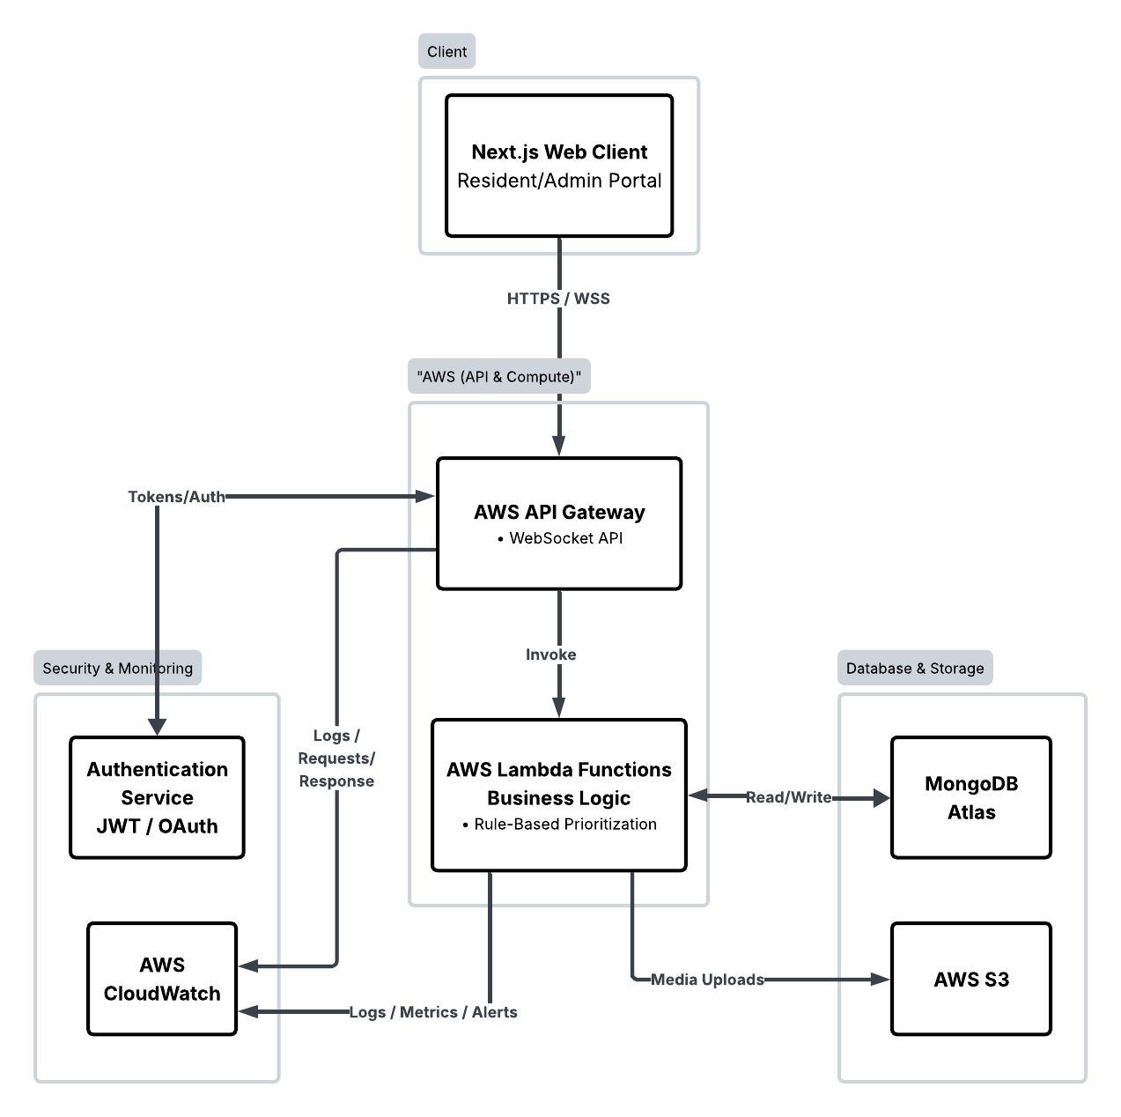
Figure 15.KaBarangayConnect High-Level Architecture Diagram

Communication Flow. Data exchange within the KabarangayConnect ecosystem is dynamically routed based on the urgency and nature of the user interaction. For routine administrative operations—such as submitting document requests, updating resident profiles, or fetching official announcements—the Next.js client application communicates with the serverless logic layer via secure HTTPS RESTful API calls through AWS API Gateway. These standard request-response cycles ensure reliable, encrypted data transmission to the AWS Lambda functions, which execute the necessary business logic and synchronize data state with the MongoDB Atlas database.
Conversely, time-sensitive operations rely on continuous streaming protocols rather than traditional HTTP polling. When a resident triggers an emergency alert, the application utilizes persistent, bi-directional WSS (WebSocket Secure) connections managed natively by the AWS API Gateway WebSocket API. This payload is instantly routed to the backend compute layer, where the Rule-Based Prioritization engine evaluates the severity of the incident. Once triaged, the system immediately broadcasts a real-time push notification to the administrative dashboard. Concurrently, any associated multimedia—such as ID verification files or incident photo evidence—is securely processed and stored directly within AWS S3 buckets.
To address the inherent stateless and short-lived nature of AWS Lambda during long-lived synchronous chat sessions (such as the Emergency Triage Chat), the architecture deliberately decouples the connection state from the compute layer. Instead of relying on Lambda to keep a session alive, Amazon API Gateway natively manages and sustains the persistent WebSocket (WSS) connection with the resident and dispatcher. AWS Lambda is invoked only momentarily to process individual message payloads. The persistent chat history and session context are immediately written to and retrieved from MongoDB Atlas using unique session IDs. This ensures that even after a Lambda function terminates its split-second execution, the continuous dialogue of the emergency triage chat is seamlessly maintained without data loss or connection drops.
This dual-protocol communication strategy ensures instantaneous, secure, and highly scalable interactions between community members and barangay officials. By structurally separating standard HTTPS traffic from real-time WebSocket alerts, the serverless architecture preserves system flexibility and maintains optimal performance across both daily bureaucratic functions and critical community crises.

Data Design
To facilitate efficient data management and persistent storage within the KabarangayConnect platform, this study utilizes MongoDB Atlas. As a fully managed cloud NoSQL database, MongoDB Atlas is renowned for its elastic scalability, flexible schema architecture, and automated maintenance protocols. This database solution is particularly well-suited for dynamic web platforms because it abandons the rigid tabular structures of traditional relational databases in favor of a versatile BSON (JSON-like) document model. Cloud architecture research confirms that NoSQL databases like MongoDB support horizontal scaling through automatic sharding and data replication, enabling the distribution of data across massive clusters to handle large volumes of information efficiently (Khan et al., 2023). These capabilities are critical for KabarangayConnect, ensuring consistent performance and fault tolerance even during sudden network surges caused by localized emergency reports.
Crucially, MongoDB Atlas integrates seamlessly with the system’s event-driven AWS Lambda architecture, efficiently handling the rapid connection cycles inherent in stateless, serverless compute environments. To maintain programmatic cleanliness and ensure seamless data mapping between the frontend client, the serverless functions, and the database, the data design enforces strict camelCase naming conventions across all collections and entity attributes (e.g., residentId, incidentType, userName, documentStatus).
Furthermore, while traditional relational database management systems (RDBMS) like PostgreSQL offer strong tabular consistency, NoSQL databases are better optimized for rapid development cycles and the management of diverse data structures where schema flexibility is paramount (Khan et al., 2023). Given these distinct advantages, MongoDB Atlas was selected over traditional on-premise relational alternatives to guarantee rapid data retrieval, effortless scalability, and secure, centralized management of community records.

Data Consistency and Relational Integrity in NoSQL. Unlike traditional Relational Database Management Systems (RDBMS) that rely on database engine-level constraints (such as foreign keys and automated SQL cascades), KaBarangayConnect enforces relational integrity and data consistency at the application/controller layer.
The platform utilizes Mongoose—a Node.js Object Data Modeling (ODM) library—within the AWS Lambda serverless backend. Mongoose enforces strict schema validation and manages document relationships using Object Reference properties (ref) rather than hard database joins.
When multi-step workflows or cascading updates occur—such as updating document request timelines, recording offline payment verifications, or resolving linked emergency chats—the business logic is handled programmatically via Mongoose middleware and controller functions. This ensures multi-document consistency, auditable record management, and schema integrity across all MongoDB Atlas collections without compromising the performance advantages of a NoSQL architecture.

Key Collections and Schema Layout. The KaBarangayConnect web platform utilizes MongoDB Atlas, a cloud-native NoSQL database, to organize system data into decoupled collections and documents. Each collection manages documents engineered with dynamic schemas that seamlessly adjust to specific administrative workflows and real-time emergency operations. To ensure strict programmatic consistency, all database entities utilize camelCase naming conventions.
- Residents Collection (Users)
  - Purpose: Manages the primary user accounts for community members, handling authentication, standardized contact information, and platform access.
  - Fields: residentId, firstName, lastName, middleName (Optional), suffix (Optional - e.g., Jr., Sr.), emailAddress, contactNumber, houseUnitNumber, streetPurokName, barangay (Read-only/Default), city (Read-only/Default), province (Read-only/Default), zipCode (Read-only/Default), passwordHash, profileImageUrl, accountStatus (e.g., active, suspended), createdAt, and updatedAt.
- Admins Collection
  - Purpose: Manages identity verification, credential logging, and authorization data for administrative personnel and municipal staff.
  - Fields: adminId, firstName, lastName, middleName (Optional), userName, emailAddress, passwordHash, assignedRole (e.g., Admin, Moderator, Content Admin), accountStatus, createdAt, and lastLogin.
- Announcements Collection
  - Purpose: Retains community bulletin information, event schedules, and official press releases featuring multi-level visibility thresholds and media support.
  - Fields: announcementId, titleText, descriptionContent, priorityLevel (e.g., high, medium, low), authorId, imageUrl (AWS S3 link for announcement banners/photos), eventDate, isHidden, createdAt, and updatedAt.
- Officials Collection
  - Purpose: Chronologically logs active administrative profiles, contact details, and distinct governance jurisdictions of local community leaders.
  - Fields: officialId, fullName, designatedPosition, contactNumber, emailAddress, officeLocation, coreResponsibilities (Array of text strings), profileImageUrl, isDeleted (Soft-delete flag for historical archiving), and updatedAt.

- Document Requests Collection
  - Purpose: Archives public service requests while facilitating stage-by-stage tracking of administrative approvals and distribution.
  - Fields: requestId, residentId (Reference to the Residents Collection), applicantDetails (Embedded object snapshot containing the applicant's fullName, contactNumber, and emailAddress at the time of request), documentType (e.g., Barangay Clearance), purpose, verificationIdUrl (AWS S3 link to the resident's uploaded valid ID for staff verification), currentStatus (e.g., Processing, Ready for Pickup), expectedCompletionDate, timeline (Array containing detailed milestone objects: step, date, status), paymentStatus (e.g., Unpaid, Paid Offline), verifiedBy (Reference to adminId who manually verified the offline transaction), verifiedAt, officialReceiptNumber (Optional string for manual OR tracking), dateRequested, and updatedAt.
  - Note on Payment Processing: Online financial transactions are out of scope for this system. Instead, the platform supports an offline payment auditing workflow. When a resident pays the required fees physically at the barangay hall, an authorized administrator manually flags the paymentStatus as paid, appending their adminId and the officialReceiptNumber to the document record to ensure an accurate, auditable paper trail.
- Incident Reports Collection
  - Purpose: Orchestrates real-time data ingestion for public emergencies, tracking automated severity levels and multimedia attachments.
  - Fields: incidentId, residentId (Reporter), incidentCategory, descriptionText, locationDetails, triagePriority (Automated classification determined by the Rule-Based Prioritization engine), evidenceMediaUrls (Array of AWS S3 links for photos/videos), incidentStatus (e.g., Pending, Responding, Resolved), reportedAt, and updatedAt.

- Chat Sessions Collection
  - Purpose: Couples residents and emergency response handlers into synchronized, live communication scopes during ongoing crisis resolution.
  - Fields: sessionId, incidentId, residentId, adminId (Responder), isActive, deviceInfo, ipAddress, messageCount, startedAt, and lastActivity.
- Messages Collection
  - Purpose: Captures contextual text logs, system flags, and structural markdown strings exchanged within an active tracking session.
  - Fields: messageId, sessionId, senderId, isUser (Boolean), messageText, formattedContent, urgencyFlag (System-detected urgency based on keyword rules), and sentTimestamp.
- Notifications Collection
  - Purpose: Stores a persistent history of automated system alerts, ensuring that both residents and barangay staff can review missed updates regarding emergencies, document statuses, or community announcements.
  - Fields: notificationId, recipientId (Reference to either an adminId or residentId to determine who receives the alert), notificationCategory (Enum: e.g., incidentAlert, documentUpdate, systemMessage), titleText (e.g., "High Priority Incident Reported"), messageBody (e.g., "A Fire incident has been reported in Purok 4."), referenceUrlId (The specific incidentId or requestId so the user can click the notification and be routed directly to the correct record), isRead (Boolean flag to toggle the unread badge on the UI), createdAt

Data Model Architecture Diagram. The following diagram illustrates the key NoSQL collections within the MongoDB Atlas database, detailing the specific document fields and data types they contain. It also maps the structural relationships between entities, highlighting the system's use of direct document references and embedded objects to optimize data retrieval and maintain historical accuracy.
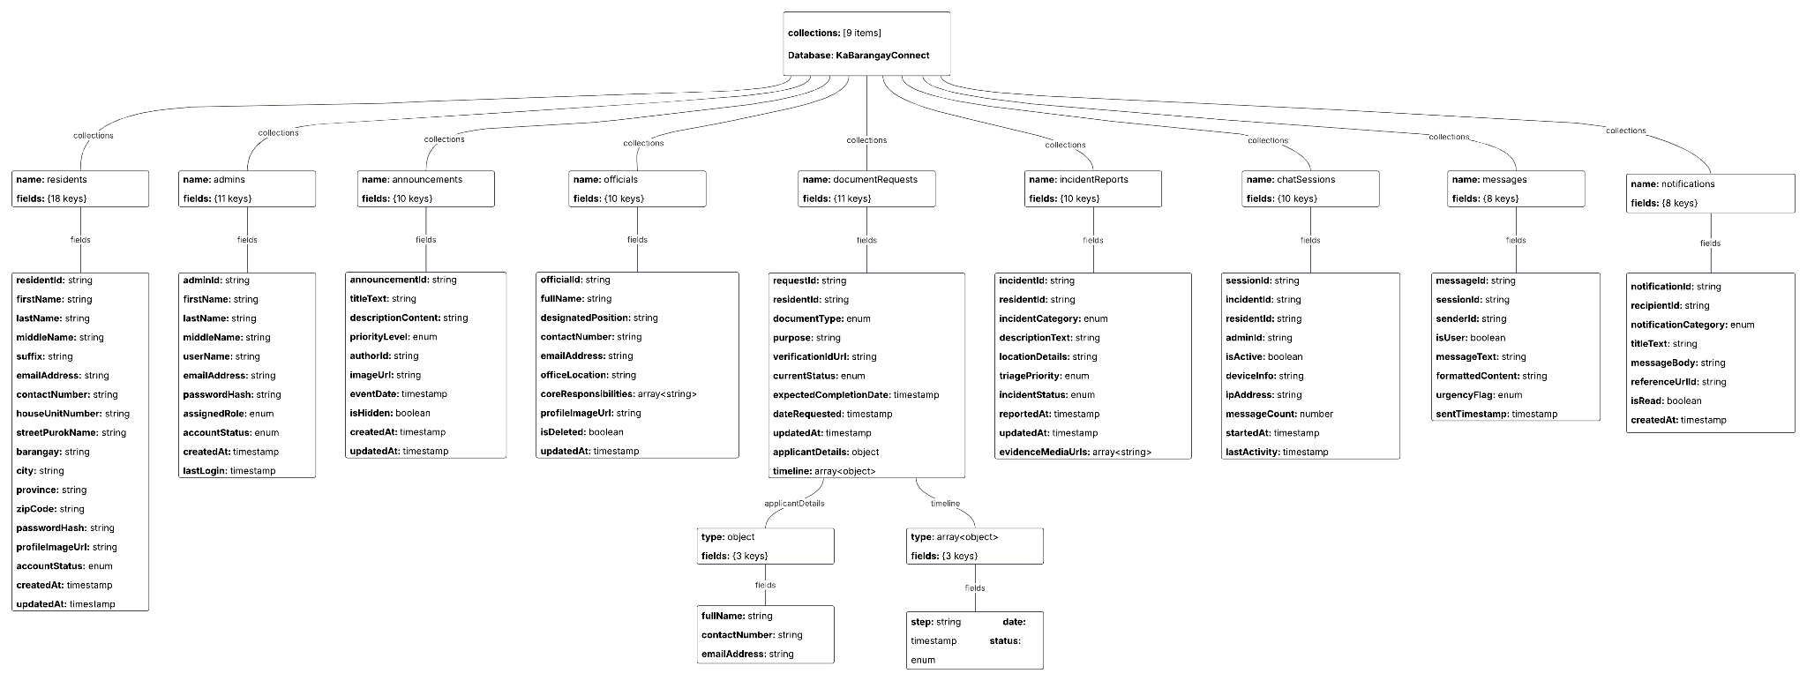
Figure 16.KaBarangayConnect NoSQL Document Schema Architecture

Data Flow Architecture. To clearly illustrate how information traverses the KaBarangayConnect platform regardless of the underlying serverless cloud infrastructure, Data Flow Diagrams (DFD) are utilized. These diagrams map the trajectory of constituent inputs, administrative state changes, and system-generated notifications across the application's core processes.
Data Flow Diagram Level 0 (Context Diagram)
The Context Diagram provides a macro-level visualization of the entire KaBarangayConnect system (Process 0) and its interactions with the two primary external entities: the Resident and the Barangay Official.
- Resident (External Entity): Inputs data such as registrationDetails, documentRequestData, incidentReportData, and chatMessage. In return, the system outputs statusUpdateNotification, documentStatus, and triageChatReply.
- Barangay Official (External Entity): Inputs data such as adminCredentials, documentStateUpdate (including offline payment verifications), incidentStatusUpdate, and announcementData. The system outputs the pendingRequestQueue, realTimeIncidentAlert, and auditLogView.
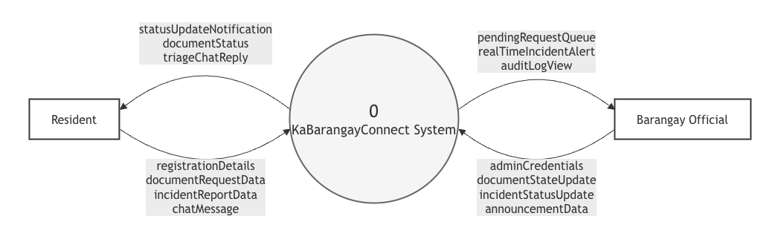
Figure 17. KaBarangayConnect DFD Level 0 (Context Diagram)

Data Flow Diagram Level 1
The DFD Level 1 breaks down the central system into five core operational processes, mapping exactly how data is routed to the MongoDB Atlas collections and AWS S3 storage buckets.
- Process 1.0: Manage Authentication & Profiles: Receives login credentials from users. Validates against the residentsCollection and adminsCollection. Outputs a secure session token and routes role-specific dashboard data back to the user.
- Process 2.0: Process Document Requests: Receives documentRequestData and an uploaded valid ID from the Resident. The ID is routed to the s3MediaBucket, while the application payload is written to the documentRequestsCollection. Officials pull from this collection to review applications and input a documentStateUpdate, which modifies the currentStatus and paymentStatus fields.
- Process 3.0: Manage Incident Triage & Chat: Receives incidentReportData and photo evidence from the Resident. The media goes to the s3MediaBucket, and the report is logged in the incidentReportsCollection. The rule-based engine assigns a severity level and pushes a realTimeIncidentAlert to the Official. During active resolution, chatMessage inputs from both actors are routed through this process and stored in the chatSessionsCollection.
- Process 4.0: Manage Civic Announcements: Receives announcementData from the Official. This data is stored in the announcementsCollection and broadcasted out to the Resident's dashboard as an announcementFeed.
- Process 5.0: Generate Notifications & Audit Logs: Acts as the system's asynchronous observer. When Process 2.0 or 3.0 registers a state change (e.g., a document is approved), this process writes an alert to the notificationsCollection and pushes a statusUpdateNotification to the Resident. Concurrently, it logs administrative actions into the immutable AWS CloudWatch audit trail to ensure internal security.
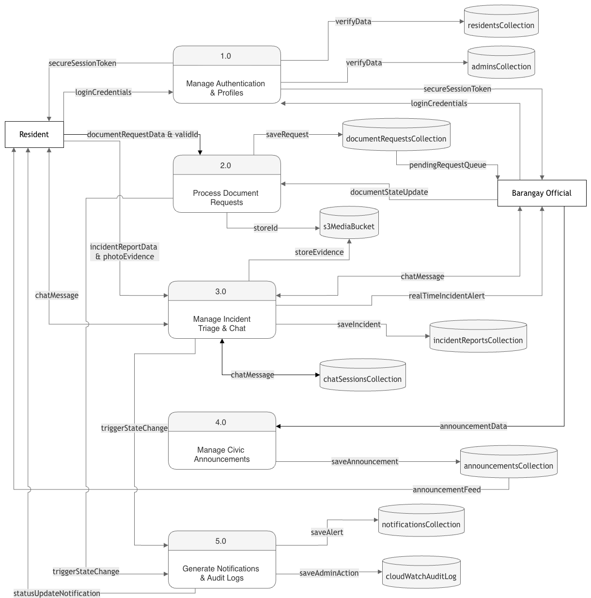
Figure 18. KaBarangayConnect DFD Level 1

Data Security and Privacy Considerations. To guarantee the protection and privacy of community data within the KaBarangayConnect platform, stringent security protocols are enforced directly at the API and serverless logic layers. By utilizing JSON Web Tokens (JWT) in conjunction with secure authentication flows (e.g., OAuth), the system enforces strict Role-Based Access Control (RBAC) across all database operations.
These programmed security measures ensure that only authenticated individuals can interact with the system, restricting data access strictly to what is permitted by the user's assigned role. For instance, standard residents are programmatically limited to viewing and modifying only their own personal profiles, submitted document requests, and incident reports. Access to highly sensitive information—such as identification files stored in AWS S3 or active emergency chat sessions—is securely restricted to the specific resident and the responding barangay staff by validating the residentId within the backend middleware.
Furthermore, the system seamlessly supports multi-tiered administrative access by validating custom user roles (e.g., Admin, Moderator, Content Admin) stored within the MongoDB Atlas database and embedded in the encrypted token payloads. This architectural approach guarantees fine-grained, programmatic control over who can read, write, or update specific community records, thereby enforcing rigorous data security and preserving the privacy of all residents on the platform.

User Interface (UI) and User Experience (UX) Design
This section delineates the design methodology for the KaBarangayConnect web application, emphasizing the development of an accessible, highly responsive, and user-centric digital environment. The architectural decisions are oriented toward translating complex backend functionalities—such as rule-based incident prioritization and automated document routing—into a coherent graphical user interface (GUI). The foundational design heuristics are derived from the operational requirements of local governance and the critical necessity for efficient civic service delivery.
Core Design Principles. To successfully accommodate the heterogeneous demographic profile of a barangay—encompassing varying levels of digital literacy—the platform’s visual architecture adheres strictly to the following criteria:
Cognitive Efficiency and Accessibility. Minimizing cognitive load is an essential design parameter, particularly during high-stress scenarios such as emergency incident reporting. The interface employs a minimalist aesthetic, mitigating extraneous visual elements that could impede rapid user interaction. By utilizing structured visual hierarchies and unambiguous calls-to-action (e.g., standardized incident submission forms and prominent emergency triggers), the system facilitates rapid task execution. This approach ensures that critical operations, such as submitting an alert or requesting a clearance, are consistently completed within defined non-functional operational thresholds.
System Transparency and Traceability. Cultivating community trust in digital governance necessitates comprehensive visibility into administrative workflows. The user interface is engineered to provide continuous, real-time feedback regarding the status of user-initiated processes. By integrating dynamic progress indicators for requested documentation and live tracking for submitted emergency alerts, the platform significantly reduces operational ambiguity. This design strategy ensures that constituents remain informed of administrative response times, thereby enforcing institutional accountability and enhancing the overall perceived reliability of the barangay's digital infrastructure.
Civic-Centric Engagement Design. KaBarangayConnect is designed to function beyond a strictly transactional public utility; it is engineered to facilitate active civic engagement and streamline community administration. The visual interface balances institutional credibility with user approachability, utilizing a standardized, high-contrast color palette and highly legible typography to ensure inclusive access across all constituent demographics. Informed by established e-governance frameworks, the platform incorporates features that extend beyond routine administrative processing. The integration of centralized public announcements and synchronous communication channels—such as live chat sessions during emergency triage—establishes a direct, responsive conduit between the barangay administration and its residents, thereby fostering cohesive and transparent community management.
Architectural Interface Blueprints. To systematically visualize the application's user flow and interaction model, a comprehensive series of structural wireframes has been engineered for the KaBarangayConnect platform. These schematic designs prioritize spatial layout, information hierarchy, and functional accessibility, serving as the foundational blueprint for the final frontend implementation. The wireframes systematically illustrate the following critical constituent journeys and administrative workflows:
- Authentication and Identity Management - Constituent login utilizing hybrid credentials and Google Single Sign-On (SSO) for frictionless access, juxtaposed with a rigorous, Multi-Factor Authentication (MFA) fortified portal for barangay administrative staff.
- Constituent Onboarding and Regulatory Compliance - Registration pathways governed by a mandatory Data Privacy Act of 2012 consent gateway to ensure secure, legal data collection prior to database execution.
- Inclusive Navigation and Support - Global slide-out routing architecture (Hamburger Menu) coupled with a dedicated Accessibility configuration module (typographic scaling, high-contrast modes, bilingual toggles) and a self-service Help & Support knowledge base.
- Geospatial Incident Command and Telemetry - Mobile emergency reporting interfaces linked directly to a desktop administrative dashboard, featuring interactive spatial mapping, automated rule-based triage prioritization, and real-time operational metrics.
- Document Lifecycle Management - End-to-end processing queues for clearance applications, integrating secure AWS S3 cloud storage for identity verification to alleviate barangay administrative friction.
- Synchronous Crisis Communication - A dedicated live emergency triage chat module enabling concurrent, multi-session dialogue between dispatched administrative responders and affected constituents.
- Civic Broadcasting and Directory Management - A centralized Content Management System (CMS) for public announcements, alongside structured database interfaces for maintaining the localized roster of barangay officials and resident demographics.
- System Governance and Security Auditing - Consolidated notification mailboxes, global platform settings, automated data retention policies, and immutable administrative access logs to enforce a zero-trust security perimeter.
Each architectural wireframe is accompanied by a comprehensive technical description detailing its core operational purpose, precise data schema alignment (e.g., strict camelCase relations), and integrated UI components. This structural documentation demonstrates absolute adherence to the platform's inclusive accessibility standards, cloud-hybrid architecture, and civic-centric design principles.

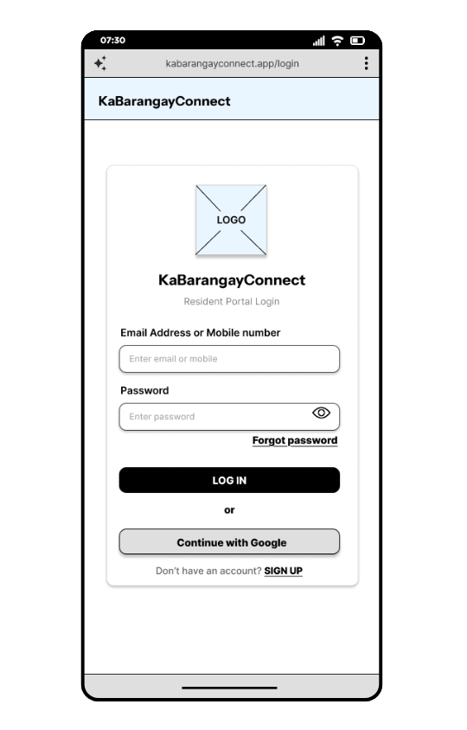
Figure 19.Resident Portal Login Interface (Mobile Browser)
The resident login screen serves as the primary secure authentication gateway for constituents accessing the KaBarangayConnect platform. Engineered specifically for mobile web browsers to ensure broad community accessibility, the interface utilizes a flexible primary authentication model that accommodates either a registered email address or a mobile number. To optimize the user experience and mitigate login friction, the form incorporates a password visibility toggle alongside a dedicated "Forgot password" routing link for autonomous credential recovery. Crucially, the architecture now integrates a Single Sign-On (SSO) mechanism—facilitated through the "Continue with Google" protocol—which bypasses traditional localized credential management to provide a highly accelerated, frictionless entry point. Coupled with a direct onboarding pathway for unregistered constituents ("SIGN UP"), this streamlined, high-contrast design minimizes cognitive load, ensuring that residents can swiftly access vital civic services and emergency reporting tools without administrative delays.
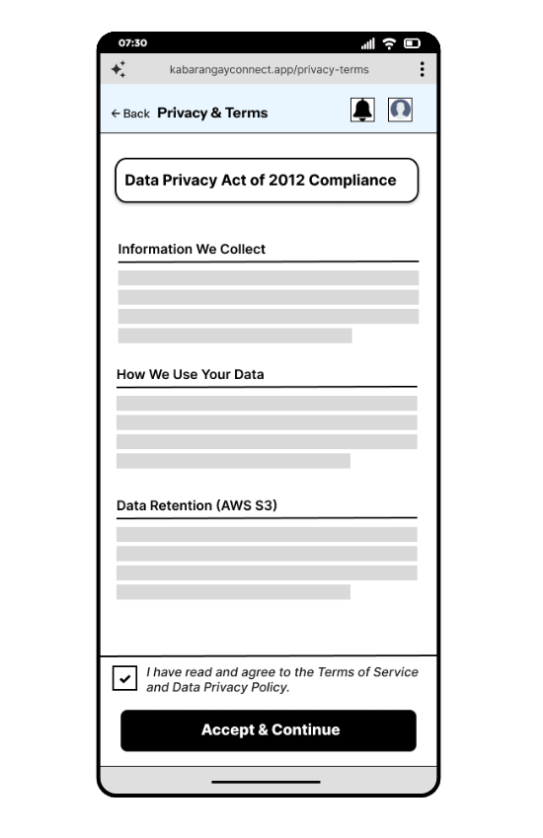
Figure 20.Data Privacy Compliance and User Consent Interface (Mobile Browser)
The Data Privacy and Terms of Service module serves as a critical, mandatory architectural gateway within the constituent onboarding and profile management workflows. To establish institutional trust and ensure strict adherence to the statutory mandates of the Data Privacy Act of 2012, the interface employs a transparent, highly legible typographic structure to delineate essential system policies. It systematically categorizes operational protocols into distinct, easily scannable sections, explicitly detailing the specific constituent information collected by the platform, its intended administrative utilization, and the security parameters governing long-term data retention within the AWS S3 cloud infrastructure. Furthermore, the design enforces active, informed user consent through a mandatory verification checkbox. This component functions as a rigid operational constraint, ensuring that the "Accept & Continue" action remains disabled until explicit legal acknowledgment is provided by the resident.
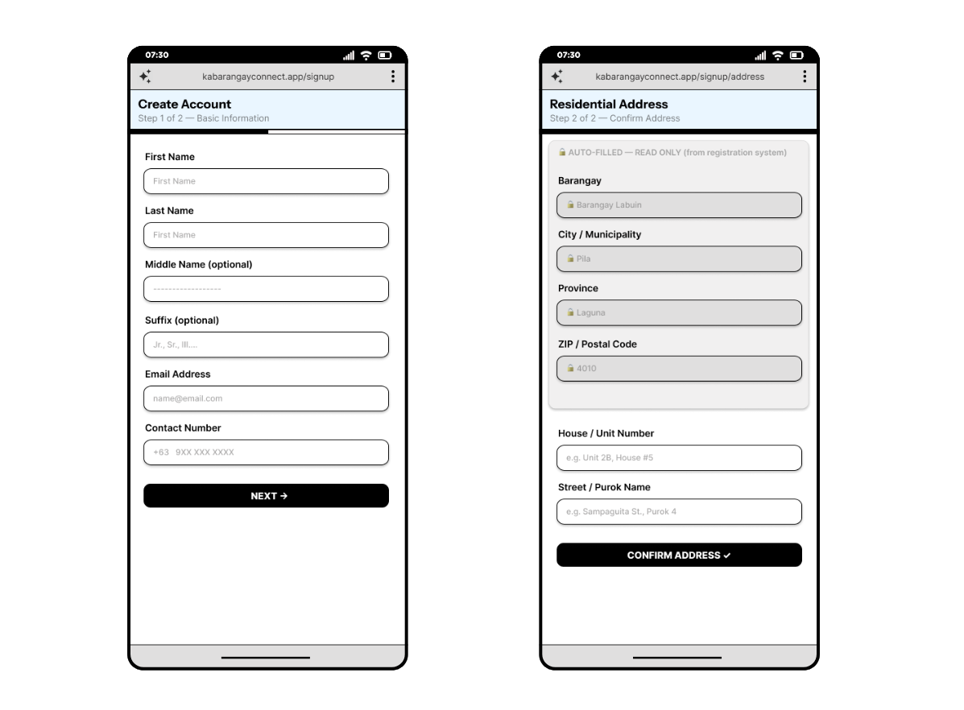
Figure 21.Resident Registration and Address Verification Interface (Mobile Browser)
The resident onboarding sequence is engineered as a two-step progressive disclosure flow, designed to minimize user friction while ensuring the comprehensive collection of critical demographic data. The initial interface captures fundamental identity and contact information necessary for account provisioning. The subsequent phase introduces a strictly controlled, hybrid address input mechanism. To guarantee jurisdictional data integrity and prevent misrouting of civic services, overarching geographical identifiers (Barangay, City, Province, and ZIP Code) are pre-configured as read-only fields tied to the system's deployment environment. Constituents are solely required to input localized, granular details such as their specific house number and street. This architectural constraint eliminates formatting discrepancies and establishes a highly standardized geographical dataset, which is critical for the accurate mapping of future incident reports and the processing of document requests.
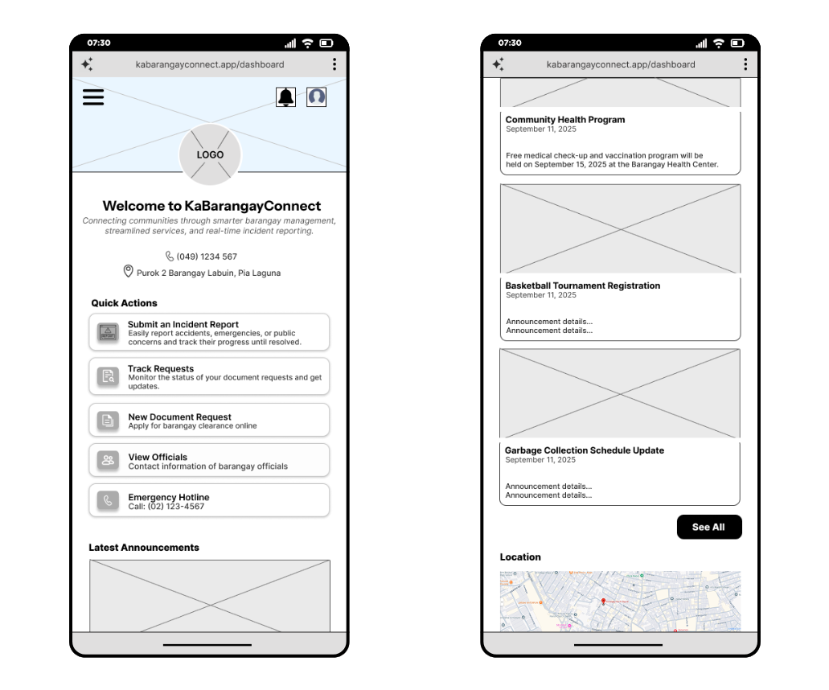
Figure 22.Resident Dashboard and Centralized Civic Hub (Mobile Browser)
The resident dashboard functions as the primary interaction nexus for constituents navigating the KaBarangayConnect platform. Engineered with an accessibility-driven, mobile-first methodology, the interface is anchored by a prominent "Quick Actions" directory. This strategic spatial hierarchy minimizes cognitive load and navigational depth, enabling users to rapidly execute critical functions—such as submitting an emergency incident report, initiating document requests, or accessing direct municipal hotlines—with absolute minimal friction.
Furthermore, the dashboard integrates a dynamic "Latest Announcements" feed, establishing a centralized, asynchronous communication channel for community updates, health programs, and scheduling changes. Supported by persistent top-tier navigation that connects directly to the platform's real-time Notification and routing system, the dashboard design ensures continuous civic engagement, rapid service delivery, and operational transparency between the barangay administration and its constituents.
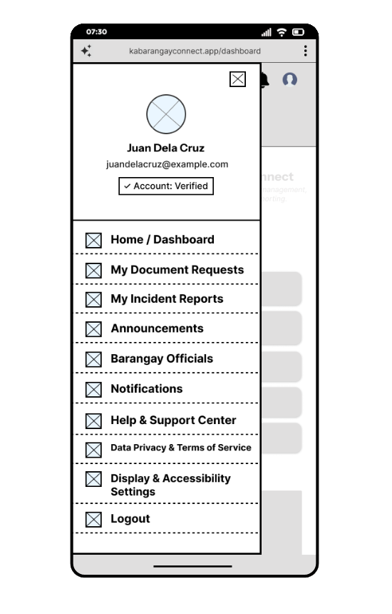
Figure 23.Global Navigation and Resident Profile Drawer Interface (Mobile Browser)
The global navigation drawer functions as the primary architectural spine of the KaBarangayConnect constituent interface. Utilizing a universally recognized slide-out "hamburger" menu paradigm, this component strategically conserves critical mobile screen real estate by concealing the comprehensive navigational directory until explicitly invoked by the user. The dashboard content remains visible but visually subordinate beneath a semi-transparent overlay, maintaining spatial context without causing distraction.
The upper tier of the interface prioritizes identity management, presenting the user's profile, contact information, and active authentication state (e.g., "Account: Verified"), which establishes immediate institutional trust and operational accountability. Beneath this header, the primary menu pathways are organized in a strict, descending hierarchical structure. By logically grouping high-frequency civic interactions (e.g., Document Requests, Incident Reports) at the top, followed by community resources (Announcements, Officials), and concluding with essential system configurations (Privacy, Support, Accessibility, and Logout), the architecture minimizes cognitive load and facilitates highly efficient, frictionless user routing across the entire platform ecosystem.

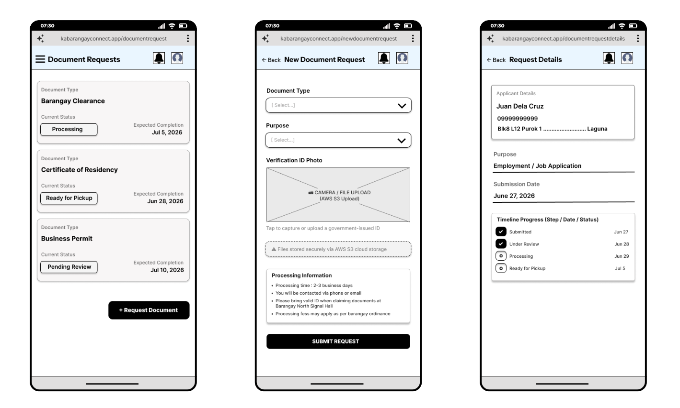Figure 24.Document Request Workflow and Status Tracking Interface (Mobile Browser)
The document request module is designed to digitize and streamline routine civic administrative processes. The primary interface (left) presents constituents with a consolidated, chronological repository of their active and historical applications. By utilizing distinct, color-coded status indicators (e.g., "Pending Review," "Processing," "Ready for Pickup"), the layout significantly minimizes operational ambiguity and reduces the cognitive load associated with tracking municipal paperwork.
The submission interface (center) employs standardized selection parameters (dropdown menus) for document types and purposes, ensuring rigid data uniformity upon entry into the database. A critical structural feature of this view is the secure file upload component, which interfaces directly with AWS S3 cloud storage. This allows residents to safely and efficiently transmit government-issued identification for administrative verification without compromising data privacy.
To strictly enforce the platform's core design principles of institutional transparency and traceability, the detailed request interface (right) features a dynamic timeline tracking component. By translating complex backend administrative state changes into a clear, user-facing chronological progress visualization, the system actively keeps the constituent informed, thereby reinforcing community trust and establishing robust accountability for barangay service-level agreements (SLAs).

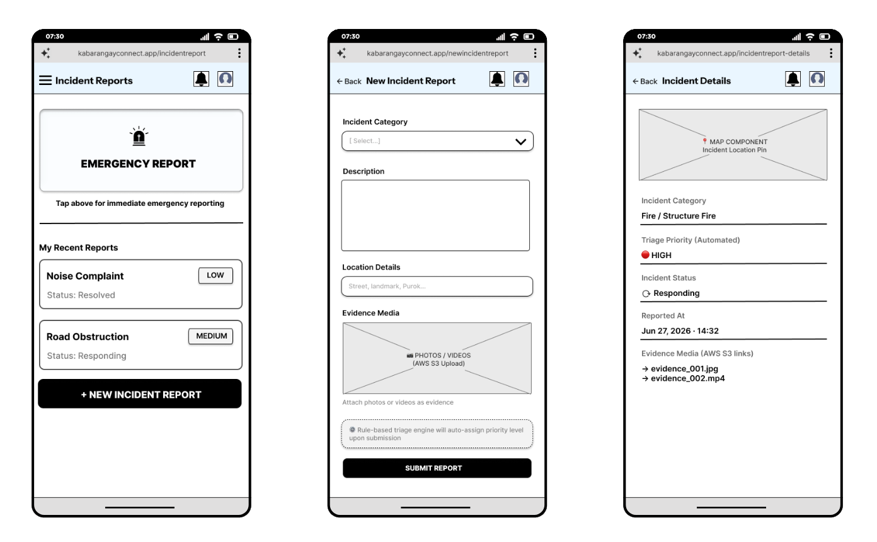
Figure 25.Incident Reporting and Emergency Triage Interface (Mobile Browser)
The incident reporting module serves as the critical operational core of the KaBarangayConnect platform. The primary interface (left) is engineered with a strict emphasis on cognitive efficiency during high-stress emergency scenarios. By anchoring the layout with an oversized, highly prominent "EMERGENCY REPORT" trigger, the design minimizes interaction latency and ensures rapid task execution when immediate responder intervention is required. Beneath this primary call-to-action, a historical ledger of submitted reports provides constituents with immediate visibility into their active and resolved civic concerns.
The report submission interface (center) facilitates the structured ingestion of critical event data. To guarantee backend data uniformity, the form utilizes standardized incident categorization alongside free-text descriptions and granular location inputs. The integration of an AWS S3-backed multimedia upload component empowers residents to attach vital photographic or video evidence securely. Crucially, the interface explicitly informs the constituent that a rule-based triage engine evaluates the submission in real-time, bridging the frontend data collection seamlessly with the backend's automated severity classification logic.
To uphold the platform's core principles of system transparency and institutional accountability, the incident details view (right) provides a comprehensive, read-only summary of the active alert. This view incorporates a geographical map component for spatial verification and clear visual indicators of both the system-assigned triage priority (e.g., "HIGH") and the current administrative response status (e.g., "Responding"). This continuous, real-time feedback loop ensures that constituents remain fully informed of the barangay's ongoing mitigation efforts.
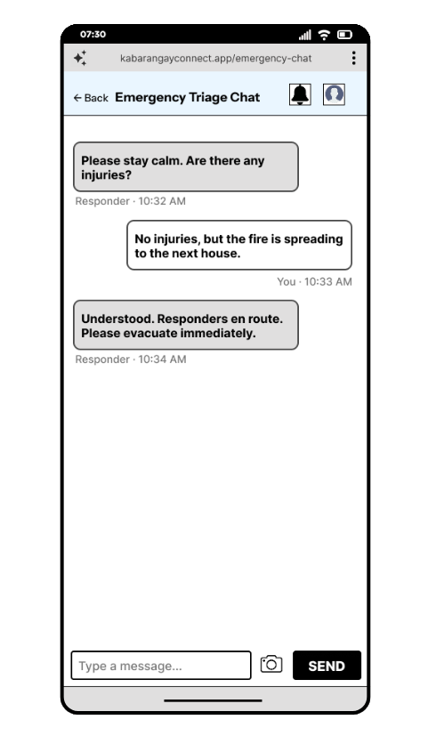
Figure 26.Synchronous Emergency Triage Chat Interface (Mobile Browser)
The Emergency Triage Chat module provides a critical, real-time communication conduit between the reporting constituent and barangay emergency dispatchers. Engineered specifically for high-stress scenarios, the interface adopts a universally recognized, chronological messaging layout to minimize cognitive load and facilitate rapid, bidirectional information exchange. By distinguishing institutional directives from user inputs through distinct visual styling and explicit role attribution (e.g., "Responder"), the system ensures absolute clarity of instruction during active crises.
Furthermore, the integration of a direct multimedia attachment component (represented by the camera icon) empowers residents to transmit live, situational photographic evidence securely to the centralized AWS S3 repository. This synchronous interaction layer critically augments the backend's rule-based incident prioritization engine; it allows human responders to dynamically verify the severity of an unfolding emergency, gather critical context (such as injury reports), and issue immediate, localized tactical guidance—such as evacuation protocols—before physical units arrive on the scene.

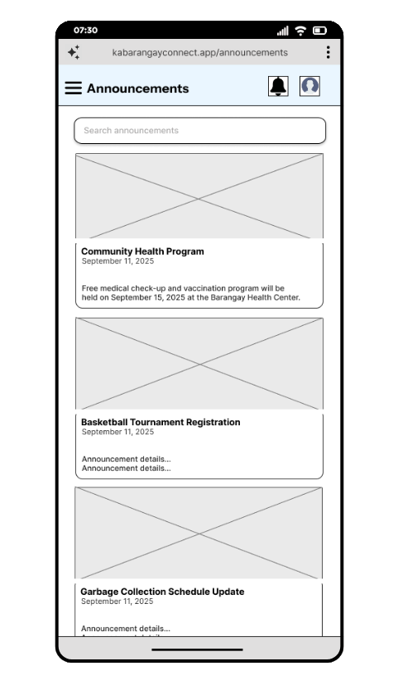
Figure 27.Centralized Civic Information and Announcements Interface (Mobile Browser)
The announcements module functions as the platform's primary mechanism for asynchronous, mass civic communication. Engineered to disseminate critical municipal updates—ranging from public health initiatives and community engagement programs to utility scheduling updates—the interface utilizes a highly scannable, card-based visual hierarchy. This modular layout integrates multimedia placeholders with concise typographic summaries to reduce cognitive friction and ensure rapid information comprehension across diverse constituent demographics. Furthermore, the integration of a dedicated query input field (search bar) enhances data discoverability, empowering residents to efficiently retrieve specific historical or contextual community information, thereby fostering a more informed and actively engaged local populace.
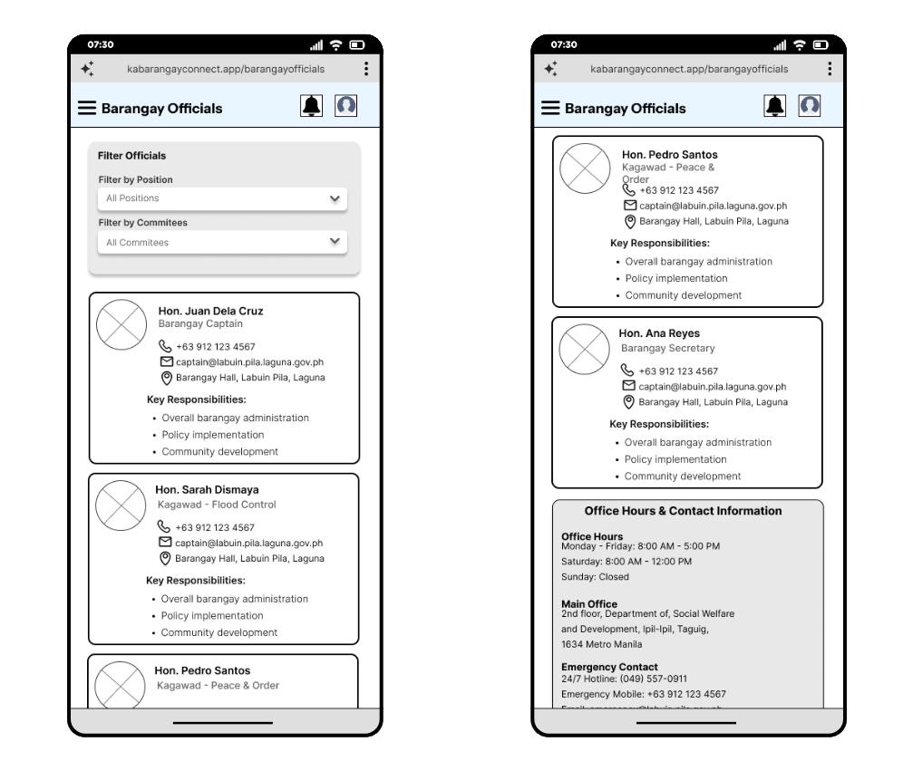
Figure 28.Barangay Officials Directory and Civic Leadership Interface (Mobile Browser)
The Barangay Officials module functions as a comprehensive digital directory, explicitly designed to enhance institutional transparency and facilitate direct constituent engagement with local leadership. To optimize data discoverability and minimize navigational friction, the interface integrates dynamic filtering parameters, allowing users to efficiently sort personnel by specific administrative positions or committee assignments (e.g., Peace & Order, Flood Control).
The directory utilizes a highly structured, card-based visual hierarchy to present official profiles. Each component encapsulates essential contact modalities, geographic assignments, and a definitive list of key jurisdictional responsibilities, thereby clarifying local governance structures for the resident. Furthermore, the strategic integration of a consolidated "Office Hours & Contact Information" panel at the terminus of the directory centralizes critical municipal operational data, including 24/7 emergency hotlines, reinforcing the platform's role as the definitive civic utility for the community.
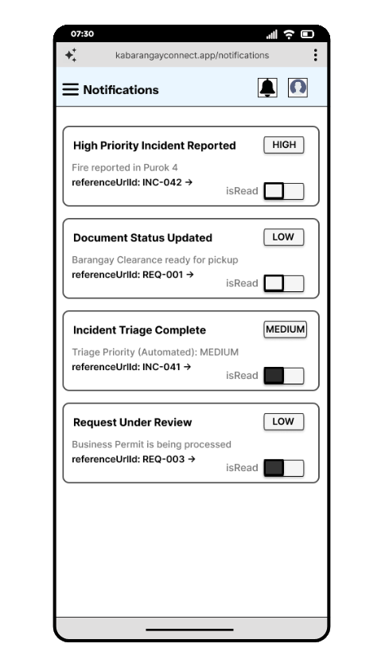
Figure 29.Persistent Notification History and Alert Routing Interface (Mobile Browser)
The notifications center operates as the centralized asynchronous communication hub for the KaBarangayConnect platform. Engineered to visualize the system's decoupled, event-driven backend architecture, this interface provides constituents with a persistent historical ledger of automated system alerts. This ensures that critical updates—such as shifts in emergency incident triage states or the fulfillment of requested municipal clearances—are reliably retained for user review. This design mitigates the risk of information loss, guaranteeing delivery even if the resident is offline during the initial real-time WebSocket broadcast.
The user interface employs a highly structured, card-based visual hierarchy that prominently features dynamic severity badges (e.g., "HIGH," "MEDIUM," "LOW") derived directly from the backend's rule-based prioritization engine. To minimize navigational friction, each notification card incorporates direct deep-linking mechanisms (referenceUrlId), enabling users to transition seamlessly from the alert directly to the specific incident or document record. Additionally, the integration of granular, user-controlled state toggles (isRead) allows residents to actively manage their notification queue, reducing cognitive overload and maintaining an organized digital environment.

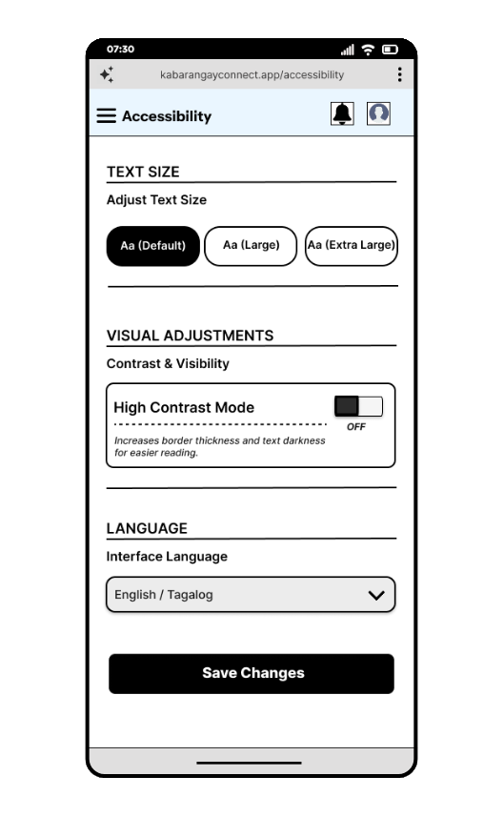
Figure 30.System Accessibility and Inclusive Design Configuration Interface (Mobile Browser)
The Accessibility configuration module represents a critical commitment to inclusive design and equitable civic engagement within the KaBarangayConnect platform. Recognizing the diverse demographic profile of barangay constituents—particularly senior citizens and individuals with varying degrees of visual or technological proficiency—this interface systematically dismantles digital interaction barriers.
The module provides users with granular control over essential display parameters. It features dynamic typographic scaling to accommodate reading difficulties, alongside a dedicated "High Contrast Mode" toggle engineered to enhance user interface element distinction and strictly adhere to digital accessibility standards (such as WCAG guidelines). Furthermore, the strategic integration of a bilingual interface selector ("English / Tagalog") ensures robust localization. By actively mitigating both visual and linguistic friction, this architecture guarantees that critical municipal services, document processing, and emergency reporting tools remain universally navigable and comprehensible for the entire community.

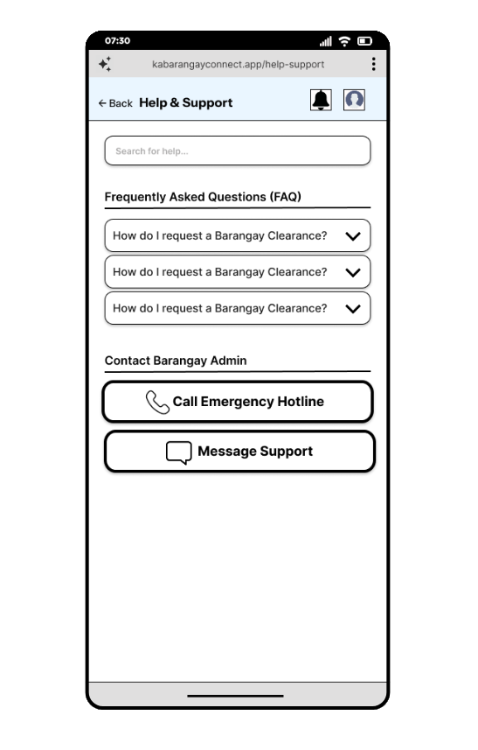
Figure 31.Constituent Support and Knowledge Base Interface (Mobile Browser)
The Help & Support module functions as a centralized constituent assistance portal, engineered specifically to enhance user autonomy and reduce municipal administrative overhead through a robust self-service knowledge base. To optimize information discoverability, the interface integrates a primary search query input, allowing users to rapidly retrieve specific procedural guidance.
Beneath the search component, the interface utilizes an accordion-style visual hierarchy for Frequently Asked Questions (FAQs), strictly applying the UX principle of progressive disclosure. This design choice strategically mitigates cognitive overload by concealing detailed operational workflows—such as the prerequisites for acquiring a Barangay Clearance—until explicitly expanded by the constituent.
Furthermore, the module establishes clear, accessible escalation pathways for complex issues requiring direct administrative intervention. By providing highly prominent, tactile calls-to-action for both synchronous ("Call Emergency Hotline") and asynchronous ("Message Support") communication channels, the system accommodates varying levels of constituent urgency and ensures continuous, equitable access to civic guidance.
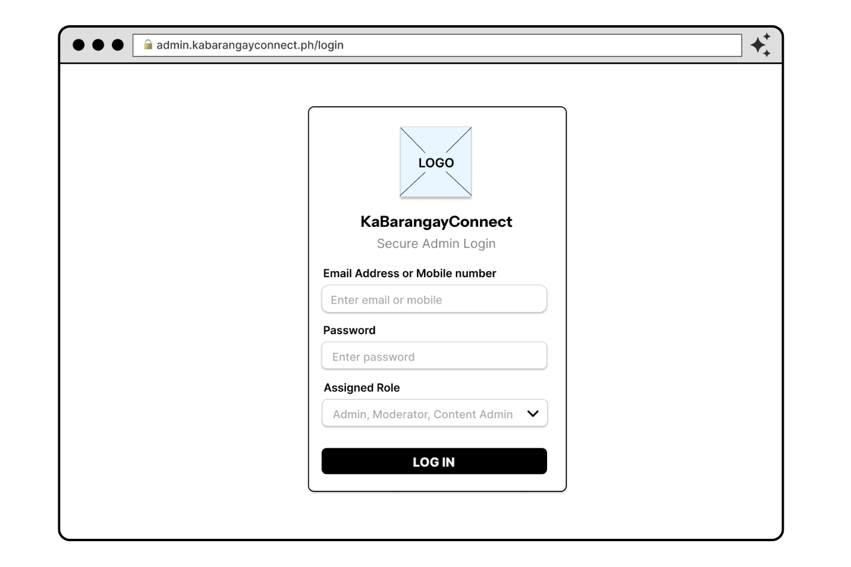
Figure 32.Admin Login Interface (Desktop Browser)
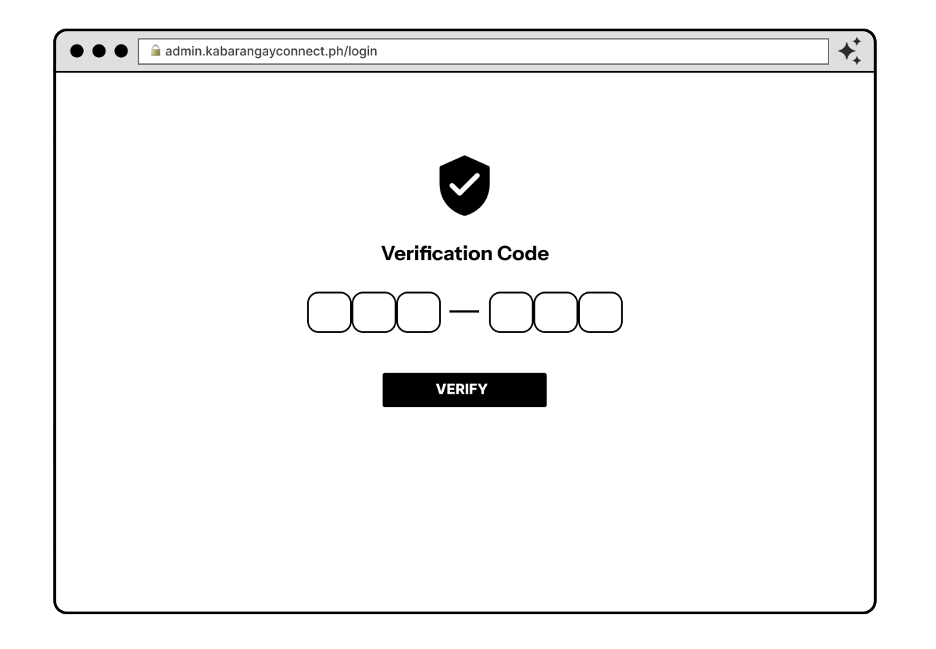Figure 33.Secure Administrative Portal Authentication and MFA Verification Workflow (Desktop Browser)
The secure administrative login interface operates as the exclusive gateway for barangay officials and administrative staff accessing the KaBarangayConnect backend dashboard. Engineered for desktop browser environments, the portal enforces rigorous, two-tiered access control protocols. During the primary authentication phase, administrators are required to supply standard credentials and explicitly define their assigned operational role (e.g., Admin, Moderator, Content Admin) prior to entry, thereby architecturally enforcing the principle of least privilege across the system.
Crucially, to safeguard highly sensitive constituent data and mitigate unauthorized system breaches, this gateway is heavily fortified with Multi-Factor Authentication (MFA). As illustrated in the sequential workflow, successful primary credential validation triggers a mandatory state transition to a secondary verification interface. Powered by the system's underlying AWS Cognito architecture, this secondary phase mandates the input of a highly secure, six-digit time-based verification token. This rigid structural requirement establishes a zero-trust security perimeter, ensuring the absolute integrity of the barangay's administrative operations and incident response infrastructure.
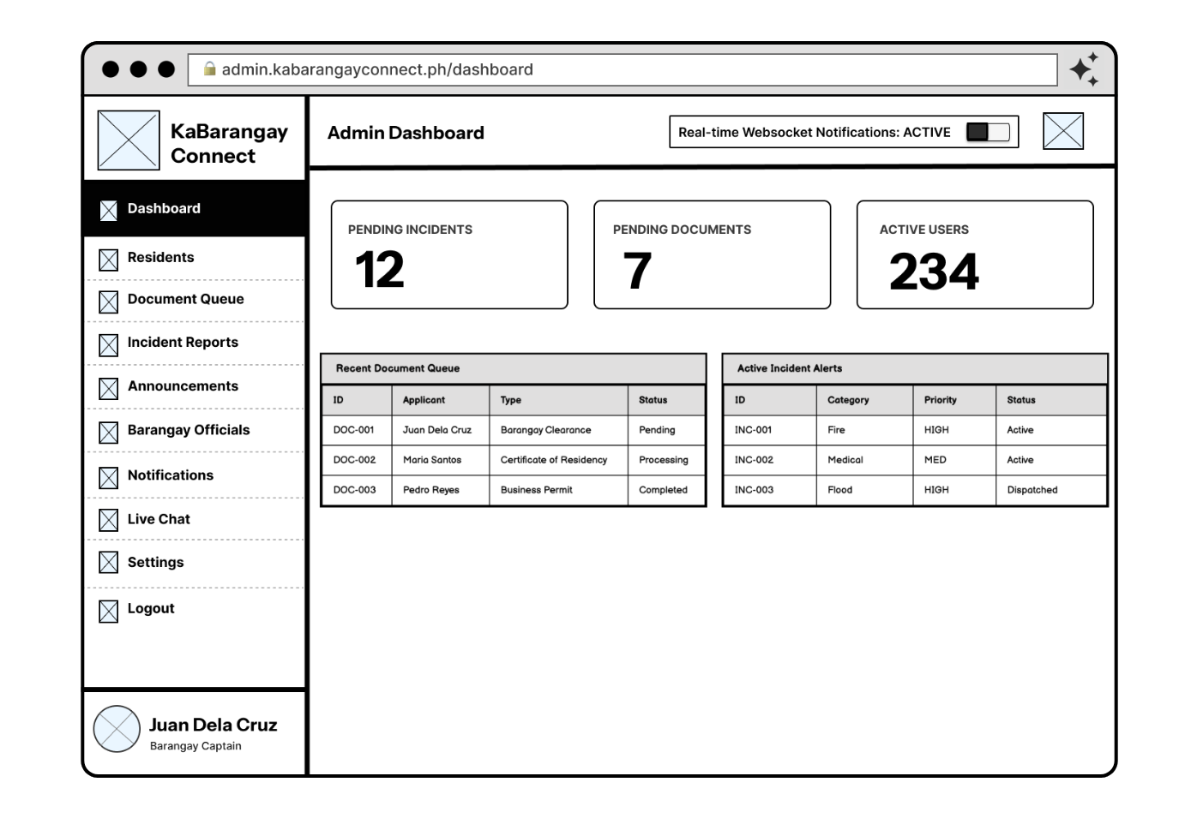Figure 34.Centralized Administrative Dashboard and Real-Time Telemetry Interface (Desktop Browser)
This interface serves as the primary operational command center for barangay officials navigating the KaBarangayConnect platform. Anchored by a persistent left-hand navigation sidebar, the layout ensures modular access across all civic management domains. The top echelon displays critical, aggregate metrics (Pending Incidents, Pending Documents, and Active Users) to provide leadership with immediate situational awareness. A defining architectural feature is the prominent "Real-time Websocket Notifications" toggle, directly reflecting the system's decoupled, event-driven backend. The lower operational view provides split-panel telemetry, offering administrative staff simultaneous, real-time visibility into the localized document processing queue and active emergency alerts categorized by the rule-based prioritization engine.
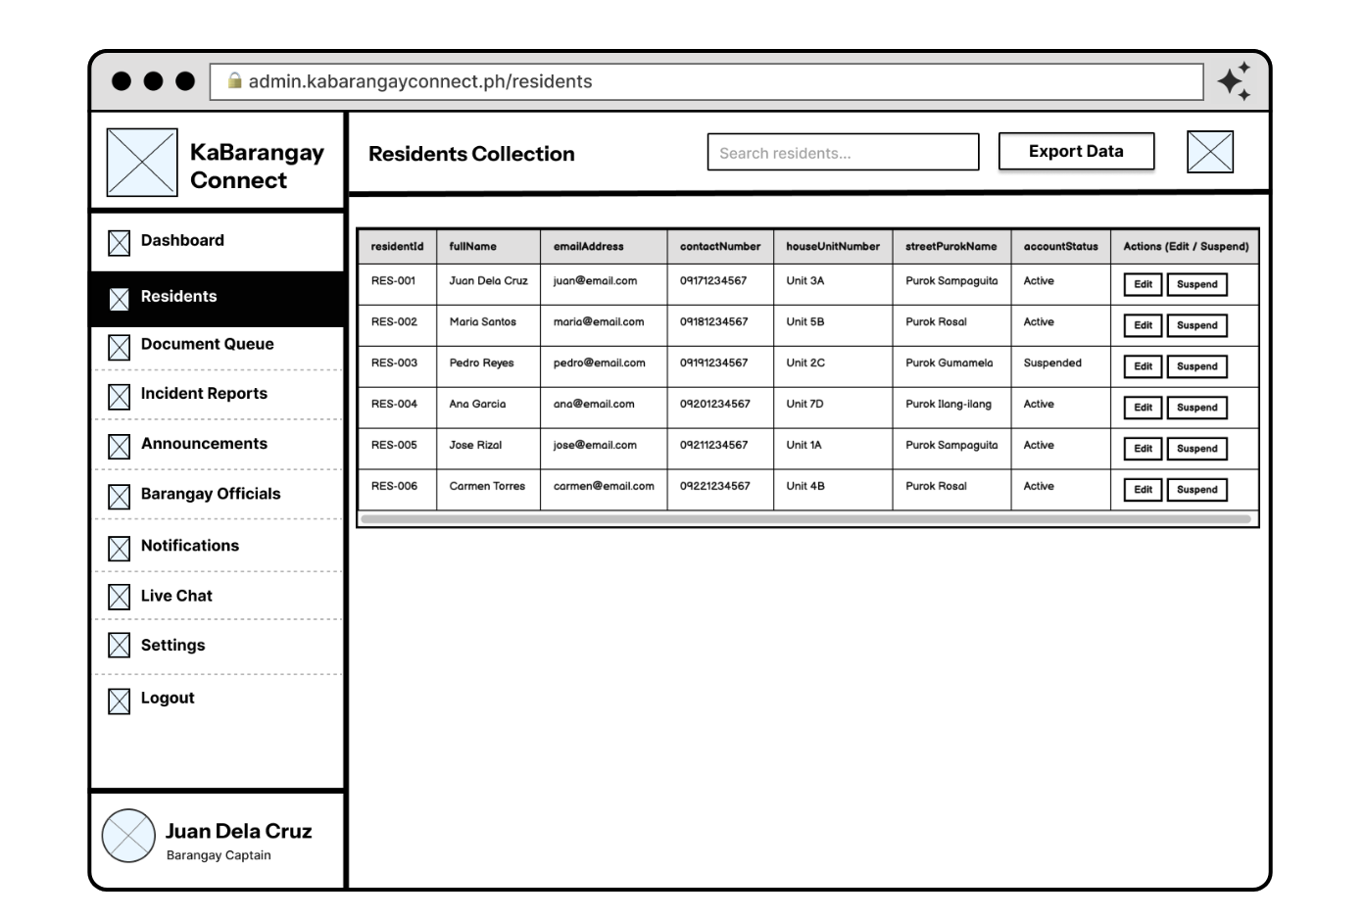
Figure 35.Resident Records Management and Demographic Database Interface (Desktop Browser)
The Residents Collection module digitizes the traditional barangay census, providing a highly structured, tabular visualization of the constituent database. To optimize administrative efficiency and data retrieval, the interface integrates a primary search input and an "Export Data" utility for external municipal reporting. The data table enforces strict schema visibility, displaying essential contact modalities, geographical routing data, and active account states. Furthermore, the column headers clearly expose the system's strict adherence to camelCase naming conventions (e.g., residentId, fullName, houseUnitNumber, streetPurokName) for database relations, ensuring seamless alignment between frontend data presentation and backend schema architecture. Action-oriented controls (Edit / Suspend) empower authorized personnel to securely moderate the platform and enforce localized governance protocols.

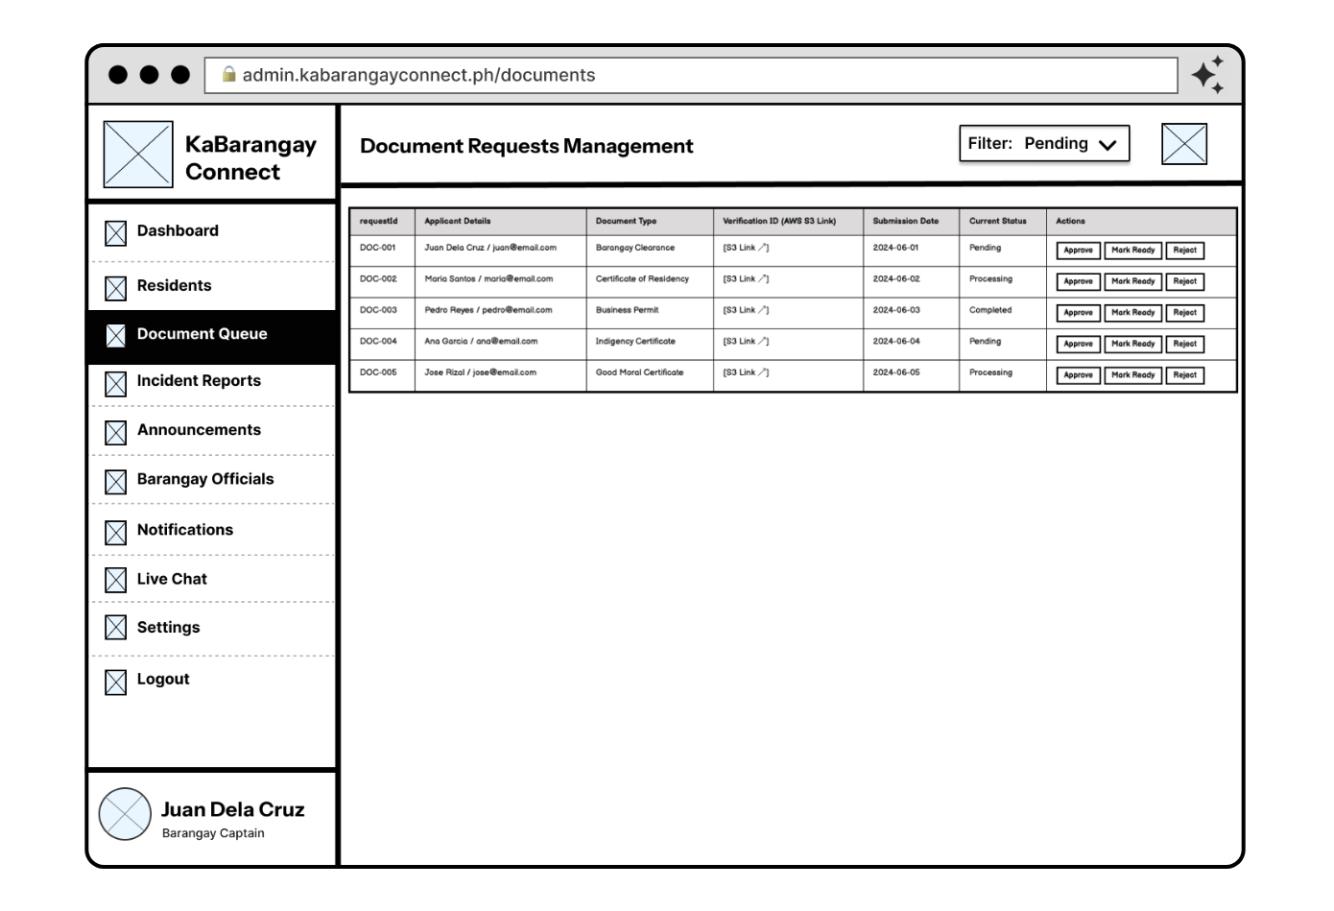Figure 36.Digital Document Queue and Administrative Workflow Interface (Desktop Browser)
Engineered to systematically alleviate barangay administrative friction, this module manages the complete digital lifecycle of constituent paperwork requests. The interface employs dynamic filtering capabilities (e.g., sorting by "Pending" status) to optimize administrative queue management and significantly reduce processing bottlenecks. The centralized data table consolidates crucial applicant details, specific document types, and chronological submission parameters, utilizing precise camelCase identifiers—such as requestId—for rigid data tracking and direct database alignment. Crucially, the table provides direct access to verification credentials securely hosted via AWS S3, enabling frictionless, cloud-based identity validation without necessitating the local download or storage of sensitive files. The explicitly defined action triggers ("Approve," "Mark Ready," "Reject") interface directly with the backend state management logic, instantly dispatching asynchronous status updates back to the requesting resident's mobile notification center.
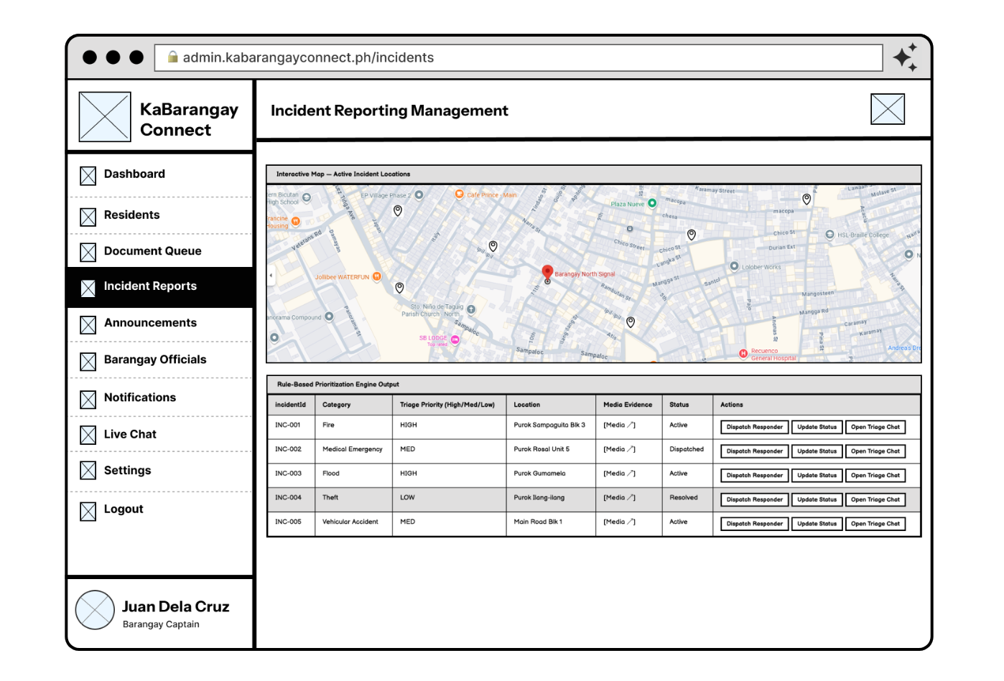Figure 37.Location-Based Incident Command and Automated Triage Interface (Desktop Browser)
This module functions as the centralized geographic and tactical command center for barangay emergency response operations. The interface features a bifurcated architectural layout, integrating an interactive spatial mapping component to provide administrative staff with real-time, topological awareness of active incident distribution across the barangay's jurisdiction. The lower telemetry panel displays the direct, tabular output of the system's rule-based prioritization engine. By systematically categorizing reported events by automated severity thresholds (e.g., HIGH, MED, LOW), the interface optimizes emergency resource allocation. Granular action controls ("Dispatch Responder," "Update Status," "Open Triage Chat") empower localized dispatchers to instantaneously initiate synchronous communication and coordinate deployment, thereby significantly reducing critical response latencies during high-stress scenarios.
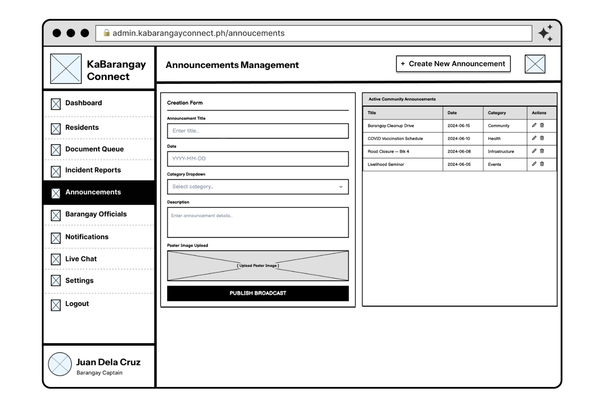Figure 38.Centralized Civic Broadcasting and Content Management Interface (Desktop Browser)
Engineered as a dedicated Content Management System (CMS) for localized civic communication, the Announcements Management module facilitates the structured, mass dissemination of public information. The interface utilizes a highly efficient split-pane architecture. The primary creation pane provides a comprehensive data entry schema, capturing precise programmatic parameters (Title, Date, Category) alongside a dedicated multimedia upload portal for digital public relations materials, which seamlessly integrates with the underlying cloud storage infrastructure. The secondary pane functions as a dynamic governance ledger, presenting a real-time audit of active community broadcasts. This structural design allows administrators to easily monitor, modify, or retract public notices, ensuring that the constituent-facing mobile application strictly reflects current administrative directives and community schedules.
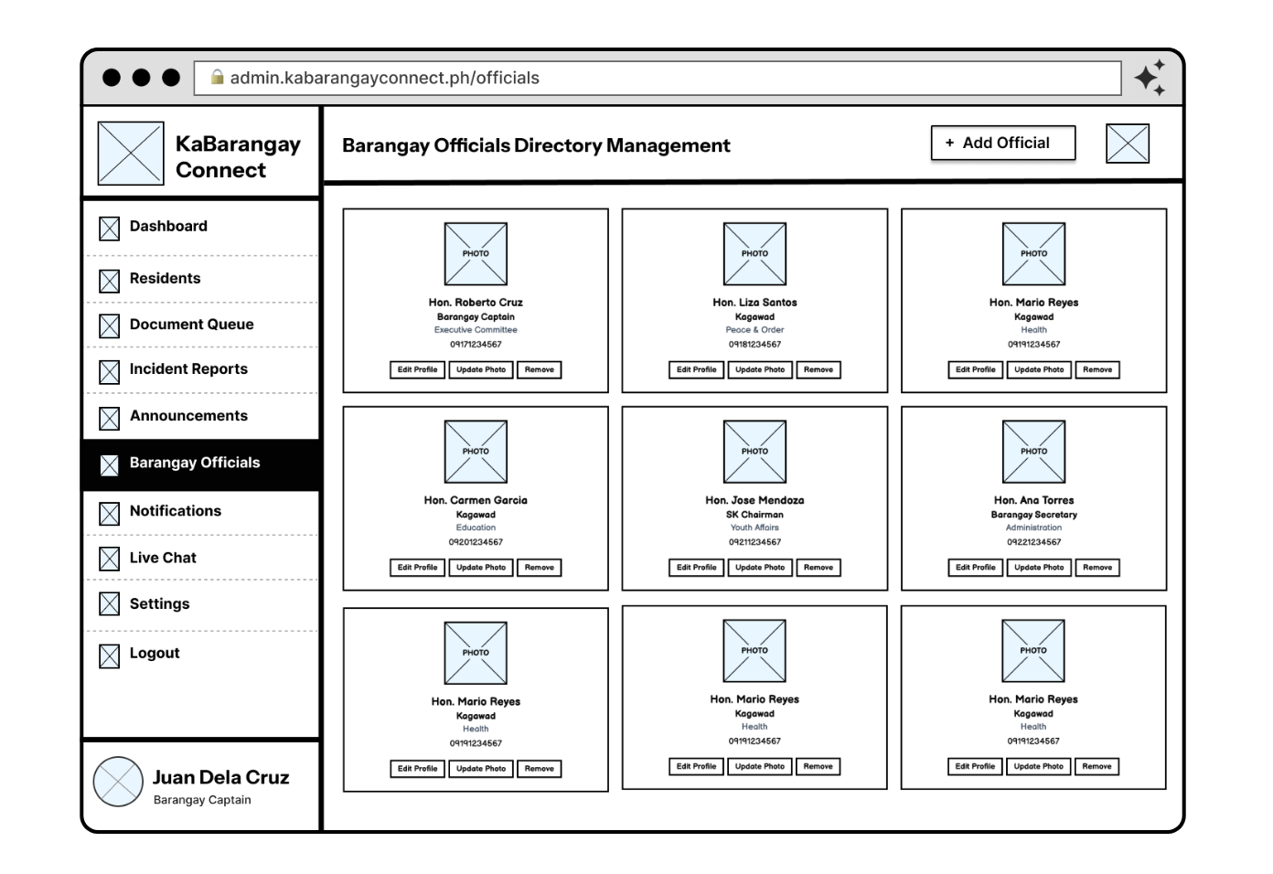Figure 39.Administrative Personnel Roster and Directory Management Interface (Desktop Browser)
The Barangay Officials Directory Management module provides a systematic, highly structured interface for maintaining the localized organizational hierarchy. Utilizing a scalable, card-based grid architecture, the interface displays the definitive roster of elected and appointed administrative personnel. Each modular component encapsulates essential identity parameters, including official designation, specific committee assignments (e.g., Peace & Order, Health), and direct contact modalities. System administrators are granted granular governance over this data ecosystem through dedicated operational triggers ("Edit Profile," "Update Photo," "Remove"). This interface enables the frictionless onboarding of new personnel and the real-time maintenance of institutional records, guaranteeing that the constituent-facing mobile directory remains an accurate, transparent reflection of the current civic leadership structure.
To address system maintenance during periods of local government transition—such as post-election turnovers—the module incorporates a strict Electoral Handover Protocol guided by the system's administrative documentation. When a new set of barangay officials assumes office, the system facilitates the secure transition of administrative privileges. Outgoing officials' profiles are not permanently erased, ensuring historical records and past audit logs remain intact; instead, their accounts are systematically deactivated utilizing a soft-delete (isDeleted) flag. This action instantly revokes their authentication privileges and JWT access tokens, structurally preventing old profiles from accessing the secure backend, while seamlessly allowing for the provisioning of new accounts for the incoming administration.
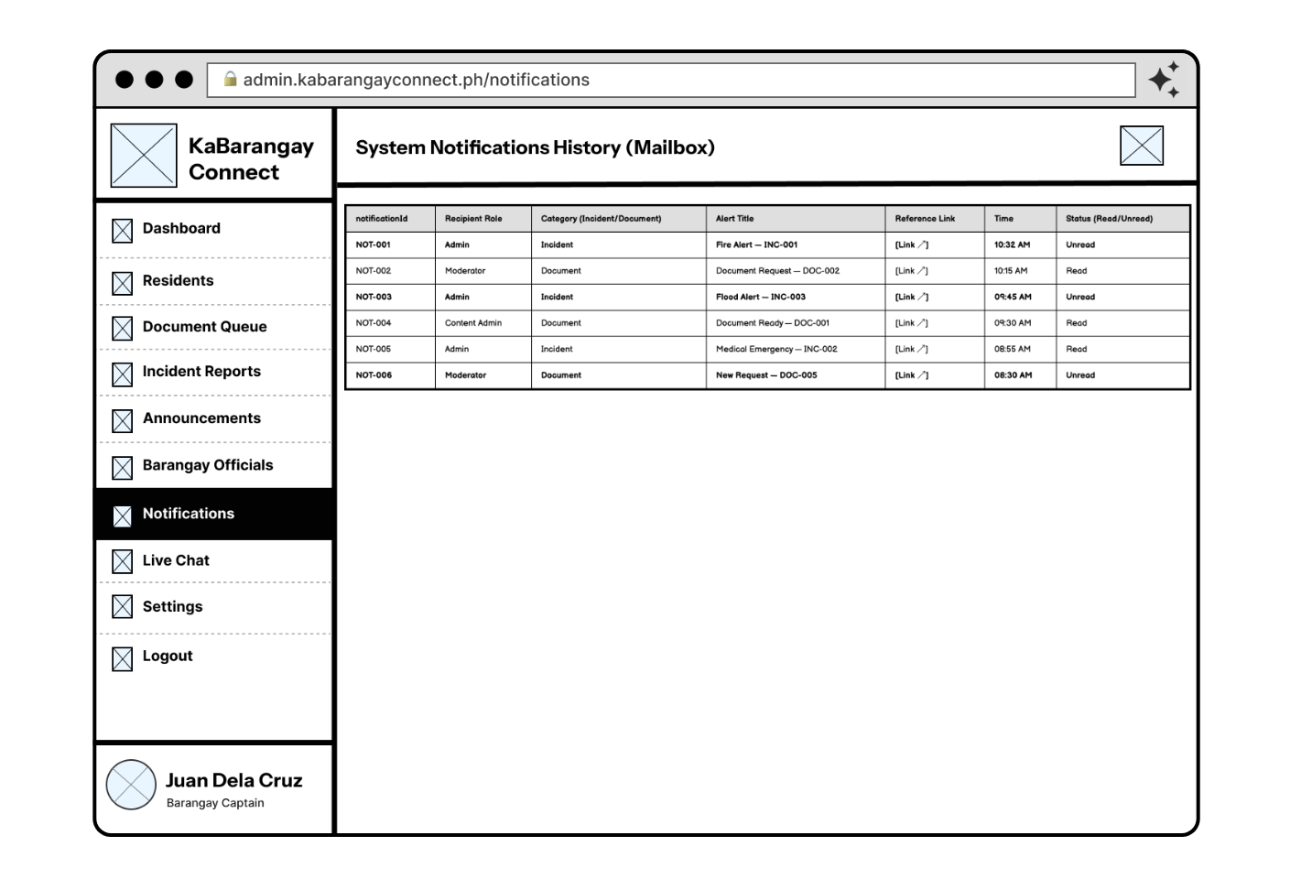Figure 40.System Notification History and Administrative Audit Log Interface (Desktop Browser)
This module serves as the persistent, centralized ledger for all automated and manual alerts generated within the KaBarangayConnect ecosystem. By providing a comprehensive tabular view of system notifications, the interface ensures absolute administrative accountability and operational continuity. The data schema explicitly tracks the notificationId, recipient roles (e.g., Admin, Moderator, Content Admin), event categorization (Incident versus Document), and active read/unread statuses. This structured mailbox architecture enables barangay officials to systematically review missed updates and asynchronously trace specific event trajectories via dedicated reference links, structurally preventing critical constituent requests or emergency alerts from being overlooked during high-volume periods.
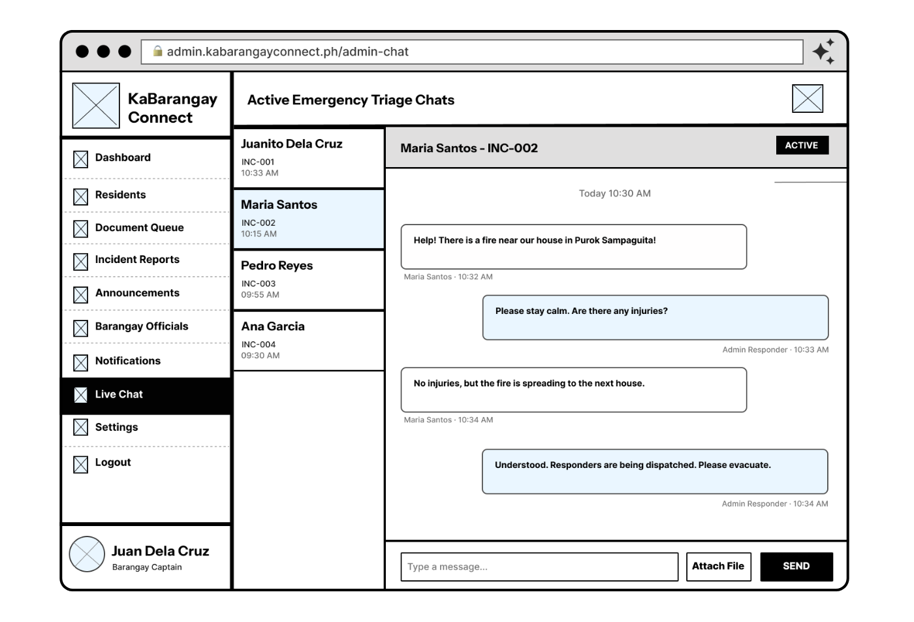Figure 41.Synchronous Emergency Triage and Multi-Session Command Interface (Desktop Browser)
Operating as the administrative counterpart to the resident-facing mobile chat, this module facilitates real-time, bidirectional crisis communication for barangay dispatchers. Engineered for high-stress operational environments, the interface utilizes a highly efficient split-pane architecture. The left column actively tracks and queues concurrent triage sessions, pairing resident names with specific database identifiers (e.g., INC-002) to maintain strict contextual awareness across multiple emergencies. The primary right-hand pane renders the active synchronous dialogue. By empowering barangay responders to seamlessly toggle between active incidents, issue immediate localized guidance, and receive multimedia context, this interface fundamentally accelerates situational assessment and resource deployment prior to physical on-site arrival.
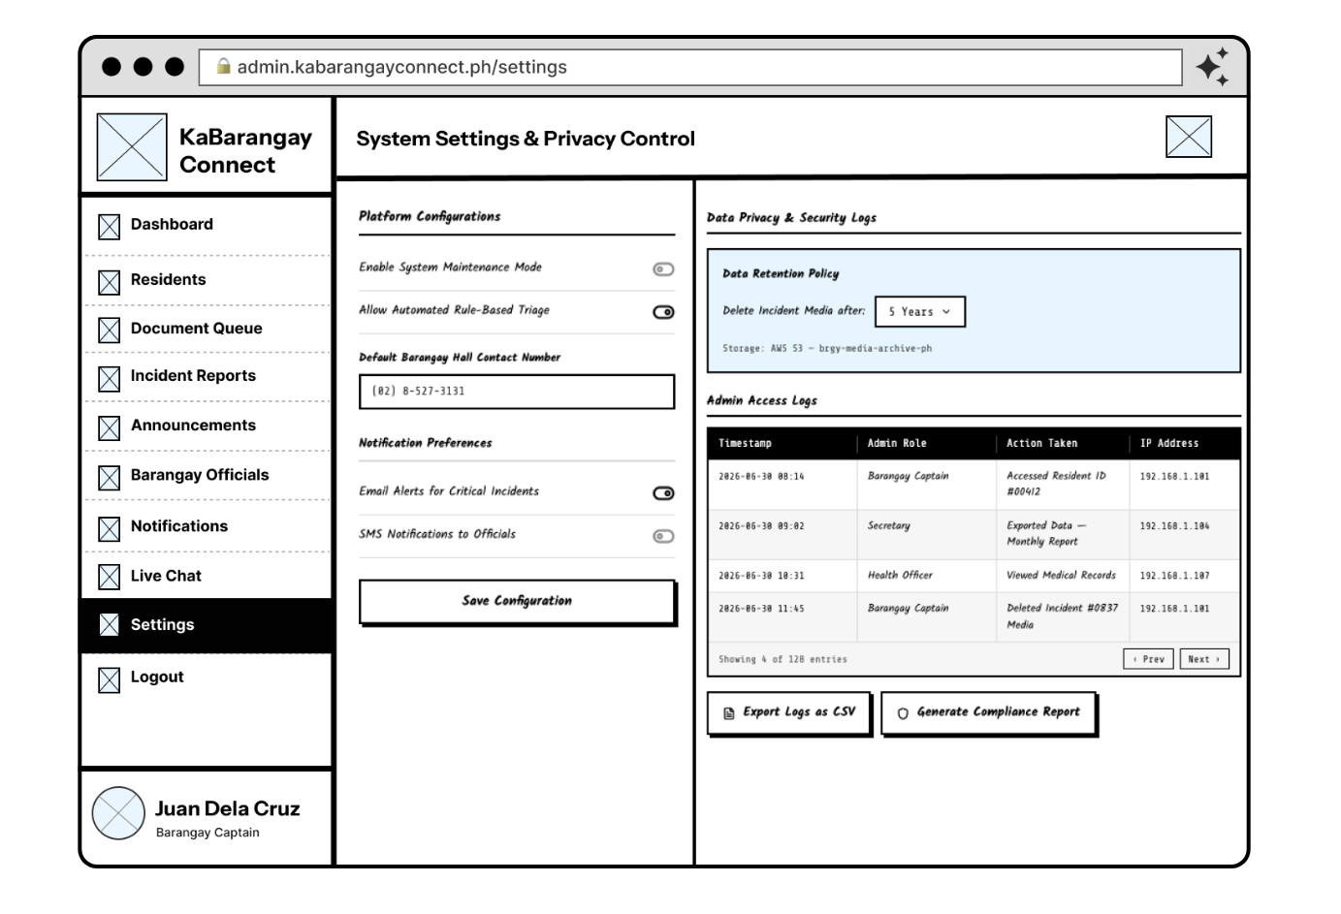Figure 42.Global System Configuration and Data Privacy Compliance Interface (Desktop Browser)
This critical administrative interface centralizes global platform configurations and enforces rigorous institutional adherence to the Philippine Data Privacy Act of 2012. The left-hand configuration panel grants authorized personnel granular control over core system behaviors, including toggles for the rule-based prioritization engine and global notification routing parameters. Crucially, the right-hand panel is dedicated entirely to strict security governance. It exposes automated data retention protocols—specifically governing sensitive incident media archived within AWS S3—and maintains an immutable, highly detailed "Admin Access Log." By systematically recording administrative actions, timestamps, and IP addresses, alongside utilities for generating structured compliance reports, this architecture establishes a zero-trust audit trail that safeguards constituent data against unauthorized internal access.

Navigation Flow. The navigation architecture of KaBarangayConnect is engineered to be highly intuitive and consistent across all digital touchpoints, ensuring a frictionless civic user experience. The primary navigation structurally adapts based on the user's role and operational device: constituents accessing the platform via mobile browsers utilize a globally accessible, slide-out navigation drawer (hamburger menu), while barangay administrators operating within desktop environments rely on a persistent left-hand navigation sidebar. This responsive architectural division maintains clear, hierarchical routing pathways while securely isolating role-specific content, preserving the user’s contextual state when transitioning between active civic modules.
Secondary navigation is managed through a strategic combination of modular overlays, modal presentations, and hierarchical stack-based routing. Complex or highly constrained workflows, such as the initial constituent registration, mandatory Data Privacy Act consent gatekeepers, and the multi-step emergency reporting sequence, are presented in isolated, full-screen views to deliberately minimize cognitive load and focus the user's attention. Stack navigation is utilized within deeper operational layers, such as the document request queues and accessibility configuration settings, allowing users to seamlessly drill down into categorical data and effortlessly return to previous overarching dashboard states.
This comprehensive structure is built leveraging responsive, component-driven web frameworks to ensure absolute cross-device fluidity. The implementation of a unified responsive design system allows for shared business logic, synchronized structural updates, and seamless parity across mobile and desktop environments. Concurrently, the platform employs adaptive UI components to guarantee stringent accessibility compliance, seamlessly integrating features like dynamic typographic scaling and high-contrast modes for inclusive design. This architectural approach is guided by strict strategies focused on visual consistency, rule-based state management for real-time websocket notifications, and robust data privacy constraints. The complete user journey is systematically visualized in the structural blueprints below, which illustrate how constituents and officials dynamically navigate the civic ecosystem while maintaining a secure operational context.

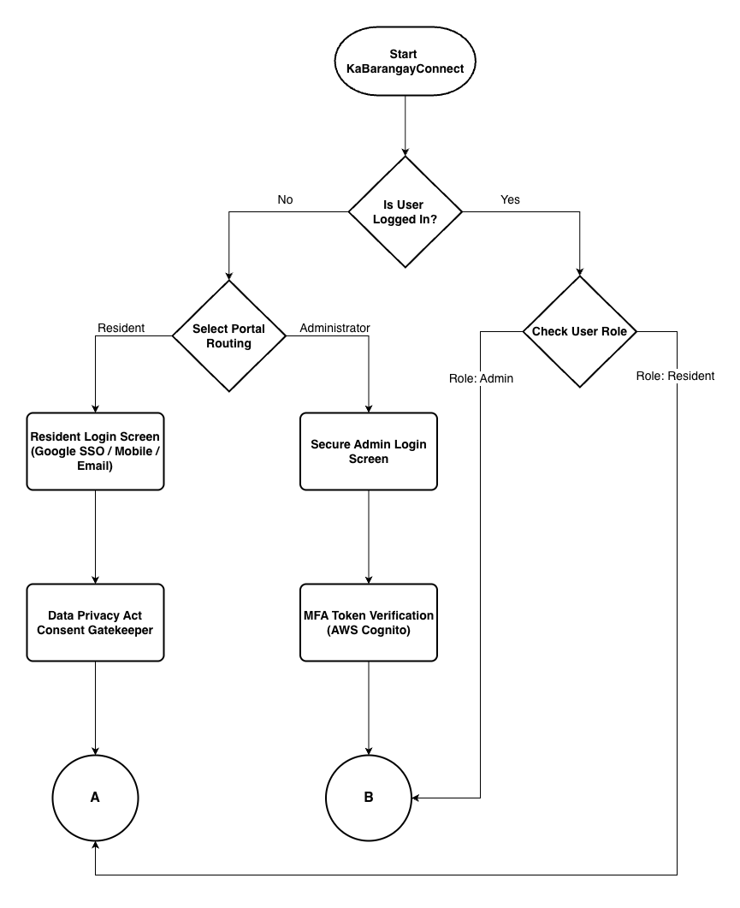
Figure 43.KaBarangayConnect Navigation Flow: Authentication and Onboarding
The user journey initiates upon accessing the KaBarangayConnect application. The system architecture first executes an authentication check to determine active session status. Unauthenticated users are routed to the primary gateway, which diverges based on user role. Constituents utilize the resident login interface, featuring options for standard credential entry or frictionless Google Single Sign-On (SSO), followed immediately by a mandatory Data Privacy Act consent gatekeeper prior to dashboard access. Conversely, administrative personnel are routed to a distinct, highly secure portal requiring strict role designation and mandatory Multi-Factor Authentication (MFA) via a verification token before backend access is granted.

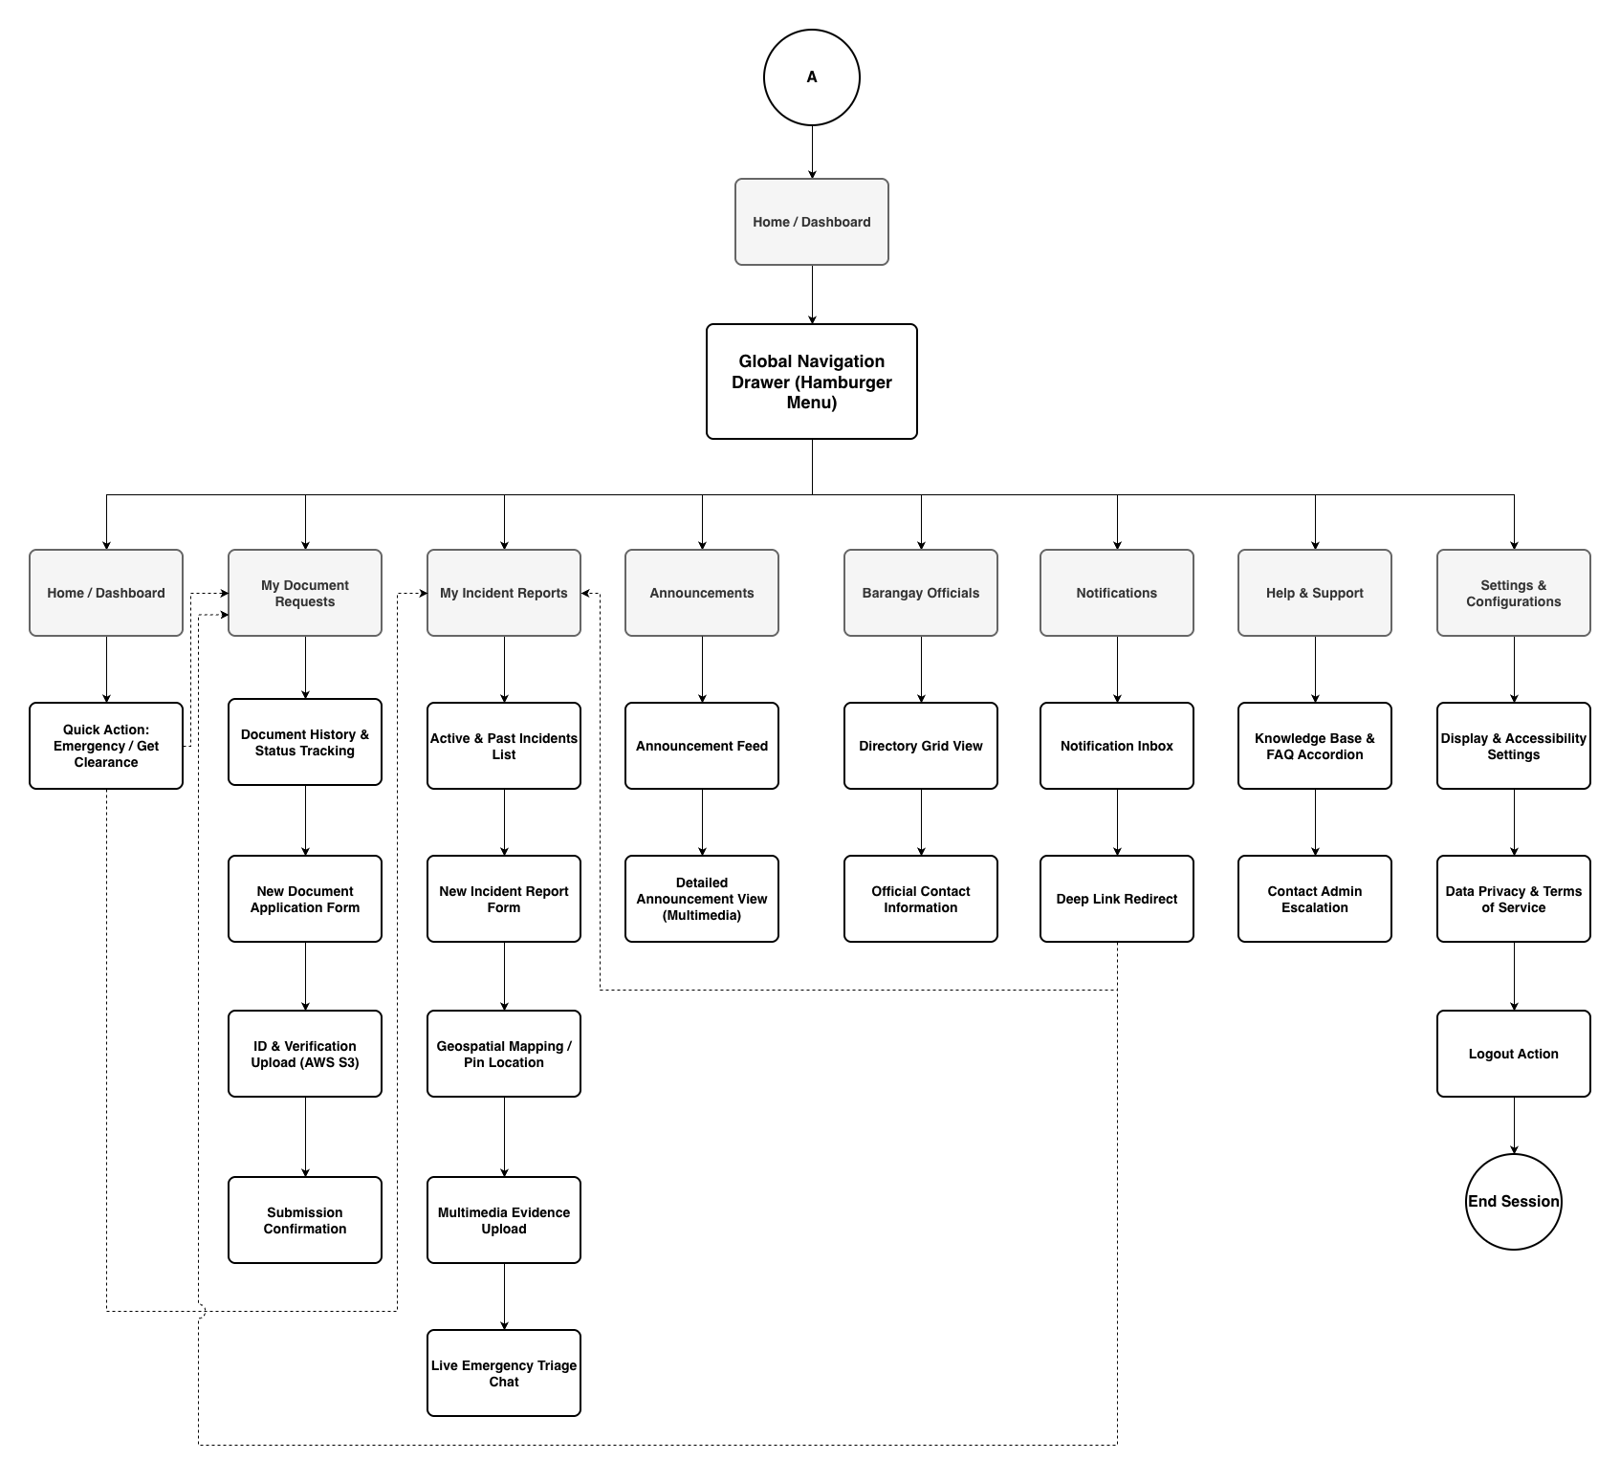
Figure 44.KaBarangayConnect Navigation Flow: Resident Constituent (Mobile)
The constituent is presented with a mobile-optimized interface anchored by a global slide-out navigation drawer (hamburger menu) which houses the primary civic modules: Home, My Document Requests, My Incident Reports, Announcements, Barangay Officials, Notifications, Help & Support, and Settings. Upon successful login, the resident defaults to the Home Dashboard. This landing screen serves as the primary operational hub, featuring high-priority "Quick Action" routing that allows users to immediately initiate an emergency alert or request a clearance document without navigating through nested menus.
The "My Document Requests" module serves as a dedicated tracker for all civic paperwork. In this section, residents can initiate a new document application form, which inherently requires the secure upload of primary identification or verification documents directly to the platform's cloud storage. Once submitted, residents utilize this same tab to monitor the real-time processing status and historical timeline of their active and past requests.
Emergency reporting and monitoring are consolidated within the "My Incident Reports" tab. When submitting a new report, the user is guided through a structured workflow: dropping a precise geospatial pin on the interactive map, uploading multimedia evidence of the situation, and formally submitting the alert. Crucially, this module also houses the active "Live Emergency Triage Chat," enabling constituents to engage in synchronous, bidirectional communication with responding barangay officials while an incident is actively being resolved.
Beyond transactional services, the navigation flow integrates community engagement and platform accessibility. The "Announcements" tab provides a chronological feed of multimedia civic broadcasts, while the "Barangay Officials" directory offers a grid-based view of localized leadership and their direct contact information. To ensure maximum accessibility and compliance, the "Settings & Configurations" module empowers users to toggle high-contrast display modes, adjust typographic scaling, and review the mandatory Data Privacy Act terms of service at any point during their session.
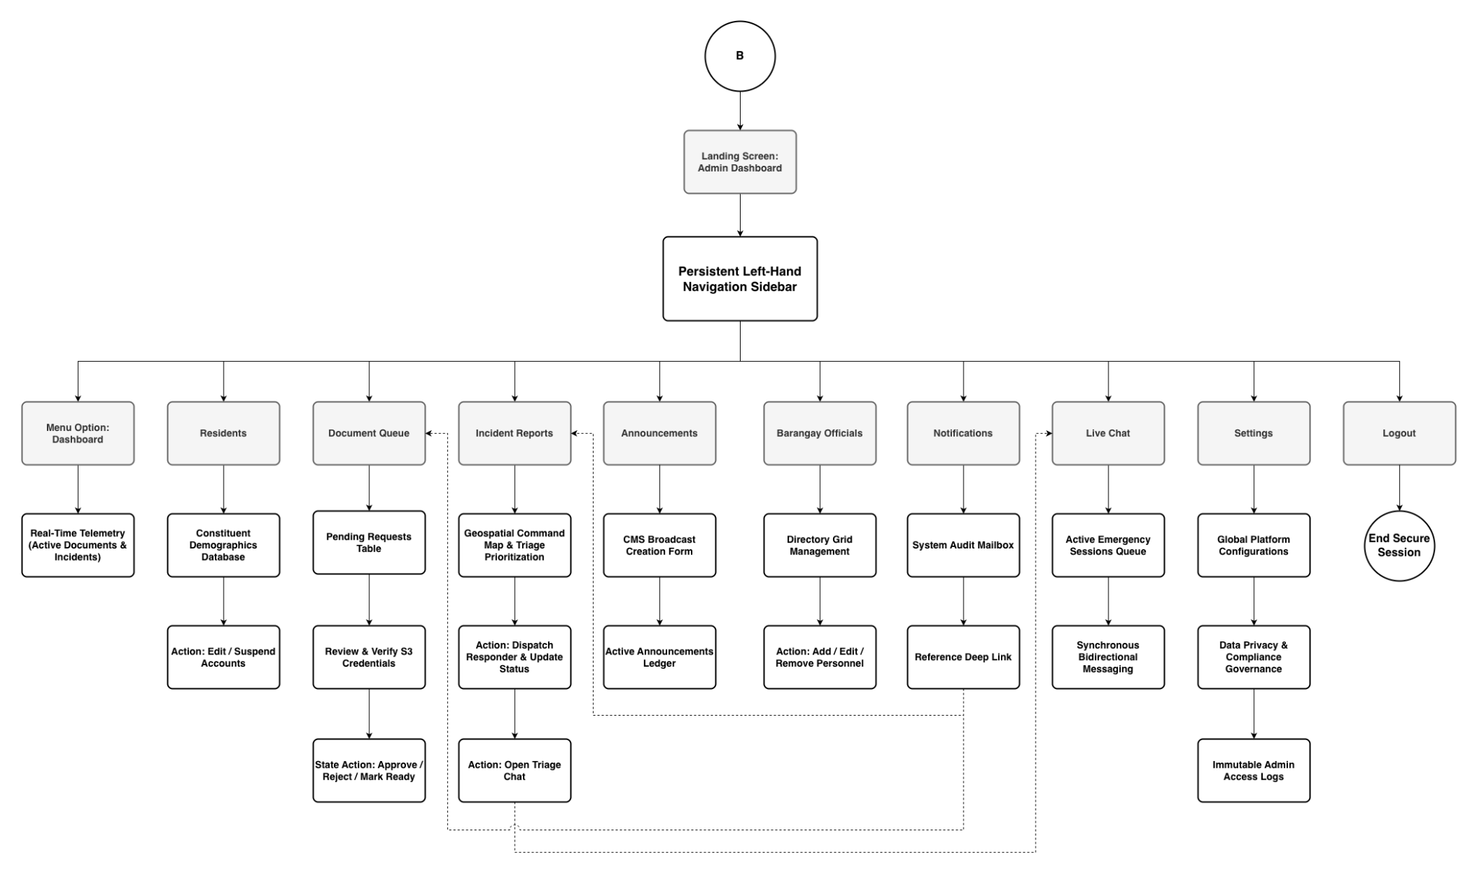
Figure 45.KaBarangayConnect Navigation Flow: Administrative Personnel (Desktop)
The administrative interface operates independently from the constituent mobile application, utilizing a persistent left-hand navigation sidebar engineered for desktop environments. Upon completing the mandatory Multi-Factor Authentication (MFA) sequence, barangay officials land on the central Admin Dashboard. This primary screen provides immediate, real-time telemetry, displaying aggregated metrics on pending document requests and the current prioritization queue of active emergency incidents across the barangay's jurisdiction.
The "Document Queue" and "Residents" tabs serve as the primary hubs for constituent data management. Within the Document Queue, administrators are presented with a tabular list of pending requests, where they can systematically review attached verification files and execute state-change actions (e.g., Approve, Reject, Mark as Ready). The Residents tab allows authorized personnel to view constituent demographics and manage platform access, including editing profiles or suspending accounts to maintain community integrity.
Incident command and emergency dispatch are orchestrated through the combined functionality of the "Incident Reports" and "Live Chat" modules. The Incident Reports tab features a comprehensive geospatial command map and an automated, rule-based triage ledger that categorizes emergencies by severity. From this interface, dispatchers can update incident statuses and seamlessly transition into the "Live Chat" queue to maintain concurrent, synchronous communication with multiple reporting residents, ensuring accurate situational assessment prior to physical deployment.
Finally, platform governance is managed through the "Announcements," "Officials," and "Settings" modules. Administrators utilize the Announcements CMS to draft and publish community broadcasts, while the Directory Management tool allows for the frictionless onboarding or removal of elected personnel. Crucially, the Settings tab enforces absolute systemic security, housing global platform configurations, automated data retention policies, and immutable Admin Access Logs to ensure strict compliance with institutional data privacy mandates.

Component / Module Design
The KaBarangayConnect platform is engineered utilizing a highly decoupled, modular architecture, with each module strictly responsible for a specific domain of the system’s civic functionality. Each module focuses on isolated operational responsibilities with clearly defined interaction boundaries and data pipelines. This modular approach significantly improves system maintainability, flexibility, and cloud scalability, ensuring that mission-critical features such as emergency triage, secure document processing, and real-time communications are executed efficiently and securely without system bottlenecks.
User Authentication & Security Module
Purpose: Handles multi-tiered system access, credential verification, and rigorous session management utilizing a cloud-hybrid authentication model.
Key Functions:
- Registers constituent users via standard email credentials or frictionless Google Single Sign-On (SSO).
- Enforces mandatory Multi-Factor Authentication (MFA) via time-based tokens for all administrative personnel.
- Acts as the primary gatekeeper for the Data Privacy Act of 2012 consent agreements during onboarding.
- Manages encrypted password resets, account recovery, and role-based access control (RBAC).
Main Interactions:
- Directly integrates with AWS Cognito to execute secure login validations, MFA generation, and token-based session management.
- Communicates with the Profile Management Module to initialize new resident database records upon successful registration.

Dashboard & Telemetry Module
Purpose: Serves as the central data aggregation hub, providing both residents and administrators with immediate, context-aware system overviews upon login.
Key Functions:
- Presents residents with contextual "Quick Actions" for frictionless access to emergency routing and clearance requests.
- Aggregates system-wide telemetry for administrators, displaying real-time metrics on pending document queues and active incident counts.
- Visualizes priority escalations to ensure barangay officials address high-severity emergencies first. Main Interactions:
Main Interactions:
- Queries the primary NoSQL database (MongoDB Atlas) to fetch aggregated, real-time counts without loading full document payloads.
- Interfaces with the Navigation Module to route users directly to specific records via deep linking.

Profile & Demographic Management Module
Purpose: Securely manages resident constituent data, account lifecycles, and the localized directory of elected barangay officials.
Key Functions:
- Allows residents to create, view, and update their personal demographic profiles and contact information.
- Provides administrators with tools to suspend or edit constituent accounts to maintain community integrity.
- Manages the Barangay Officials directory, enabling the frictionless addition, removal, and updating of personnel contact data. Main Interactions:
Main Interactions:
- Utilizes the primary NoSQL database (MongoDB Atlas) to store and retrieve structured demographic information.
- Interfaces with the Document and Incident Modules to automatically append verified user data to specific clearance requests or emergency alerts.

Document Processing Module
Purpose: Facilitates the end-to-end digital lifecycle of barangay clearance and permit applications, from constituent submission to administrative approval.
Key Functions:
- Captures user input for various document types and securely accepts primary identification uploads.
- Provides residents with a real-time tracking timeline for their active application statuses.
- Presents administrators with a consolidated queuing interface to review submissions, verify credentials, and execute state changes (Approve, Reject, Mark Ready).
Main Interactions:
- Integrates heavily with AWS S3 for the encrypted storage and retrieval of sensitive constituent identification media.
- Triggers the Notification Module to automatically alert residents when a document state changes (e.g., transitioning from "Pending" to "Ready for Pickup").

Geospatial Incident Reporting Module
Purpose: Manages the submission, spatial mapping, and automated rule-based triage of community emergency alerts and localized incident reports.
Key Functions:
- Enables residents to pinpoint exact incident coordinates using an interactive geospatial mapping interface.
- Allows for the attachment of multimedia evidence (photos/videos) to provide context for emergency situations.
- Automates incident prioritization for administrators by categorizing incoming alerts based on predefined severity rules.
- Tracks responder dispatch status and incident resolution timelines.
Main Interactions:
- Leverages Maps APIs for accurate location telemetry and coordinate processing.
- Stores critical incident media within dedicated, highly secure AWS S3 archive buckets.
- Directly bridges active emergency records to the Real-Time Communication Module to initiate synchronous triage.

Real-Time Communication (Live Chat) Module
Purpose: Provides a secure, low-latency, bidirectional communication channel between dispatched barangay responders and affected constituents during active crises. Key Functions:
Key Functions:
- Facilitates concurrent, multi-session text communication for administrators handling simultaneous emergencies.
- Allows for real-time situational updates and guidance prior to the physical arrival of responders.
- Maintains an immutable historical log of all emergency transcripts for post-incident review.
Main Interactions:
- Utilizes bi-directional WebSocket Secure (WSS) connections via AWS API Gateway to maintain the persistent live connection, effectively bypassing the short-lived, stateless limitations of AWS Lambda. Lambda is strictly utilized for momentary message processing, while MongoDB Atlas acts as the persistent ledger for the session ID and message history, ensuring instantaneous message delivery without manual page refreshes.
- Relies on the Incident Reporting Module to accurately pair incoming messages with the correct active emergency notificationId.
Civic Broadcasting (Announcements) Module
Purpose: Functions as a localized Content Management System (CMS) for publishing official barangay advisories, news, and community event updates.
Key Functions:
- Allows authorized Content Admins to draft, format, and publish multimedia announcements.
- Generates a chronological public newsfeed accessible via the constituent mobile dashboard.
- Supports detailed announcement views incorporating images and extended text formatting.
Main Interactions:
- Stores broadcast metadata and text payloads in the primary database.
- Leverages AWS S3 for hosting any graphical assets or images attached to the announcements.

Notification & System Audit Module
Purpose: Centralizes the delivery of all asynchronous system alerts while simultaneously enforcing strict security governance through comprehensive administrative activity logging.
Key Functions:
- Delivers targeted status updates to constituents regarding their documents and incident reports.
- Maintains structured mailbox interfaces for users to review past notifications and read/unread states.
- Records highly detailed, immutable logs of all administrative actions, timestamps, and IP addresses.
- Executes automated data retention policies (e.g., deleting archived incident media after 5 years).
Main Interactions:
- Listens to state changes across the Document, Incident, and Broadcasting modules to generate contextual alerts.
- Integrates with AWS CloudWatch to securely store and export the administrative audit logs for compliance reporting.

Help & Support (Knowledge Base) Module
Purpose: Provides a self-service resolution center for constituents, reducing the administrative burden on barangay staff for common inquiries.
Key Functions:
- Hosts an expandable FAQ accordion detailing barangay operating hours, clearance requirements, and emergency protocols.
- Provides a structured escalation pathway for residents to contact administrators directly for complex platform issues.
- Acts as a centralized repository for user guides and systemic tutorials.
Main Interactions:
- Retrieves static structural content from the database to populate the Help Center.
- Integrates with the Notification Module to route support escalation tickets to the administrative dashboard.

System Accessibility & Configuration Module
Purpose: Empowers users to customize their digital environment for inclusive access while ensuring continuous platform compliance with legal data frameworks.
Key Functions:
- Allows users to toggle highly specific UI/UX preferences, including dynamic typographic scaling and high-contrast color modes.
- Manages user-facing legal documentation, ensuring the Data Privacy Act of 2012 Terms of Service are always accessible for review.
- Handles secure session termination (Logout) across all active devices.
Main Interactions:
- Utilizes local device storage (e.g., mobile cache or browser storage) to persist accessibility preferences without taxing the cloud database.
- Interfaces with the User Authentication Module to securely revoke active access tokens during the logout sequence.

Use Case Diagrams
Below are the blueprints for your two primary Use Case Diagrams for KaBarangayConnect. These diagrams perfectly mirror the academic standard of your reference document by showcasing the precise interactions between your two main actors (the Resident and the Administrator) and the platform's core modules, utilizing standard UML relationships (<<include>> and <<extend>>).
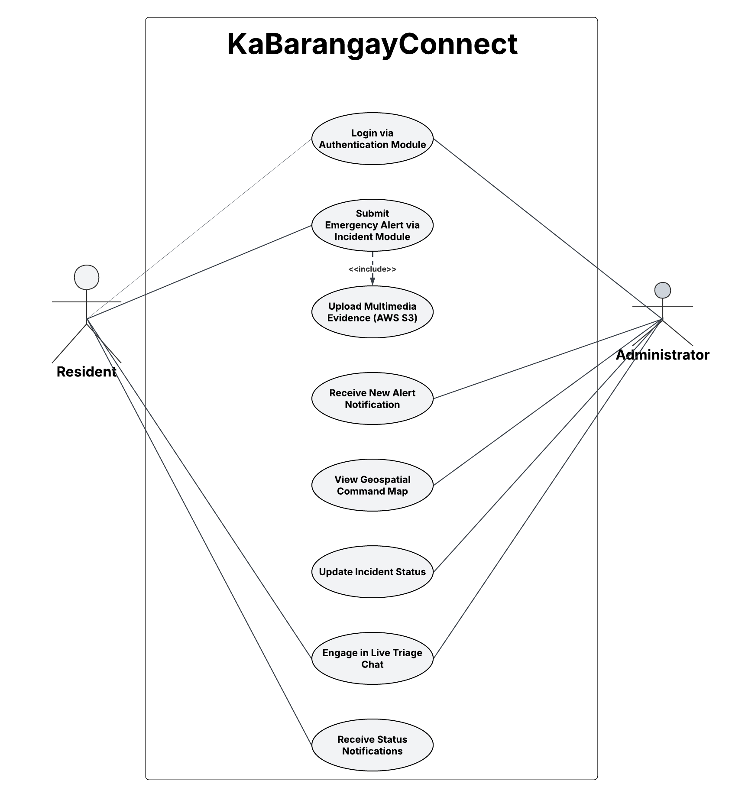
Figure 46.Use Case for Emergency Incident Reporting & Triage
This use case diagram illustrates the synchronous interaction sequence between the constituent and the barangay official during a crisis event. Both actors initiate their session via the User Authentication Module. The resident's primary action—submitting an emergency alert—structurally requires (<<include>>) the secure upload of multimedia evidence to AWS S3 to ensure data validity. Upon submission, the system routes an immediate incoming alert notification to the administrator, prompting them to access the geospatial command map and evaluate the threat. Following triage, the administrator updates the dispatch status, which triggers automated status updates back to the resident. Crucially, the architecture converges at the Real-Time Communication Module, where both actors concurrently engage in live chat to exchange situational intelligence.
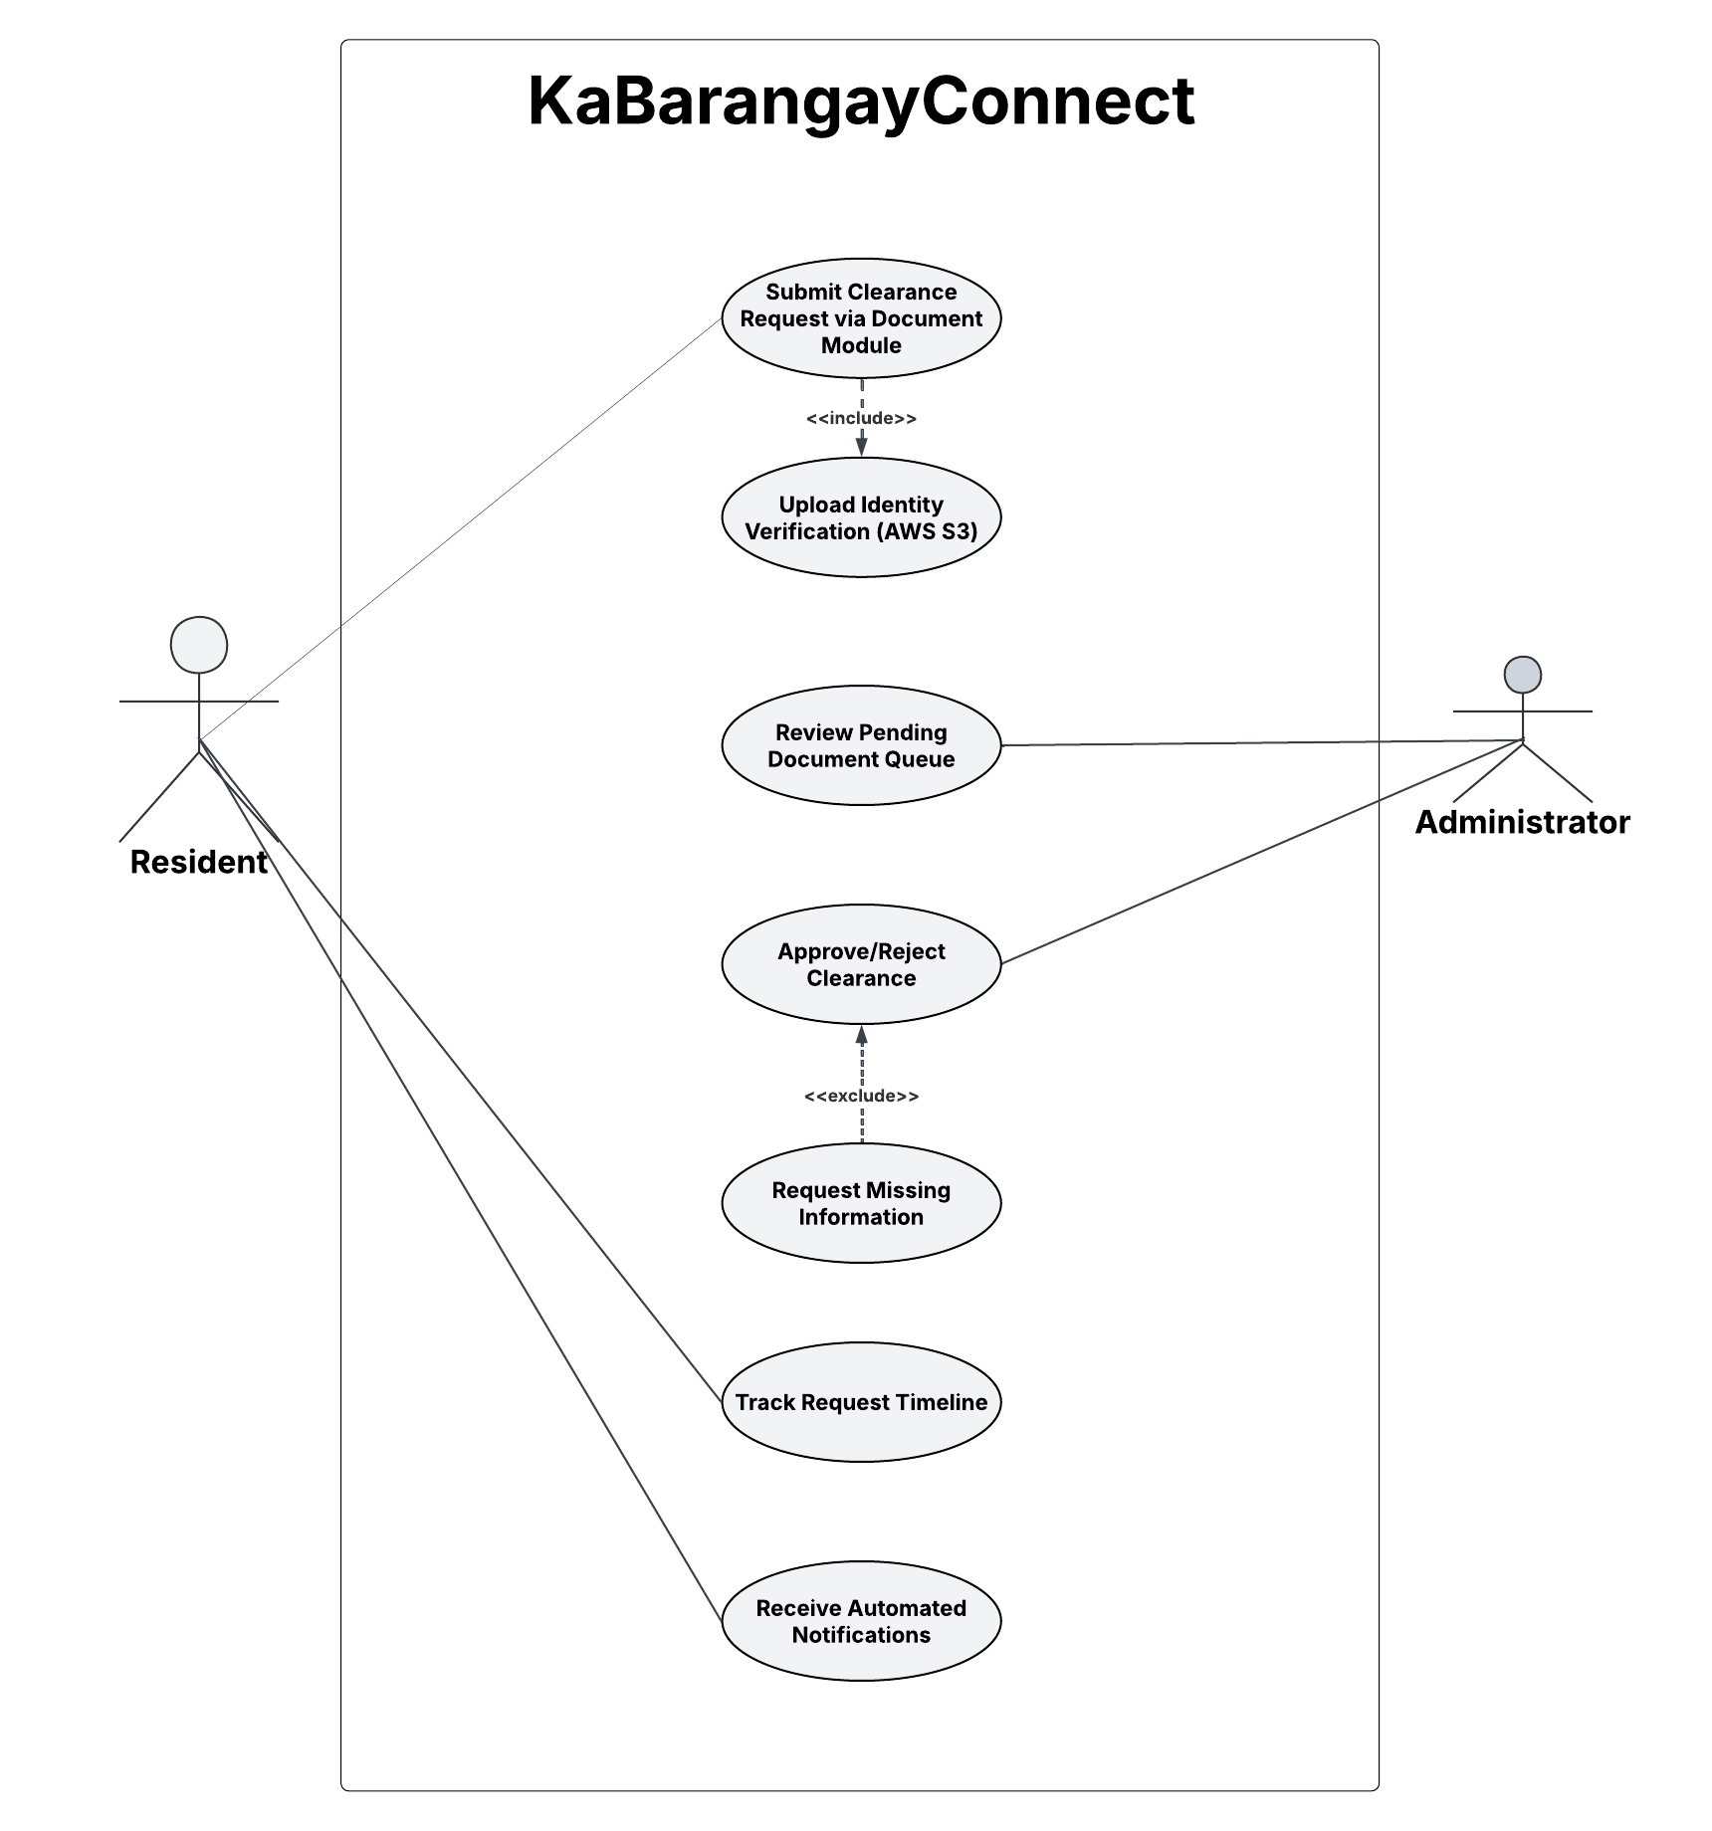
Figure 47.Use Case for Document Clearance Processing
This diagram visualizes the asynchronous administrative workflow governing civic paperwork. The resident initiates the process via the Document Processing Module; this action mandatorily requires (<<include>>) the provision of identity verification files. The administrator's primary workflow involves querying the pending queue and executing state changes on the document (Approve or Reject). If the uploaded credentials are insufficient, the administrator's workflow expands to conditionally trigger (<<extend>>) a request for missing information. Throughout this lifecycle, the Notification Module continuously pushes automated updates to the resident, enabling transparent tracking of the request timeline.

Technology Stack
The technological infrastructure of KaBarangayConnect is specifically engineered to support a cloud-native, decoupled web architecture. To fulfill the platform's rigorous demands for real-time responsiveness, secure data isolation, and elastic scalability during localized emergencies, the following modern frameworks and managed cloud services have been deliberately integrated into the system design.

Frontend (Client Application Layer)
- Framework and Component Library: Next.js (React) and Material UI (MUI)
  - The constituent-facing dashboard and administrative command center will be developed as a unified, component-based web application utilizing Next.js, styled with the Material UI (MUI) component library.
  - Justification: Next.js functions as the primary public and administrative portal, delivering a highly dynamic, server-rendered, and mobile-responsive user experience. By pairing this with Material UI, the platform leverages enterprise-grade, pre-built React components that inherently comply with strict accessibility standards (WCAG). This accelerates the development of complex interfaces—such as the incident triage map and document request queues—and natively supports essential features like high-contrast themes and responsive design without the need to write extensive custom CSS.

Backend (Serverless Logic and API Layer)
- Compute Engine and Runtime: AWS Lambda (Node.js)
  - The serverless backend will utilize Node.js as the primary programming runtime environment executing inside AWS Lambda. All core business logic, including the Rule-Based Prioritization engine and automated document state transitions, will be scripted in this environment.
  - Justification: Utilizing an event-driven Node.js runtime inside a serverless compute architecture eliminates the need for heavy, always-on traditional backend frameworks (such as Express.js or Laravel). Lambda functions scale elastically and execute code only when triggered by an API request, ensuring that time-sensitive emergency alerts are processed instantaneously during traffic surges while minimizing idle computing costs.
- Deployment Granularity: Microservices-Style Serverless (Function-per-Use-Case)
  - Rather than deploying a monolithic backend wrapped inside a single, oversized serverless function (a "Fat Lambda"), the system's architecture strictly employs a Function-per-Use-Case deployment model. Each distinct civic feature or operational workflow—such as submitDocumentRequest, updateTriagePriority, or broadcastAnnouncement—is deployed as an independent, single-purpose AWS Lambda function.
  - Justification: This microservices approach provides profound operational benefits. First, it creates isolated failure domains; if the document processing function encounters an error, the emergency incident reporting functions remain entirely unaffected and fully operational. Second, it enables hyper-efficient, independent scaling. During a severe weather event, the specific functions handling incident reports can scale massively to handle thousands of concurrent requests without unnecessarily scaling the administrative or document-processing components, thereby optimizing cloud consumption costs and maximizing system reliability.

- API Management: AWS API Gateway
  - The system will utilize AWS API Gateway to orchestrate both standard HTTP requests and real-time streaming protocols.
  - Justification: This service acts as the secure ingress point for the platform, structurally separating routine bureaucratic traffic (via RESTful APIs) from critical, low-latency interactions (managed via the API Gateway WebSocket API).

Database and Persistence
- Primary Database System: MongoDB Atlas
  - Persistent data—including resident profiles, clearance timelines, and triaged incident queues—will be managed within MongoDB Atlas.
  - Justification: As a fully managed cloud NoSQL database, MongoDB Atlas abandons rigid tabular constraints in favor of a flexible BSON document model. This schema agility, coupled with automatic sharding and replication, ensures highly available, fault-tolerant data distribution. Furthermore, its rapid connection handling is optimally suited for integration with stateless, serverless computing environments.
- Object Data Modeling (ODM): Mongoose
  - The system will utilize Mongoose as the ODM library integrated within the Node.js Lambda backend to govern data interactions with MongoDB Atlas.
  - Justification: Because MongoDB Atlas is inherently a schema-less NoSQL database, Mongoose acts as the essential data controller layer. It is used to programmatically enforce strict schema validation, establish referential constraints using camelCase identifiers, and execute cascading updates via middleware hooks. This ensures robust relational integrity and data consistency for complex workflows (like document approvals and triage chat logs) without the overhead of traditional relational database engines.

Cloud Platform and Object Storage
- Primary Cloud Provider: Amazon Web Services (AWS)
  - AWS will serve as the foundational enterprise cloud ecosystem powering the application's backend infrastructure.
  - Justification: AWS provides a globally distributed, highly compliant infrastructure essential for public service platforms. It guarantees robust disaster recovery and secure network isolation to protect localized government operations.
- Media Storage: AWS S3 (Simple Storage Service)
  - Justification: Dedicated AWS S3 buckets will be utilized strictly for object storage, ensuring the encrypted retention of sensitive, unstructured user files, such as valid identity verification cards and photographic evidence attached to geospatial incident reports.

Security and Communication Services
- Authentication & Access Control: Role-Based Access Control (RBAC) via Encrypted Tokens
  - To maintain absolute data integrity, session management will rely on encrypted web tokens (e.g., JWT). This ensures that administrative command capabilities, such as viewing specific Document Requests or Chat Sessions, are strictly limited to authorized personnel.
- Real-Time Streaming: WebSocket Secure (WSS)
  - Justification: Unlike traditional HTTP polling, bi-directional WSS connections will be integrated to push instant telemetry to the frontend. This technology is critical for powering the synchronous Live Triage Chat and guaranteeing that administrative dashboards receive emergency alerts the exact millisecond they are submitted.

Development Tools and Version Control
- Integrated Development Environment (IDE): Visual Studio Code (VS Code)
  - Justification: VS Code serves as the primary code editor for compiling the Next.js frontend and scripting the serverless backend functions. It provides a lightweight, highly customizable environment with native support for JavaScript/TypeScript syntax highlighting, linting, and integrated terminal operations essential for modern web development.
- Version Control & Repository Hosting: Git and GitHub
  - Justification: Git is utilized for local source code management, tracking incremental changes, and branching features during development. GitHub serves as the centralized, secure cloud repository hosting the platform's codebase. This facilitates collaborative integration, structured version rollback tracking, and continuous deployment triggers for cloud hosting.
- API Development & Testing Utilities: Postman
  - Justification: Postman is implemented as the primary API client to construct, mock, and test the stateless serverless endpoints. It allows for the isolated validation of HTTP requests, payload structures, and response behaviors from AWS Lambda functions before they are fully integrated into the client-side user interface.

Security Design Considerations
Ensuring constituent trust and maintaining absolute data integrity is paramount for a civic platform like KaBarangayConnect, especially when processing sensitive demographic information, emergency telemetry, and government-issued identification. This section outlines the system’s defensive mechanisms, focusing on rigorous authentication, data encryption, and adherence to modern institutional privacy standards.
Authentication and Authorization. KaBarangayConnect utilizes robust identity management protocols to verify and manage user access securely across the web platform. Constituents can authenticate via:
- Standard email and password combinations.
- Frictionless Google Single Sign-On (OAuth 2.0).
To protect the backend from unauthorized command execution, administrative personnel are subjected to stricter access requirements, including mandatory Multi-Factor Authentication (MFA).
Upon successful authentication, the system issues a secure JSON Web Token (JWT) which is attached to all subsequent client requests. These tokens are:
- Cryptographically verified server-side at the AWS API Gateway layer to authorize access to protected endpoints.
- Given strict expiration windows to maintain session integrity and prevent token hijacking.
Role-Based Access Control (RBAC) is strictly enforced. The payload of the JWT contains custom claims that differentiate roles (e.g., Resident, Moderator, Admin), ensuring users can only interact with system resources permitted by their clearance level.
Data Protection. All structured community data—including demographic profiles, document request timelines, and synchronous chat logs—is securely managed within MongoDB Atlas. To ensure comprehensive data protection:
- Database Security: MongoDB Atlas enforces strict network isolation and encrypts all data at rest using industry-standard AES-256 encryption. Access to specific collections is governed by programmatic role assignments.
- Object Storage Security: Sensitive user-generated media, such as valid identification cards and photographic incident evidence, are stored in AWS S3 buckets. Public access to these buckets is universally blocked; files are only retrievable via securely generated, time-limited presigned URLs requested by authorized clients.
All communication between the Next.js client application, AWS API Gateway, and MongoDB Atlas occurs exclusively over HTTPS/TLS 1.2+, ensuring end-to-end encryption of all data in transit and preventing man-in-the-middle (MitM) interception.
API Security (Serverless Functions). Because the core business logic is executed via AWS Lambda functions exposed through HTTP and WebSocket endpoints, additional defensive controls are implemented:
- Strict input validation and payload sanitization are executed prior to database querying to prevent NoSQL injection attacks or malformed data ingestion.
- Custom Lambda Authorizers are utilized to decode, validate, and verify the signature of every JWT before any core backend execution is permitted.
- Rate limiting and throttling are configured at the AWS API Gateway level to mitigate Distributed Denial of Service (DDoS) attacks and prevent API abuse.
Immutable Audit Logging Constraints. To guarantee absolute institutional accountability and defend against rogue administrative actors, the backend framework strictly prohibits the alteration of system logs. Whenever an official performs a mutating action (e.g., updating a document status or triage priority), the AWS Lambda controller intercepts the request, extracts the unique administrative identifier (adminId) directly from the secure AWS Cognito JWT token, and generates a structured log entry in AWS CloudWatch. Crucially, the backend API architecture intentionally does not expose any PUT (edit) or DELETE endpoints for the log collections. This architectural constraint structurally prevents any administrator, regardless of their clearance level, from clearing out or altering log entries to hide their system changes.
Data Privacy Act (DPA) Compliance. As a platform handling civic data, KaBarangayConnect is engineered to comply with the Data Privacy Act of 2012. The system guarantees:
- Explicit, mandatory consent gatekeepers during the constituent registration workflow.
- Automated data retention policies, ensuring that sensitive media (e.g., resolved incident photos) is systematically archived or purged after a legally designated timeframe.
- Immutable system logging via AWS CloudWatch, recording all administrative actions, timestamps, and IP addresses to maintain a transparent, unalterable audit trail.
Addressing Common Vulnerabilities. To protect against known web architecture vulnerabilities, development adheres to stringent security frameworks:
- All engineering practices align with the OWASP Web Security Top 10 guidelines.
- The Next.js framework natively mitigates Cross-Site Scripting (XSS) attacks by automatically escaping dynamic data before rendering it in the browser.
- Error messages are heavily sanitized in the production environment to prevent the accidental disclosure of stack traces or database schema structures.
- Third-party dependencies and NPM packages are routinely audited using automated tools to identify and update vulnerable libraries, protecting the platform from supply chain exploits.

Deployment Considerations
The deployment strategy for KaBarangayConnect is architected to guarantee continuous high availability, robust security, and seamless delivery across all constituent and administrative touchpoints. By strictly utilizing a managed cloud ecosystem, the platform ensures rapid rollout and elastic scalability without the overhead of traditional infrastructure.
- Client Application Hosting The Next.js web application—encompassing both the mobile-responsive resident dashboard and the persistent administrative desktop portal—will be deployed utilizing AWS Amplify Hosting. This fully managed service provides a global Content Delivery Network (CDN) to ensure low-latency access for the community. AWS Amplify natively supports Next.js server-side rendering (SSR) and automatically provisions SSL/TLS certificates to enforce secure HTTPS connections across the entire platform.
- Serverless Backend Operations All backend logic, data validation, and real-time routing will be deployed as serverless compute functions using AWS Lambda, orchestrated through AWS API Gateway. This strictly serverless deployment model scales dynamically based on constituent traffic, ensuring the platform remains highly responsive during sudden spikes in emergency reporting. By completely eliminating the need for manual server provisioning or traditional Elastic Load Balancing, this architecture minimizes idle costs while maximizing fault tolerance.
- Database Management The platform's persistent data layer will be hosted on MongoDB Atlas, a fully managed cloud database-as-a-service (DBaaS). Atlas abstracts away complex database administration tasks, automatically handling cluster scaling, data replication, and automated disaster recovery backups, seamlessly peering with the AWS backend to ensure secure, low-latency data transmission.
- CI/CD Integration A robust Continuous Integration and Continuous Deployment (CI/CD) pipeline will be engineered utilizing GitHub Actions. This pipeline will automate the software lifecycle; every authorized code commit will automatically trigger isolated testing environments, build processes, and subsequent deployments to AWS Amplify and Lambda. This automation significantly improves deployment reliability, eliminates human error during production releases, and accelerates iterative development cycles.
This comprehensive, cloud-native deployment approach leverages the inherent strengths of the AWS serverless ecosystem to deliver a highly secure, fault-tolerant, and consistently performant civic management platform accessible from any web-enabled device.
Cloud Cost Management and Financial Feasibility
To ensure long-term financial viability for a standard local barangay budget, the architecture is specifically optimized to leverage consumption-based cloud free tiers. The primary NoSQL database utilizes the MongoDB Atlas M0 Free Tier, which provides a 512 MB storage limit. Because structured text data (JSON/BSON) is highly lightweight, this capacity is more than sufficient for the operational records of a single pilot barangay. To prevent exceeding this limit, all heavy multimedia files (incident photos, ID verifications) are completely offloaded to AWS S3, which offers highly economical object storage. Furthermore, the serverless AWS Lambda backend charges only per invocation milliseconds; during periods of low civic activity, compute costs effectively drop to zero, insulating the barangay from the excessive, continuous billing associated with traditional always-on servers.

Summary of System Design
The proposed system design for KaBarangayConnect effectively addresses the project’s complex civic requirements by leveraging a modern, serverless cloud architecture with Amazon Web Services (AWS) at its core, paired with a dynamic, component-based Next.js frontend client. This strategic choice of technology directly supports the platform’s primary goals, enabling rapid deployment and elastic scalability without the bottleneck of traditional on-premise server management. The architecture ensures continuous high availability through AWS Lambda and API Gateway, features robust NoSQL database capabilities with MongoDB Atlas for agile data synchronization, and integrates essential services like AWS Cognito and the Google Maps Platform for secure identity management and precision geospatial incident routing.
The design is structurally organized into distinct, highly decoupled modules—including Document Processing, Geospatial Incident Reporting, Real-Time Live Chat, and Civic Broadcasting—each strictly responsible for specific operational functionalities. Stringent defensive measures are deeply ingrained into the architecture, utilizing encrypted Role-Based Access Control (RBAC), secure AWS S3 object storage for sensitive verification files, and immutable AWS CloudWatch auditing to guarantee absolute compliance with the Data Privacy Act of 2012. Ultimately, these calculated design choices work in concert to deliver a highly accessible, fault-tolerant, and secure web application that fulfills KaBarangayConnect’s core mission of modernizing localized governance and empowering rapid, community-driven emergency response.

Development Plan

This section outlines the structured, practical development approach taken for building KaBarangayConnect, including technology selection, development phases, deployment configuration, and version control strategies.

3.2.1 Technology Stack Selection
KaBarangayConnect utilizes a lightweight, cloud-native, and highly scalable technology stack engineered for barangay-scale deployment. This stack was specifically chosen to guarantee high availability, secure real-time data processing, and strict compliance with the Data Privacy Act of 2012. The full stack includes:
- Frontend: The system utilizes Next.js, a modern, component-based React framework, to deliver a responsive, server-rendered web interface. This allows the platform to be seamlessly accessed across standard desktop and mobile browsers, providing role-specific dashboards for residents and administrators without requiring native app installation.
- Backend: AWS Lambda functions, orchestrated through Amazon API Gateway, serve as the serverless backend. This event-driven architecture handles core API requests, secure authentication token verification, automated rule-based incident prioritization, and real-time WebSocket routing without the need for manual server provisioning.
- Database: The architecture employs decoupled storage to optimize performance. MongoDB Atlas, a fully managed NoSQL database, is utilized for the dynamic, structured storage of user profiles, document request timelines, and chat sessions. Concurrently, AWS S3 is used as dedicated object storage to securely house sensitive, unstructured user attachments (e.g., identity verification cards and photographic incident evidence).
- Hosting/Deployment: AWS Amplify Hosting is utilized to deploy and host the web application. It provides a highly reliable, global Content Delivery Network (CDN) and an automated CI/CD pipeline, ensuring secure HTTPS connections and a streamlined deployment workflow for the barangay.
- Version Control: Git is utilized for local version tracking and source code management, while GitHub serves as the remote repository to facilitate secure backups, team collaboration, and automated deployment triggers.

3.2.1.1 Software Development Methodology
KaBarangayConnect adopts an Agile-Scrum framework as its core software development methodology. This iterative, collaborative approach is well suited for capstone-level development because it accommodates changing requirements from weekly mentor feedback, produces demonstrable increments at the end of each sprint, and encourages shared accountability among team members. The group functions as a Scrum team with rotating facilitation responsibilities; the team collectively maintains a backlog of user stories and action items derived from the functional and non-functional requirements in Tables 1 and 2, as well as from feedback received during the Capstone 1 oral defense. Each development cycle follows the standard Scrum pattern of Sprint Planning (Monday), daily brief stand-ups, mid-week blocker checks, and Sprint Review and Retrospective (Friday) so that progress is transparent and impediments are resolved quickly.

3.2.1.2 Sprint Overview and Development Phases
The entire Capstone 2 development timeline is organized into 12 one-week sprints, aligned with the term schedule from August 17, 2026 to November 6, 2026. These sprints are grouped into six sequential development phases that build on each other incrementally:

- Sprint 1 (August 17–21, 2026) – Capstone 1 Panel Feedback and Revisions: Revising Sections 1–3 of the paper to address all defense recommendations before coding begins, updating database schemas to reflect the approved serverless design, and finalizing ethical clearance documents.
- Sprint 2 (August 24–28, 2026) – Infrastructure and Base Setup: Provisioning AWS services (Amplify, Lambda, API Gateway), configuring MongoDB Atlas clusters, implementing JWT authentication with RBAC, setting up GitHub Actions CI/CD pipelines, and establishing the shared component-based Next.js UI foundation.
- Sprint 3 (August 31–September 4, 2026) – Authentication and Onboarding: Building the resident Google SSO login flow, administrative MFA login, DPA consent gatekeeper interface, and global responsive navigation (sidebar + hamburger menu).
- Sprint 4 (September 7–11, 2026) – Document Requests and Administrative Dashboard: Developing the resident document request form with S3 ID upload, offline payment tracking fields, and the admin split-panel dashboard with request status controls.
- Sprint 5 (September 14–18, 2026) – Incident Command and Live Triage: Building the oversized emergency quick button, media upload pipeline, AWS Lambda rule-based prioritization engine, WebSocket notifications, and bidirectional emergency chat.
- Sprint 6 (September 21–25, 2026) – CMS, Notifications, and Quality Assurance: Implementing the announcements CMS, barangay officials directory, automated notification system, immutable CloudWatch audit logs, structured QA pass over all modules, and high-severity bug resolution.
- Sprint 7 (September 28–October 2, 2026) – Milestone: Prototype Presentation: Integrating all modules, preparing the prototype demonstration deck, conducting internal dry runs, and finalizing UAT instruments before pilot deployment.
- Sprint 8 (October 5–9, 2026) – Pilot Deployment and Data Gathering: Deploying the production build, conducting the one-hour barangay staff training, administering the UAT questionnaires and task scenarios to residents and personnel, and capturing observational notes.
- Sprint 9 (October 12–16, 2026) – Results Analysis (Chapter IV): Computing weighted means per ISO/IEC 25010 criterion, thematically coding open-ended feedback, triangulating quantitative and qualitative results, and drafting all tables, charts, and narrative interpretation for Chapter IV.
- Sprint 10 (October 19–23, 2026) – Conclusion and Final Polish (Chapter V): Synthesizing findings with the research questions and objectives, writing conclusions and actionable recommendations, standardizing all references and appendices, and cross-checking all figures against the final dataset.
- Sprint 11 (October 26–30, 2026) – Milestone: Final Oral Defense: Preparing the final presentation deck, conducting dry runs, anticipating panel questions, and polishing the paper based on adviser review.
- Sprint 12 (November 2–6, 2026) – Final Paper Revision: Incorporating all post-defense comments, resubmitting the corrected final paper, archiving source code, and compiling all required deliverables for submission.

3.2.1.3 Project Timeline and Gantt Chart
The complete week-by-week schedule of all development, research writing, and milestone activities is maintained in the project's Gantt Chart workbook (MO-IT200D2 _ A4104 Group 4 Capstone 2 Gant Chart.xlsx) and reproduced in summary form in the weekly progress reports (Appendix G). The overall project window runs 12 weeks from Monday, August 17, 2026 to Friday, November 6, 2026, with two dedicated milestone weeks (Prototype Presentation on Week 7 and Final Oral Defense on Week 11) and a final post-defense revision buffer on Week 12. All sprints run on a Monday-to-Friday cadence, with Saturdays reserved for optional catch-up, documentation work, and adviser consultation as needed.

3.2.1.4 Task Assignments and Roles by Member
Each member of Group 4 (Section A4104) holds primary accountability for the work packages listed below. In addition, the entire team participates in cross-cutting activities such as weekly sprint planning, peer code review, paper proofreading, and dry-run rehearsals for presentations. Responsibility for shared deliverables is rotated to ensure equal distribution of workload. Primary task assignments per member are as follows:

Alex S. Resurreccion – Primary Lead for Architecture and Backend Services: Leads the design and implementation of the AWS serverless backend (Lambda, API Gateway, WebSocket configuration, RBAC middleware, rule-based incident prioritization engine), owns the MongoDB Atlas schema design and data consistency logic, and coordinates with the team on authentication flows (Google SSO and admin MFA). Also leads Section 3 (Methodology) writing and Section 5 (Conclusions and Recommendations) drafting.

Rick C. Cabugnason – Primary Lead for Real-Time Communication and Integration: Owns the live emergency triage chat module, API Gateway WebSocket connection handlers, persistent chat session storage design, notification routing, audit log immutability pipeline on AWS CloudWatch, and deployment automation through GitHub Actions. Co-leads pilot deployment planning and the fallback/offline workflow documentation.

Roxane Myles A. Andrade – Primary Lead for User Interface and Resident Experience: Owns the Next.js frontend implementation, including the responsive resident portal, oversized emergency quick button, document request forms, accessibility and color-theme controls, and the administrative split-panel dashboard. Leads UI wireframe refinement, navigation flow diagrams, and drafting of Chapter 2 (Review of Related Literature) and Section 3.1 (Requirement Analysis) narrative.

Monina Angela D. Patiño – Primary Lead for Testing, Data Gathering, and Research Writing: Designs the full testing plan (unit, integration, system, and UAT), prepares the ISO/IEC 25010 evaluation instrument and printed survey forms, schedules and facilitates the UAT sessions at Barangay Labuin, conducts statistical analysis of Likert-scale results, and leads the writing of Chapter 4 (Presentation, Analysis, and Interpretation of Data) and the appendices.

3.2.2 Development Phases
KaBarangayConnect was developed incrementally in focused phases to ensure alignment with core requirements:

1. Requirements and Design Phase (Weeks 1–2):
- Defined core functional/non-functional requirements and role-based workflows
- Drafted database schema ( schema.sql ) and user interface wireframes
- Documented scope, limitations, and pilot site selection
2. Core Module Development (Weeks 3–5):
- Implemented account registration and login with secure password hashing
- Built document request submission, status tracking, and dashboard monitoring
- Added incident reporting with attachment support
- Implemented record archiving and basic search
3. Usability and Security Iteration (Weeks 6–7):
- Added role-based access restrictions
- Added mobile-responsive UI adjustments
- Added safe attachment handling (type/size validation)
- Implemented audit-style timestamps for all status changes
4. Pilot Preparation (Week 8):
- Prepared tenant configuration for Barangay Labuin, Pila, Laguna
- Finalized core user tasks for pilot testing
- Planned offline queue enhancement: Client-side local storage for request/report drafts, auto-submit when Wi-Fi is restored, to address DPA and connectivity concerns.
- Prepared walkthrough guides for pilot users

3.2.3 Deployment and Hosting Configuration
The deployment strategy for KaBarangayConnect follows a controlled, cloud-native workflow aligned with the selected AWS-based technology stack. The objective is to ensure secure delivery, stable releases, and consistent availability for both residents and barangay administrators.

1. Local Development and Configuration
Developers run the system locally using the Next.js development server to validate core workflows such as account access, document request submission and tracking, incident reporting, and file upload handling. Environment variables are configured for development to connect the application to the required services, including MongoDB Atlas for structured records and AWS S3 for secure media storage.
2. Version Control and Team Collaboration
All source code changes are managed using Git and stored in a shared GitHub repository. A branch-based workflow is used for collaboration: features are developed in separate branches, reviewed by teammates, and merged only after basic checks and functional verification are completed.
3. Build and Deployment to Hosting (Frontend
The web application is deployed through AWS Amplify Hosting, which is connected to the GitHub repository. Once approved changes are merged, AWS Amplify automatically builds and publishes the updated Next.js application, enforcing secure HTTPS access and enabling consistent availability through a managed hosting environment.
4. Backend Deployment (Serverless API)
Backend operations are implemented using AWS Lambda functions and exposed through Amazon API Gateway. This serverless setup supports core API operations (e.g., record updates, request timelines, incident routing) without manual server provisioning. This architecture is elastic and supports the system’s expected traffic patterns during both routine service requests and urgent incident reporting.
5. Database and Storage Deployment
Operational data (e.g., user profiles, requests, incidents, and logs) are stored in MongoDB Atlas as the primary NoSQL database. Sensitive attachments such as identity verification media and incident evidence are stored in AWS S3 with controlled access rules to support privacy compliance under the Data Privacy Act of 2012 (RA 10173).
6. Monitoring and Operational Readiness
System monitoring and diagnostics are supported through AWS-native monitoring/logging tools (e.g., AWS CloudWatch) to track errors, performance behavior, and operational events. This supports maintenance, troubleshooting, and post-deployment validation prior to pilot rollout.

3.2.4 Non-digital Workflow Integration and Transition Plan
To support adoption in Barangay Labuin and account for users without digital access, a clear integration and fallback plan is defined:

- Assisted Encoding: Residents who walk into the barangay hall can submit requests/reports via the usual desk form; barangay staff will then encode the transaction into KaBarangayConnect to ensure all records are centralized.
- Fallback During Outages and Severe Calamities: The platform is designed to augment, not entirely replace, local governance. If internet connectivity is unavailable due to severe weather conditions (e.g., typhoons) or power outages, the barangay will not be forced into an online-only operation. Barangay staff will temporarily revert to the existing manual process utilizing logbooks and on-site reporting to ensure community safety is not compromised. Once connectivity and power are restored, authorized staff will backfill these manual records into KaBarangayConnect to maintain a centralized digital archive.
- Gradual Onboarding: Start with a single core module (document requests + tracking) for the first month of pilot, then expand to incident reporting once staff/resident comfort grows.

3.2.5 Pre-deployment Training Plan
Before the pilot launch in Barangay Labuin, Pila, Laguna, a structured 1-hour training session will be conducted for authorized barangay personnel (secretary, clerk, assigned staff) to ensure smooth adoption and reinforce privacy practices aligned with the Data Privacy Act of 2012 (RA 10173):

- Walkthrough of core modules (account login, document request submission/monitoring, incident reporting, admin dashboard status updates)
- Hands-on guided practice with the user interface
- Distribution of a one-page quick reference guide
- Q&A session for workflow questions and role assignments
- Privacy recap: data minimization, role-based access, and proper handling of sensitive attachments

Testing Plan

This section presents the testing strategy designed to verify that KaBarangayConnect functions correctly, meets the functional and non-functional requirements identified in the Tables 1 and 2, and delivers an acceptable user experience to its intended stakeholders. The testing plan combines technical verification with user-centered evaluation, ensuring that both the system’s internal accuracy and its real-world acceptability are independently assessed before pilot deployment at Barangay Labuin, Pila, Laguna.

3.4.1 Testing Approach and Framework
KaBarangayConnect adopts a multi-layered testing approach modeled on the V-Model of software testing, where every development activity has a corresponding validation activity. This ensures that defects are identified at the earliest possible stage and that the final system is evaluated against measurable, predefined success criteria.
For user-centered evaluation, the system's evaluation criteria are aligned with the ISO/IEC 25010 Software Product Quality Model, the international standard for software product quality. Six of its eight quality characteristics correspond to the evaluation criteria defined in Chapter I: Functional Suitability, Usability, Reliability, Performance Efficiency, Security, and Compatibility (Accessibility). The framework is used as an organizing structure for the evaluation criteria rather than as a strict instrument adaptation; questionnaire items were developed to measure each characteristic in the specific context of barangay operations and were reviewed by the research team's faculty adviser prior to deployment. Anchoring the evaluation in a recognized international standard strengthens the construct validity of the results and ensures they are interpretable alongside other software quality studies.

Evaluation Criterion (Chapter I) | ISO/IEC 25010 Characteristic | Focus of Evaluation
Functionality | Functional Suitability | Can residents complete document requests and incident reports without missing features?
Usability | Usability | Can a first-time resident submit a request without staff guidance?
Reliability | Reliability | Does the system handle simultaneous submissions without errors during peak hours?
Performance Efficiency | Performance Efficiency | Do requests submit in under 5 seconds on barangay-hall Wi-Fi?
Security | Security | Are resident records inaccessible to unauthorized users?
Accessibility | Compatibility / Usability | Does the system work on older smartphones common in Barangay Labuin?
Table 3. ISO/IEC 25010 Mapping of Evaluation Criteria
3.4.2 Testing Types
Four levels of testing will be conducted, progressing from low-level technical verification to high-level user acceptance. Each level has a defined purpose, executor, and exit criterion.
- Unit Testing - Individual components and functions (ex, login validation, document request submission) are tested in isolation by the development team. Conducted continuously during development. Exit criterion: each unit passes all defined input cases without error.
- Integration Testing - Tests how modules interact (ex, does the document request form correctly write to MongoDB Atlas through the AWS Lambda backend and trigger a status notification via WebSockets?) . Conducted after each module is merged into the staging branch. Exit criterion: end-to-end workflows complete without error in at least 95% of test runs.
- System Testing - Evaluates the complete platform against the functional and non-functional requirements in Tables 1 and 2. Includes performance, security, and reliability testing. Conducted before pilot deployment. Exit criterion: all 15 requirements pass their defined acceptance criteria.
- User Acceptance Testing (UAT) - Conducted with selected barangay personnel and residents at Barangay Labuin, Pila, Laguna. Evaluates the system against the ISO/IEC 25010 criteria using a survey-based instrument. Exit criterion: weighted mean of at least 4.20 ("Very Good") across all evaluated characteristics.

Unit-Level Test Cases
Test Case ID | Related Requirement | Description | Test Steps | Expected Result | Pass / Fail Criteria
TC-U01 | FR-01 | Login validation with correct credentials | 1. Navigate to login page.  2. Enter a registered email and correct password.  3. Click "Login". | User is authenticated and redirected to the resident dashboard. | Pass: redirect occurs within 2 seconds and dashboard loads.  Fail: error shown, or no redirect, or wrong dashboard loads.
TC-U02 | FR-01 | Login validation with incorrect password | 1. Enter a registered email with an incorrect password.  2. Click "Login". | System displays an "Invalid credentials" error and does not log the user in. | Pass: error message displayed, no session created.Fail: login succeeds, or system crashes, or no error shown.
TC-U03 | FR-02 | Administrator MFA enforcement | 1. Log in with valid admin credentials.  2. Attempt to access the admin portal without completing MFA. | Access to the admin portal is blocked until the MFA one-time code is verified. | Pass: portal inaccessible without MFA; access granted only after correct code.  Fail: portal accessible without completing MFA.
TC-U04 | FR-03 | Role-based access restriction | 1. Log in as a Resident account.  2. Attempt to directly access an admin-only URL/route. | Resident is denied access and redirected or shown a "Not authorized" message. | Pass: admin routes/data are inaccessible to Resident role.  Fail: Resident can view or act on admin-only functions/data.
TC-U05 | FR-05, FR-06 | Document request form field validation | 1. Open the document request form.  2. Submit with a required field left blank (ex. no ID upload).  3. Submit with all required fields completed. | Form blocks submission when required fields are missing; form submits successfully when all fields and ID upload are valid. | Pass: blank submission is rejected with inline error; complete submission is accepted.  Fail: incomplete form is accepted, or valid form is rejected.
TC-U06 | FR-09, FR-10, FR-11 | Incident report form and attachment validation | 1. Open the incident report form.  2. Pin a location on the interactive map.  3. Attach a photo (valid format, ex, JPG under size limit).  4. Attach an invalid file (ex .exe or oversized file). | Valid photo attachment and map pin are accepted; invalid file type/size is rejected with a clear error. | Pass: valid report with map pin and photo submits successfully; invalid file is rejected.  Fail: invalid attachment is accepted, or valid submission fails.
TC-U07 | FR-19 | Accessibility settings toggle | 1. Open Accessibility Settings.  2. Toggle text size to "Large".3. Toggle high-contrast view on. | Interface text size and contrast update immediately and persist across the session. | Pass: visual changes apply and persist on page reload.Fail: settings do not apply, revert unexpectedly, or crash the interface.

B. Integration-Level Test Cases
Test Case ID | Related Requirement | Description | Test Steps | Expected Result | Pass / Fail Criteria
TC-I01 | FR-05, FR-07 | Document request submission writes to database and reaches staff queue | 1. Resident submits a barangay clearance request.  2. Check MongoDB Atlas for the new record.  3. Check that the request appears in the Barangay Staff processing queue. | A new record is created in the database within 5 seconds, matching submitted fields, and appears in the staff's pending queue. | Pass: record matches submitted data and appears in staff queue within threshold.  Fail: record missing, mismatched, delayed beyond 5s, or absent from queue.
TC-I02 | FR-06 | ID/document upload storage and linkage | 1. Resident uploads a valid ID during document request.  2. Verify the file is stored in cloud storage.  3. Verify the stored file is correctly linked to the resident's request record. | Uploaded file is stored securely and referenced correctly in the associated request record. | Pass: file is retrievable and correctly linked to the correct request.  Fail: file fails to upload, is corrupted, or is linked to the wrong record.
TC-I03 | FR-08, FR-14 | Status update triggers real-time notification | 1. Barangay Staff updates a document request status (ex, "Approved").  2. Observe the resident's account for a notification via WebSocket. | Resident receives an in-app/real-time notification reflecting the updated status without needing to refresh manually. | Pass: notification appears within 5 seconds of the status change.  Fail: no notification received, delayed significantly, or shows incorrect status.
TC-I04 | FR-09, FR-12 | Incident report reaches officials' management dashboard | 1. Resident submits an incident report.  2. Check that the report appears on the Barangay Officials' incident dashboard.  3. Official classifies severity and updates status. | Report appears in real time on the officials' dashboard with correct details; severity classification and status updates save correctly. | Pass: report visible to officials with accurate data; updates persist.  Fail: report missing, delayed, or updates fail to save.
TC-I05 | FR-13 | Real-time chat between resident and barangay official | 1. Resident and official open the chat thread for an active incident.  2. Resident sends a message.  3. Official replies. | Messages are delivered and displayed in real time on both ends without page refresh. | Pass: messages appear on both ends within 3 seconds, in correct order.  Fail: messages delayed, lost, duplicated, or out of order.
TC-I06 | FR-16 | Announcement publishing visibility | 1. Administrator creates and publishes a new barangay announcement.  2. Check the resident-facing dashboard/feed. | Published announcements appear on residents' dashboards; unpublished/archived announcements do not appear. | Pass: only published announcements are visible to residents, correctly formatted.  Fail: unpublished content is visible, or published content fails to appear.
C. System-Level Test Cases
Test Case ID | Related Requirement | Description | Test Steps | Expected Result | Pass / Fail Criteria
TC-S01 | All FRs (End-to-End) | Full document request lifecycle | 1. Register a new resident account.  2. Submit a document request with ID upload.  3. Staff verifies and approves the request.  4. Resident tracks status and receives pickup notification. | Each stage completes successfully in sequence, with accurate status transitions and a final "Ready for Pickup" notification. | Pass: all stages complete without error and final status is accurate.  Fail: any stage fails, stalls, or produces an incorrect final status.
TC-S02 | FR-09–FR-13 (End-to-End) | Full incident report lifecycle | 1. Resident reports an incident with location pin and photo evidence.  2. Official reviews, classifies severity, and updates status.  3. Resident and official exchange chat messages.  4. Official marks incident as resolved. | Incident flows correctly from submission through resolution, with accurate status and communication logs at each step. | Pass: end-to-end flow completes with accurate data at every step.  Fail: data loss, incorrect status, or communication failure at any step.
TC-S03 | NFR-03, NFR-04 (Reliability, Scalability) | Concurrent submissions under simulated peak load | 1. Simulate 20 simultaneous document/incident submissions using a load-testing tool.  2. Monitor for errors, duplicates, or data loss. | System processes concurrent submissions without crashing, duplicating records, or losing data. | Pass: at least 95% of submissions complete successfully with no data loss.  Fail: below 95% success rate, system crash, or duplicate/corrupted records.
TC-S04 | NFR-01 (Performance Efficiency) | Page load and form submission response time | 1. Load the resident dashboard on standard barangay-hall Wi-Fi.  2. Submit a document request form and measure response time. | Dashboard loads and form submits within defined performance thresholds. | Pass: page load under 3 seconds; form submission response under 5 seconds.  Fail: either threshold is exceeded.
TC-S05 | NFR-02, NFR-10 (Security) | Unauthorized access attempt to protected data | 1. Attempt to access another resident's document request or incident report by manipulating the URL/request ID.  2. Attempt to access the admin portal without valid admin credentials. | System denies unauthorized access attempts and does not expose other users' data. | Pass: access denied in all attempts; no data leakage observed.  Fail: unauthorized data is accessible, even partially.
TC-S06 | NFR-07, FR-19 (Compatibility/Accessibility) | Cross-device and low-end smartphone compatibility | 1. Access the system on an older/low-end Android smartphone common in Barangay Labuin.  2. Perform core resident tasks (login, request submission, incident report). | Core features function correctly and remain usable on lower-spec devices without major layout or performance issues. | Pass: all core tasks complete successfully with acceptable performance.  Fail: features break, layout fails, or device cannot complete core tasks.
TC-S07 | FR-21, NFR-11 (Auditability) | Administrative action logging | 1. Perform a series of administrator actions (login, document approval, incident update, announcement edit).  2. Review the audit log. | All actions are accurately logged with timestamp, actor, and action type. | Pass: every action appears correctly and completely in the audit log.  Fail: any action is missing, mislabeled, or logged with incorrect details.
Table 4. Detailed Test Cases by Testing Level

3.4.3 Test Participants and Sampling
User Acceptance Testing will employ purposive sampling, selecting participants based on their direct involvement with barangay services. The respondent group consists of barangay personnel who process requests and reports, and residents who submit them. Although the sample size is not statistically generalizable beyond the pilot site, it is appropriate for a pilot capstone evaluation focused on depth of feedback rather than statistical inference.
The composition shown in Table 4 represents the initial planning target for the pilot at Barangay Labuin and may be adjusted based on participant availability and coordination outcomes with the barangay office.

Respondent Group | Count | Composition
Barangay Personnel | 3 | 1 administrative clerks, 2 tanods or public safety officers
Residents | 5 | Distributed across age groups (18–30, 31–50, 51+) and digital literacy levels; mixed sex distribution
Total | 8 | Purposive sampling
Table 5. User Acceptance Testing Respondent Breakdown (Planning Target)
Coordination with Barangay Labuin was formalized through a Letter of Request (Appendix E) addressed to the Office of the Punong Barangay prior to participant recruitment.
3.4.4 Test Scenarios and Task Protocol
Each participant will perform a standardized set of tasks reflecting the core workflows of KaBarangayConnect. Standardizing tasks across testers ensures comparability of results and minimizes researcher bias. The complete task protocol is presented below.
ID | User Role | Task to Perform
T1 | Resident | Register a new account using valid credentials
T2 | Resident | Submit a barangay clearance request with required details
T3 | Resident | Check the status of a submitted document request
T4 | Resident | Submit an incident report with photo attachment
T5 | Resident | View an in-app notification of a status update
T6 | Barangay Staff | Log in and access the administrative dashboard
T7 | Barangay Staff | Update the status of a pending document request
T8 | Barangay Staff | View, assign, and respond to an incident report
T9 | Barangay Staff | Search the digital archive for a specific past record
T10 | Barangay Staff | Generate a summary report for a defined period
Table 6. Standardized Test Scenarios for User Acceptance Testing
3.4.5 Data Collection Instruments
Three instruments will be used to capture quantitative and qualitative data, enabling triangulation of findings. All instruments are administered through Google Forms, with printed versions made available for participants who prefer paper-based responses. The complete questionnaire is provided in Appendix B.
- Pre-Test Questionnaire - Captures participant demographics, current habits in dealing with the barangay, and baseline digital literacy. Completed before any system interaction.
- Post-Test Likert Survey - A 20-item questionnaire aligned with the six ISO/IEC 25010 criteria, using a 5-point scale from 1 (Strongly Disagree) to 5 (Strongly Agree). Completed immediately after the participant has explored the system's core features.
- Open-Ended Feedback Form - Seven open questions exploring what participants liked, found confusing, expected but could not do, and would change. Provides qualitative depth to complement the Likert ratings.

The complete questionnaire contains 38 items for residents and 34 items for staff, structured into four parts: consent and demographics, current experience, the 20-item ISO/IEC 25010 Likert evaluation, and open-ended feedback. Test sessions will be conducted at the Barangay Labuin hall, where participants are guided to the survey link or handed a printed form. Each session is expected to last between 15 and 20 minutes. Prior to participation, each respondent will receive and sign an Informed Consent Form (Appendix C) and a Data Privacy Notice (Appendix D), both of which detail the handling of their data in accordance with the Data Privacy Act of 2012 (RA 10173).
3.4.6 Bug Tracking and Issue Resolution
Defects identified during any testing phase will be logged in a centralized GitHub Issues tracker, integrated with the project repository for traceability. Each issue will be categorized by severity, assigned to a responsible developer, and verified through regression testing before closing.
Severity | Definition | Resolution Policy
Critical | System crash, data loss, or security breach | Must be resolved before next testing iteration
Major | Core feature unusable or produces incorrect output | Must be resolved before next testing iteration
Minor | Feature works but with usability or display issues | Queued for post-pilot improvements
Cosmetic | Visual inconsistencies with no functional impact | Queued for post-pilot improvements
Table 7. Defect Severity Classification and Resolution Policy
3.4.7 Success Criteria
The testing plan defines clear, measurable thresholds for declaring KaBarangayConnect ready for pilot deployment. These criteria align with both the technical requirements and the user-centered evaluation framework.
Metric | Success Threshold
Self-reported task ease | At least 80% of participants Agree or Strongly Agree with "I could complete tasks without getting confused"
Page load time | Under 3 seconds on standard broadband
Form submission response time | Under 5 seconds
System uptime during pilot | At least 95% across the testing period
Functional Suitability rating | (Very Good)
Usability rating | (Very Good)
Reliability rating | (Very Good)
Performance Efficiency rating | (Very Good)
Security rating | (Very Good)
Critical/Major bugs at pilot start | Zero
Table 8. Success Criteria for System Readiness
3.4.8 Data Analysis
Quantitative data from the Likert-scale survey will be analyzed by computing the weighted mean per ISO/IEC 25010 characteristic. The resulting mean will be interpreted using the descriptive scale presented in Table 9, which is a standard scale used in Philippine capstone evaluations. Qualitative data from open-ended responses will be coded thematically, with recurring themes triangulated against the quantitative scores to identify confirmed strengths and weaknesses of the system.
Mean Range | Verbal Interpretation | Implication
4.21 – 5.00 | Excellent | Meets or exceeds expectations
3.41 – 4.20 | Very Good | Acceptable for pilot deployment
2.61 – 3.40 | Satisfactory | Refinement needed before deployment
1.81 – 2.60 | Fair | Significant rework required
1.00 – 1.80 | Poor | Feature must be redesigned
Table 9. Likert Scale Interpretation for Evaluation Results
3.4.9 Testing Tools and Frameworks
The testing activities will be supported by lightweight tools consistent with the development stack defined in Section 3.2.1.
- Manual Functional Testing - Browser-based execution of test cases against staging and production environments.
- Performance Monitoring - AWS CloudWatch for backend Lambda execution logs, API Gateway request metrics, and error tracking; browser DevTools Network panel for client-side response time measurement.
- Security Verification - OWASP Top 10 checklist used as a reference framework for validating authentication, access control, input handling, and file upload safety.
- Bug Tracking - GitHub Issues, organized by severity labels and milestone tags.
- Survey Administration - Google Forms as the primary instrument, with printed forms available for participants preferring paper-based responses.
- Data Analysis - Microsoft Excel or Google Sheets for computing weighted means, percentages, and frequency distributions.
3.4.10 Testing Workflow Summary
Figure 7 summarizes the end-to-end testing workflow, from unit testing during development to user acceptance testing during pilot. The workflow ensures that no untested component reaches the residents and staff of Barangay Labuin.
Unit Testing | → | Integration Testing | → | System Testing | → | User Acceptance Testing | → | Pilot Deployment
Figure 48. KaBarangayConnect Testing Workflow
Through this layered approach - combining standardized testing types, an internationally recognized evaluation framework, predefined success criteria, and triangulated data collection; the testing plan ensures that KaBarangayConnect is verifiably ready for the pilot at Barangay Labuin and that the results of its evaluation are defensible, measurable, and replicable.

Implementation Plan

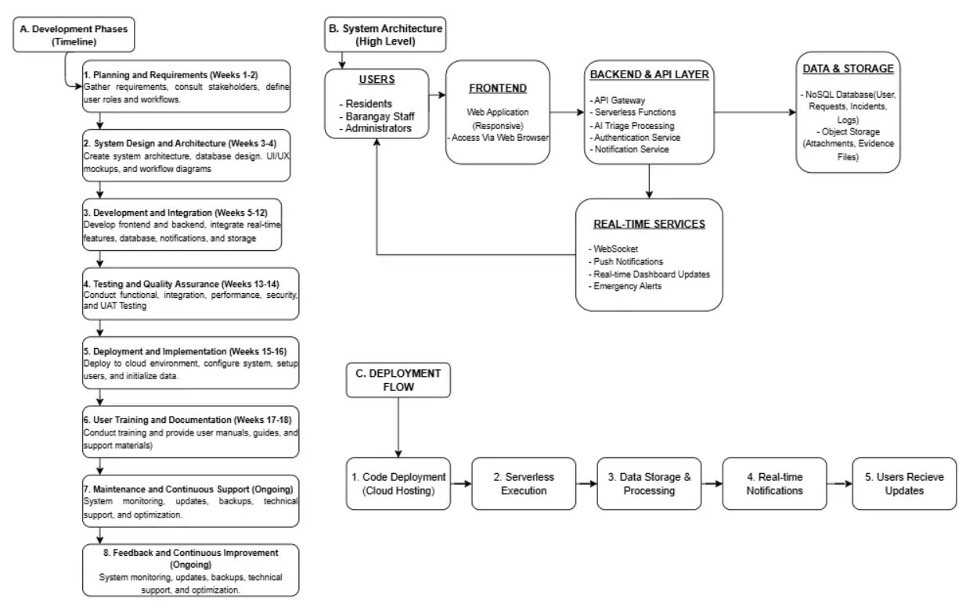
Figure 49. Implementation Plan Diagram
The implementation of KaBarangayConnect follows a structured deployment and operational strategy designed to ensure seamless adoption, long-term sustainability, and strict adherence to data privacy standards. This plan outlines the technical requirements, deployment environments, and post-launch support protocols necessary for successful integration into the barangay's daily operations.
1. Hardware and Software Requirements As a cloud-native, serverless web application, KaBarangayConnect minimizes the need for expensive on-premise hardware.
- For Barangay Personnel: Standard desktop computers or laptops running modern, updated web browsers (e.g., Google Chrome, Mozilla Firefox, or Microsoft Edge) connected to a reliable broadband internet connection.
- For Residents: Any internet-enabled smart device (smartphone, tablet, or PC) with a standard mobile or desktop web browser. No native application download is required.
- System Infrastructure: A registered Amazon Web Services (AWS) account utilizing AWS Amplify, Lambda, API Gateway, S3, and CloudWatch, paired with a MongoDB Atlas cloud database account.
2. Staging and Production Environments
To maintain data integrity and prevent disruption to live civic services, the deployment architecture is strictly divided into isolated environments:
- Staging Environment: A complete replica of the live system used exclusively by the development team. This environment utilizes dummy data to rigorously test system updates, UI modifications, and security patches prior to public release.
- Production Environment: The live, constituent-facing application where all verified barangay transactions, emergency reports, and official chatSessionsCollection data are securely processed and stored.
3. Deployment Strategy
The platform utilizes a Continuous Integration and Continuous Deployment (CI/CD) strategy orchestrated through GitHub Actions. Upon successful testing in the staging environment, approved code commits automatically trigger deployment pipelines. The Next.js frontend is deployed via AWS Amplify Hosting, leveraging a global Content Delivery Network (CDN) for fast loading times, while backend logic is deployed directly to AWS Lambda. This automated strategy ensures zero-downtime updates and eliminates human error during production rollouts.
4. User Training Plan for Barangay Personnel
To ensure high adoption rates and correct system utilization, a structured training program will be executed prior to the official handover:
- Role-Specific Workshops: Administrative staff will receive hands-on training focused on navigating the command dashboard, processing items within the documentRequestsCollection, and managing localized content. Dispatchers will receive specialized training on monitoring the geospatial map and utilizing the real-time Emergency Triage Chat.
- Data Privacy Briefings: Staff will be trained on the strict protocols regarding the handling of sensitive resident data and AWS S3-hosted identity verifications to maintain compliance with the Data Privacy Act of 2012.
- Documentation: Comprehensive user manuals and quick-reference guides will be provided to the barangay hall for continuous offline support.
5. Data Backup Procedures
The system implements robust, automated disaster recovery mechanisms.
- Structured Data: MongoDB Atlas is configured to perform automated daily snapshots of all database collections (e.g., residentsCollection, incidentReportsCollection), allowing for point-in-time recovery in the event of accidental data corruption.
- Unstructured Data: AWS S3 object versioning is enabled to securely backup all resident-uploaded multimedia evidence and identification files.
6. System Maintenance Plan
Scheduled maintenance windows will be established during historically low-traffic periods (e.g., late night or early morning hours). These windows will be utilized to update NPM dependencies, patch identified security vulnerabilities, optimize NoSQL database indexing for faster queries, and review data retention policies (such as purging expired verification files from AWS S3).
7. Monitoring and Support Procedures After Deployment
Following the pilot launch, continuous system telemetry and support channels will be activated:
- Infrastructure Monitoring: AWS CloudWatch will be actively utilized to monitor API Gateway traffic, track Lambda execution latencies, log system errors, and maintain the immutable administrative audit trail.
- Post-Deployment Support: A dedicated technical support pipeline (e.g., a ticketing system or direct contact line) will be established for barangay officials to report bugs, request account role modifications, or seek assistance with operational bottlenecks during the initial transition period.

REFERENCES
Antasuda, V., Barrientos, M. J., Cabalhug, V. G., & Doroy, F. M. (2020). Barangay health center management system (BHCMS). University of Cebu – Lapulapu and Mandaue.
Belanger, F., & Carter, L. (2008). Trust and risk in e-government adoption. The Journal of Strategic Information Systems, 17 (2), 165-176. https://doi.org/10.1016/j.jsis.2007.12.002
Bacus, T. M. D. G., Macadangdang, M. B. C., Patayon, C. M. A., & Bokingkito, P. B., Jr. (n.d.). eDokumento: An e-government system for an administrative unit web-based document request in the Philippines. International Journal of Computing and Digital Systems.
Cegarra-Navarro, J.-G., Cordoba-Pachon, J. R., & Moreno-Cegarra, J. L. (2012). E-government and citizen’s engagement with local affairs through e-websites: The case of Spanish municipalities. International Journal of Information Management, 32 (5), 469-478. https://doi.org/10.1016/j.ijinfomgt.2012.02.008
Carpio, C. O. (2020). Barangay management system. International Journal of Multidisciplinary Research and Publications (IJMRAP), 3(2), 26–32. https://ijmrap.com/wp-content/uploads/2020/07/IJMRAP-V3N1P78Y20.pdf
Correa, J. M. C., Garcia, R. J., Mutas, J., Bañez, J. G. D., & Nava, M. P. (2022). Strategies and mechanisms of local government units for e-governance. Pangasinan State University.
Dacayanan, L. P. (2026). Crime incidence and responsiveness of police-barangay joint operations in Barangay Buenavista and Barangay Sta. Lucia, Sablayan, Occidental Mindoro. International Journal of Recent Advances in Multidisciplinary Topics, 7(4).
Dela Cruz, J. K. A., Fernandez, J. A., Dalma, J. D., Antiga, R. L., & Dela Cruz, S. M. P. (2024). Improving an office procedure on document transaction in Barangay Sauyo, Quezon City. Ascendens Asia Singapore – Bestlink College of the Philippines Journal of Multidisciplinary Research, 3(1B). https://ojs.aaresearchindex.com/index.php/aasgbcpjmra/article/view/12970
Delos Reyes-Urmanita, M. J., & Moreno, F. (2024). An analytical examination of the preparedness and challenges in the implementation of e-governance for the optimization of public service delivery in Zamboanga City, Philippines. MPRA Paper No. 122799. https://mpra.ub.uni-muenchen.de/122799
de los Santos, J. R. N., Michelle, G., Copino, R. C., & Loyaga, L. (2020, December). Bandilyo app: A disaster risk reduction monitoring and incident reporting system with geolocation and SMS technology. In 2020 IEEE 12th International Conference on Humanoid, Nanotechnology, Information Technology, Communication and Control, Environment, and Management (HNICEM) (pp. 1–5). IEEE. https://ieeexplore.ieee.org/abstract/document/9400138
Department of Information and Communications Technology. (2022). Philippine Digital Transformation Strategy 2022–2028. https://dict.gov.ph
Department of Information and Communications Technology. (2024). The Philippine government's digital transformation through DICT's e-government initiatives. Development Academy of the Philippines. https://coe-psp.dap.edu.ph/compendium-innovation/the-philippine-governments-digital-transformation-through-dicts-e-government-initiatives/
Department of Science and Technology (DOST). (2025, October 30). DOST highlights incident monitoring system for LGUs during the Handa Pilipinas in Negros. https://www.dost.gov.ph/knowledge-resources/news/86-2025-news/4215-dost-highlights-incident-monitoring-system-for-lgus-during-the-handa-pilipinas-in-negros.html
Development Academy of the Philippines. (2024). The Philippine government’s digital transformation through DICT’s e-government initiatives . https://dap.edu.ph/the-philippine-governments-digital-transformation-through-dicts-e-government-initiatives/
DICT eGovernment. (2026). eGovPH (Version 2.7.3) [Mobile app]. Apple App Store. https://apps.apple.com/ph/app/egovph/id6447682225
eBarangay. (n.d.). Services. https://ebarangay.ph/services
Enaño, J. V., Natividad, K. P., Pantoja, D. R., Carlo, F., Bautista, J. V., & Cura, D. (2025). BarangayConnect: A web-based information portal for resident data, administrative services, and community records using data analytics and linear regression algorithms. International Journal of Research and Innovation in Social Science, 9(10), 1485–1497. https://doi.org/10.47772/ijriss.2025.910000127
Gasmido Jr., W., De Guzman, J., Natividad, C. J., Sicuan, C. K. B., & Reyes, D. (2025). Digital Barangay: Ayos Lomboy's web-based management and information system. Psychology and Education: A Multidisciplinary Journal, 37(5). https://ejournals.ph/article.php?id=30193
GAS Publishers. (2024). Guardian insight: Empowering safety through advanced data analytics. https://gaspublishers.com/wp-content/uploads/2024/09/Guardian-Insight-Empowering-Safety-through-Advanced-Data-Analytics.pdf
Gupta, P., & Chauhan, S. (2024). Factors influencing trust in e-government services: A meta-analytic review. In 2024 Tenth International Conference on eDemocracy & eGovernment (ICEDEG) . IEEE. https://doi.org/10.1109/ICEDEG61611.2024.10702083
Ignaco, M. A. E. (2021). Mobile application for incident reporting. International Journal on Informatics Visualization, 5(4), 388–394. https://doi.org/10.30630/joiv.5.4.677
International Journal of Research and Innovation in Social Science (IJRISS). (2025). BarangayConnect: A Web-Based Information Portal for Resident Data, Administrative Services, and Community Records Using Data Analytics. RSIS International. https://rsisinternational.org/journals/ijriss/uploads/vol9-iss10-pg1485-1497-202511_pdf.pdf
International Journal of Research and Scientific Innovation (IJRSI). (2026). An IoT-enabled barangay panic button system using ESP32-C3 with verified email alert and cloud-based logging. RSIS International. https://rsisinternational.org/journals/ijrsi/uploads/vol13-iss1-pg1079-1095-202602_pdf.pdf
International Organization for Standardization. (2019). ISO 9241-210:2019 Ergonomics of human-system interaction—Part 210: Human-centred design for interactive systems. https://www.iso.org/standard/77520.html
Kayle, A., Culi, B., Labitoria, C., Louise, K., Tusing, F., Dimanlig, H., & Vergara, R. (2026). Smart application for emergency response (S.A.F.E.R.): An Android mobile application for real-time safety and location tracking in Manila.
Khan, S., Kawle, L., Patil, K., & Sangit, P. (n.d.). Real-time incident alert dashboard. K.C College of Engineering and Management Studies and Research.
Khan, W., Kumar, T., Zhang, C., Raj, K., Roy, A. M., & Luo, B. (2023). SQL and NoSQL database software architecture performance analysis and assessments: A systematic literature review. Big Data and Cognitive Computing, 7(2), Article 97. https://doi.org/10.3390/bdcc7020097
Marie, J., Anne, R., & Luciano, R. G. (2025). Smart crime informatics and decision support for police–community partnerships. International Journal of Innovative Research and Scientific Studies, 8(6), 1781–1789. https://doi.org/10.53894/ijirss.v8i6.10033
Microbiz One. (n.d.). Brgy911 [Mobile app]. Google Play. https://play.google.com/store/apps/details?id=com.microbizone.brgy911
Monteiro, M., Vasconcelos, L., Viterbo, J., Salgado, L., & Bernardini, F. (2021). Assessing the quality of local e-government service through citizen-sourcing applications. In 2021 IEEE 24th International Conference on Computer Supported Cooperative Work in Design (CSCWD) . IEEE. https://doi.org/10.1109/CSCWD49262.2021.9437746
National Privacy Commission. (2023). Privacy management program guidelines . https://privacy.gov.ph
Osman, M. S. (2026). Development and evaluation of a digital barangay management system. Journal of Research in Science and Engineering, 8(4).
Padwal, A., Godse, S., Mishra, V., Bhusari, N., & Bojewar, S. (2020). Web-based attendance and reporting system. International Research Journal of Engineering and Technology (IRJET), 7(4), 4319–4321.
Palma, R., et al. (2023). Designing an incident reporting web application for Barangay Sinisian, Calaca, Batangas. ResearchGate. Department of Information and Communications Technology. (2022). Philippine digital transformation strategy 2022–2028. Retrieved August 26, 2026, from https://dict.gov.ph

National Privacy Commission. (2023). Privacy management program guidelines. Retrieved August 26, 2026, from https://privacy.gov.ph
Zentech Inc. (2024). BarangayOS. Retrieved August 26, 2026, from https://barangayos.com/
eBarangay. (n.d.). Services. Retrieved August 26, 2026, from https://ebarangay.ph/services
RAGPH. (n.d.). OneBarangay. Retrieved August 26, 2026, from https://onebarangay.ragph.com/
Republic Act No. 7160. (1991). Local Government Code of 1991. Retrieved August 26, 2026, from https://www.officialgazette.gov.ph/1991/10/10/republic-act-no-7160/
Republic Act No. 10173. (2012). Data Privacy Act of 2012. Retrieved August 26, 2026, from https://lawphil.net/statutes/repacts/ra2012/ra_10173_2012.html https://www.researchgate.net/publication/352150222
Philippine E-Journals. (2024). Digital Barangay: Ayos Lomboy’s Web-based Management and Information System. https://ejournals.ph/article.php?id=30193
Pressman, R. S., & Maxim, B. R. (2020). Software Engineering: A Practitioner's Approach (9th ed.). McGraw-Hill.
RAGPH. (n.d.). OneBarangay. https://onebarangay.ragph.com/
Ramos, J. F. (2025). Documentary requirements on government transactions among barangays. EPRA International Journal of Economics, Business and Management Studies (EBMS), 12(8). https://eprajournals.com/IJHS/article/17383
Rebadulla, R., & Espina, L. (2025). E-governance readiness of local government units in Eastern Visayas. International Journal of Research and Innovation in Social Science (IJRISS). https://rsisinternational.org/journals/ijriss/Digital-Library/volume-9-issue-9/2980-2991.pdf
Republic Act No. 8792. (2000). Electronic Commerce Act of 2000. https://lawphil.net/statutes/repacts/ra2000/ra_8792_2000.html
Republic Act No. 7160. (1991). Local Government Code of 1991 . https://www.officialgazette.gov.ph/1991/10/10/republic-act-no-7160/
Republic Act No. 10173. (2012). Data Privacy Act of 2012. https://lawphil.net/statutes/repacts/ra2012/ra_10173_2012.html
Republic Act No. 8792. (2000). Electronic Commerce Act of 2000. https://lawphil.net/statutes/repacts/ra2000/ra_8792_2000.html
Shaffi, S. M., & Sidhick, J. N. (2025). Real-time incident reporting and intelligence framework: Data architecture strategies for secure and compliant decision support. World Journal of Advanced Research and Reviews, 26(3), 110–118. https://doi.org/10.30574/wjarr.2025.26.3.2160
Siriwatana, K., & Pongpanich, S. (2025). Developing and evaluating a dental incident reporting system: A user-centered approach to risk management. BMC Oral Health, 25 , Article 339. https://doi.org/10.1186/s12903-025-05729-5
Taruc, F. S., Martin, T. A. S., Olipas, C. N. P., & Alegado, R. T. (2023). Docu-Go: The development and assessment of a web-based barangay document requesting system. International Journal of Information Technology & Computer Engineering, 3(04), 40–49. https://doi.org/10.55529/ijitc.34.40.49
Tolentino, J., Cochanco, R., & Luciano, R. G. (2025). Smart crime informatics and decision support for police–community partnerships. International Journal of Innovative Research and Scientific Studies, 8(6), 1781–1789. https://doi.org/10.53894/ijirss.v8i6.10033
Tosper, R., Mangalino, J., Obena, K., Simon, M., Tayag, M., Villano, K. J., & Reyes, D. (2025). WebYu: A Barangay Yuson web-based information management system initiatives. Psychology and Education: A Multidisciplinary Journal, 37(5), 432–442. https://doi.org/10.70838/pemj.370502
Villones, T. T. (2021). Barangay constituents information and services management system. International Journal of Computer Science and Mobile Computing, 10(4), 63–66. https://doi.org/10.47760/ijcsmc.2021.v10i04.009
Winckler, M., Bernhaupt, R., & Bach, C. (2016). Identification of UX dimensions for incident reporting systems with mobile applications in urban contexts: A longitudinal study. Cognition, Technology & Work, 18 , 673-694. https://doi.org/10.1007/s10111-016-0383-1
Yaneza, Junico S. (2025). Online emergency response management system for City Disaster Risk Reduction Management Office of Calamba City, Laguna. International Journal of Advanced Research in Computer Science, 16(03), 138–145. https://doi.org/10.26483/ijarcs.v16i3.7254
Zentech Inc. (2024). BarangayOS. Barangayos.com. https://barangayos.com/

APPENDICES

Appendix A: Link to Prototype
Access the working prototype here: [insert hyperlink]
(Note: Ensure proper access permissions, e.g., “Anyone in MMDC can view/comment”)

Appendix B: Disclosure of Artificial Intelligence Tools Used in Research

Disclosure of Artificial Intelligence Tools Used in Research

The authors of this paper, Roxane Myles A. Andrade, Rick C. Cabugnason, Monina Angela D. Patiño, Alex S. Resurreccion, from section A4101, enrolled in MO-IT200D2 - Capstone 2 for Term 2, under the supervision of their adviser, Glenn Baluyot, disclose the use of the following Artificial Intelligence (AI) Research tools in this Capstone Paper, titled KaBarangayConnect: An Integrated Web-Based Management and Real-Time Incident Reporting System, that is supportive and ethical, consistent to the guidelines issued by the school:

Further, this is to certify the following:

No AI tools were used to generate original arguments, research gap analysis, hypothesis, data analysis, conclusions, or recommendations. The authors understand that thesis/feasibility and capstone projects showcase original content.
No confidential and/or privileged information was uploaded for AI use or training, including data collected, interview clips, or any other similar items.
No AI-generated content was fully lifted and without verification. The authors recognize the supportive nature of AI Research tools and certify their ethical use.
AI Research tools used are limited and supportive, e.g., enhancement of sentence structure, improving phrasing, etc.
If requested by the faculty adviser, attachments of the full prompts and responses of the AI tool shall be included in the appendix.

The specific AI research support tools utilized by the group, together with their intended purpose and the extent of human review performed on the generated output, are summarized as follows:

AI Tool | Specific Use/Purpose | AI-aided Sections/Chapters
Grammarly (Web and Desktop App) | Mechanical proofreading only: flagging typographical errors, subject-verb agreement issues, sentence fragment detection, comma placement and punctuation suggestions. Configured to Philippine English and formal academic tone. | All Chapters (I, II, III, IV, V), all Appendices, and the Acknowledgments and Dedication pages. Applied as a final mechanical review pass per section after the assigned member finished writing.
QuillBot (Paraphraser Mode) | Limited sentence rephrasing only, applied when an early draft sentence was awkwardly phrased or too closely resembled the wording of a cited source and needed rewording for originality while preserving the source's factual meaning. Never used to generate new claims or extend arguments. | Chapter II (Review of Related Literature) specifically sections describing prior studies (BarangayOS, Bandilyo, BarangayConnect Portal studies). Chapter I (Statement of the Problem Background paragraphs, 3 sentences total).
ChatGPT 4o (Brainstorming and Outline Clarification Only) | Three limited sounding-board sessions only: (1) listing typical subsections expected in a BS IT undergraduate capstone Methodology chapter, (2) recalling exact APA 7th citation patterns for Philippine statutes and government circulars, (3) generating a candidate ISO/IEC 25010 characteristics list that the team then narrowed down to the 6 criteria actually adopted. No output copied verbatim into the paper. | Chapter III (Methodology) Subsection outline brainstorming for 3.1 through 3.5 (20 min meeting, notes transcribed, then team re-drafted from scratch). References Section citation pattern self-check against APA 7th rules (applied manually after cross-verification). Chapter I quality-criteria wording for Research Objective 3.
Google Bard / Gemini (Fact-Checking Cross-Reference for Technology Specifications) | Four secondary sanity-check sessions only for publicly documented vendor technical specifications: MongoDB Atlas M0 512 MB storage limit, AWS Lambda default execution timeout, Amazon API Gateway WebSocket support, and AWS Amplify free-tier HTTPS CDN behavior. This was ALWAYS a secondary check; the primary reference was always the official AWS and MongoDB vendor documentation sites. | Chapter III (Methodology) - Section 3.2.1 Technology Stack Selection (4 specific numeric vendor-figure sentences in the deployment and database sub-paragraphs). All figures cross-validated against the official vendor URLs; AI values that conflicted with vendor docs were discarded.
Claude AI | Syntax boilerplate suggestions only during prototype coding: AWS Lambda handler skeletons, Mongoose schema field definitions, Next.js page/layout patterns, basic try-catch wrappers, and unit test scaffolding. NEVER used to generate the core incident prioritization business logic, RBAC rules, or document workflow state transitions. | Chapter III (Methodology) - specifically Section 3.2 Technology Stack paragraphs describing implementation decisions, Section 3.2.2 Development Phases (individual sprint deliverable descriptions), and Section 3.4.3 Test Case step outlines that mirror code paths. No code was copied from AI output into the paper's prose; only prose describing architectural decisions was lightly assisted.

The authors assume full responsibility and accountability for the accuracy, originality, and quality whether for course requirements of this course, publication, or any other academic use bearing the name of both the authors and the institution.

Signed:

Alex S. Resurreccion
Roxane Myles A. Andrade
Jiullano Pepito B. Baldeo
Rick C. Cabugnason
Monina Angela D. Patiño

Conforme:

Glenn Baluyot

Appendix C: Evaluation Questionnaires
Evaluation Questionnaires
This appendix contains the complete evaluation questionnaires used during the User Acceptance Testing of KaBarangayConnect at Barangay Labuin, Pila, Laguna. Two versions of the questionnaire are provided: one for residents (Form 1) and one for barangay personnel (Form 2). Both instruments are structured around the ISO/IEC 25010 Software Product Quality Model and were administered through Google Forms for digitally literate participants and as printed forms for residents with limited digital access.
Note: The Likert-scale items use a 5-point rating from 1 (Strongly Disagree) to 5 (Strongly Agree). Demographic data are collected for descriptive analysis only and are not used to identify individual respondents.

FORM 1 - KaBarangayConnect Evaluation
For Resident Respondents
Thank you for participating in the KaBarangayConnect usability testing. This survey is part of a capstone research project conducted by students of Mapúa Malayan Digital College. Your responses will remain confidential and will be used solely to improve the system before its pilot implementation in Barangay Labuin.
The survey will take approximately 10–15 minutes to complete. Your participation is entirely voluntary, and you may withdraw at any time without any consequences.
By proceeding with this survey, you consent to the collection and use of your confidential responses for academic research purposes in accordance with the Data Privacy Act of 2012 (Republic Act No. 10173).
Part 1.Pahintulot at Impormasyon (Consent and Background)
Q1. Sumasang-ayon po ba kayong lumahok sa pagsusuri na ito?/ Do you agree to participate in this study?
☐ Oo, sumasang-ayon ako/ Yes, I agree to participate.
☐ Hindi (mangyaring huminto na po dito)/ No, I don't want to participate.
Part 1: Background
Q1. Ano po ang inyong papel?/ What is your role?
☐ Residente ng Barangay Labuin/ I am a resident in Barangay Labuin.
☐ Kawani ng Barangay (Staff)/ I am a staff of Barangay Labuin.
Q2. Anong edad po ninyo?/ How old are you?
☐ 18–25
☐ 26–35
☐ 36–50
☐ 51 and above
Q3. Kasarian/ Gender
☐ Male
☐ Female
☐ Prefer not to say
Q4. Pinakamataas na natapos sa pag-aaral/ Educational Attainment
☐ Elementary
☐ Junior High School
☐ Senior High School
☐ Vocational / Technical
☐ College / Undergraduate
☐ Master's Degree or higher
☐ Other (please specify): _____________
Q5. May sarili po ba kayong smartphone o computer na may internet?/ Do you own a smartphone or a computer with internet access?
☐ Yes
☐ No
Q6. Gaano po kadalas kayong gumagamit ng internet?/ How often do you use the internet?
☐ Daily
☐ Weekly
☐ Rarely
☐ Never
Part 2. Current Experience with the Barangay
Q7. Sa nakalipas na 12 buwan, ilang beses po kayong humingi ng dokumento sa barangay?/ In the past 12 months, how many times have you requested a document from the barangay?
Number of times: ______________________________________________
Q8. Karaniwan po, gaano katagal bago ninyo makuha ang dokumento pagkatapos hilingin?/ Typically, how long does it take for you to receive the document after requesting it?
☐ Same day
☐ 1–2 days
☐ 3–7 days
☐ More than a week
Q9. Kinailangan mo na bang mag-report ng insidente sa barangay?/ Have you ever needed to report an incident to the barangay?
☐ Yes
☐ No
Q10. Kung oo, na ituloy mo ba ang pag-file ng report?/ If yes, did you proceed on filling the report?
☐ Yes
☐ No
☐ Not applicable
Q11. Kung hindi ninyo isinumbong, ano ang naging hadlang? (Opsyonal)/ If you did not report it, what prevented you from doing so?(Optional)
________________________________________________________________
________________________________________________________________
________________________________________________________________
— End of Form 1 —
Thank you for your participation!

FORM 2 - KaBarangayConnect Evaluation
For Barangay Personnel
Thank you for participating in the KaBarangayConnect usability testing. This survey is part of a capstone research project conducted by students of Mapúa Malayan Digital College. Your responses will remain anonymous and will be used solely to improve the system before its pilot implementation in Barangay Labuin.
The survey will take approximately 10–15 minutes to complete. Your participation is entirely voluntary, and you may withdraw at any time without any consequences.
By proceeding with this survey, you consent to the collection and use of your anonymous responses for academic research purposes in accordance with the Data Privacy Act of 2012
Part 1.Pahintulot at Impormasyon (Consent and Background)
Q1. Sumasang-ayon po ba kayong lumahok sa pagsusuri na ito?/ Do you agree to participate in this study?
☐ Oo, sumasang-ayon ako/ Yes, I agree to participate.
☐ Hindi (mangyaring huminto na po dito)/ No, I don't want to participate.
Part 2: Background
Q1. Ano po ang inyong papel sa barangay?/ What is your current role?
☐ Barangay Secretary
☐ Administrative Clerk
☐ Kagawad / Council Member
☐ Barangay Tanod / Public Safety Officer
☐ Iba pa:________
Q2. Ilang taon na po kayo sa posisyong ito?/ How many years have you been in this position? ______________________________________________
Q3. Halos ilang document requests po ang pinoproseso ng barangay bawat linggo?/ Approximately how many document requests does the barangay process each week? ______________________________________________
Q4. Halos ilang incident reports po ang natatanggap kada buwan? / Approximately how many incident reports are received each month? ______________________________________________
Part 2. Current Process
Q5. Anong paraan po ang ginagamit ngayon para i-record ang document requests?/ What method is currently used to record document requests?
________________________________________________________________
________________________________________________________________
________________________________________________________________
Q6. Anong paraan po ang ginagamit ngayon para i-record ang incident reports?/ What method is currently used to record incident reports?
________________________________________________________________
________________________________________________________________
________________________________________________________________
Q7. Ano po ang pinaka-madalas na hirap na naeengkwentro sa kasalukuyang proseso?/ What is the most frequent difficulty encountered in the current process?
________________________________________________________________
________________________________________________________________
________________________________________________________________
— End of Form 2 —
Thank you for your participation. Salamat po!

Appendix D: Informed Consent Letter (English Version)

INFORMED CONSENT LETTER
Title of the Study:
KaBarangayConnect: An Integrated Web-Based Management and Real-Time Incident Reporting System
Researchers:
Alex Resurreccion
Jiullano Pepito Baldeo
Monina Angela Patiño
Rick Cabugnason
Roxane Myles Andrade
Bachelor of Science in Information Technology Major in Software Development
Mapúa Malayan Digital Colleges
Participant Information
Dear Participant,
Good day!
We are fourth-year Bachelor of Science in Information Technology students from Mapúa Malayan Colleges Laguna (MMDC), a college under Mapúa Malayan Colleges Laguna (MMCL), conducting our capstone project entitled 'KaBarangayConnect: An Integrated Web-Based Management and Real-Time Incident Reporting System.' We respectfully invite you to participate in our survey for the residents, barangay officials, and administrators of Barangay Labuin, Pila, Laguna.
The purpose of this survey is to gather information regarding the current barangay processes, document requests, incident reporting, communication practices, and the need for a web-based management system. The information you provide will help us identify system requirements and evaluate the proposed features of KaBarangayConnect.
Your participation is completely voluntary. You may refuse to answer any question or withdraw from the survey at any time without any consequences. The survey will take approximately 10–15 minutes to complete.
All information collected will be treated with strict confidentiality and will be used solely for academic purposes. No personally identifiable information will be disclosed in any report or publication. The collected data will be securely stored and handled in accordance with the Data Privacy Act of 2012 (Republic Act No. 10173).

If you have any questions regarding this study, you may contact:
Email: lr.mapatino@mmdc.mcl.edu.ph
lr.alresurreccion@mmdc.mcl.edu.ph
Thank you for your time and valuable participation.
Informed Consent
By signing below, I confirm that:
□ I have read and understood the purpose of this study.
□ My participation is voluntary.
□ I may withdraw at any time without penalty.
□ My responses will be kept confidential and used only for academic research.
□ I voluntarily agree to participate in this study.

Participant's Name: ________________________________
Signature: ________________________________________
Date: _____________________________________________

INFORMED CONSENT FORM
Tagalog Version
LIHAM NA PAHINTULOT
Pamagat ng Pag-aaral:
KaBarangayConnect: An Integrated Web-Based Management and Real-Time Incident Reporting System
Mga Mananaliksik:
Alex Resurreccion
Jiullano Pepito Baldeo
Monina Angela Patiño
Rick Cabugnason
Roxane Myles Andrade
Bachelor of Science in Information Technology Major in Software Development
Mapúa Malayan Digital Colleges
Impormasyon para sa Kalahok
Magandang araw!

Kami ay mga ikaapat na taong mag-aaral ng Bachelor of Science in Information Technology Major in Software Development mula sa Mapúa Malayan Digital Colleges (MMDC), isang kolehiyo sa ilalim ng Mapúa Malayan Colleges Laguna (MMCL). Isinasagawa namin ang aming capstone project na pinamagatang 'KaBarangayConnect: An Integrated Web-Based Management and Real-Time Incident Reporting System.' Magalang po naming inaanyayahan ang mga residente, opisyal ng barangay, at mga administrador ng Barangay Labuin, Pila, Laguna na lumahok sa aming survey.

Layunin ng sarbey na ito na makakalap ng impormasyon tungkol sa kasalukuyang proseso ng barangay sa pamamahala ng dokumento, pag-uulat ng insidente, komunikasyon, at pangangailangan para sa isang web-based na sistema. Ang inyong mga kasagutan ay gagamitin lamang upang matukoy ang mga kinakailangan at masuri ang mga tampok ng KaBarangayConnect.

Ang inyong paglahok ay ganap na boluntaryo. Maaari kayong tumangging sumagot sa alinmang tanong o umatras anumang oras nang walang kaparusahan. Ang pagsagot sa sarbey ay tatagal lamang ng humigit-kumulang 10–15 minuto.

Ang lahat ng impormasyong inyong ibibigay ay mananatiling kumpidensyal at gagamitin lamang para sa akademikong layunin. Walang personal na impormasyon ang ilalathala o ibabahagi sa anumang ulat. Ang lahat ng datos ay pangangalagaan alinsunod sa Data Privacy Act of 2012 (Republic Act No. 10173).

Kung mayroon kayong katanungan, maaari kaming kontakin sa:
lr.mapatino@mmdc.mcl.edu.ph
lr.alresurreccion@mmdc.mcl.edu.ph

Maraming salamat po sa inyong oras at pakikilahok.

Pahayag ng Pahintulot
- Nabasa at naunawaan ko ang layunin ng pag-aaral.
- Boluntaryo ang aking paglahok.
- Maaari akong umatras anumang oras nang walang kaparusahan.
- Ang aking mga sagot ay mananatiling kumpidensyal at gagamitin lamang para sa akademikong pananaliksik.
- Malaya kong pinahihintulutan ang aking paglahok sa pag-aaral na ito.

Pangalan ng Kalahok: __________________________
Lagda: ____________________ Petsa: ____________________

Appendix E: Data Privacy Form
Data Privacy Form
KaBarangayConnect Evaluation Study

This notice describes how the KaBarangayConnect research team collects, uses, stores, and protects your personal information during the evaluation of the system. This notice complies with Republic Act No. 10173, known as the Data Privacy Act of 2012, and its Implementing Rules and Regulations issued by the National Privacy Commission.
1. Data We Collect
- Demographic information - age group, sex, educational attainment, role at the barangay (for staff respondents)
- Experience data - frequency of barangay interactions, current process pain points
- Evaluation responses -Likert-scale ratings and open-ended feedback about the system
- Consent records - your signed Informed Consent Form, which is stored separately from your evaluation responses
Aside from your signature on the Informed Consent Form, we do NOT collect your name, address, contact number, government-issued ID, or any other directly identifying information in connection with your evaluation responses.
2. Confidentiality of Your Responses
Your evaluation responses will be kept confidential. The Informed Consent Form you sign is stored separately from your survey responses, and your name is not linked to your evaluation answers in any published report, presentation, or appendix. Only aggregated, anonymized results will appear in the final capstone report.
3. Purpose of Data Collection
Data is collected solely for the academic evaluation of KaBarangayConnect, including: assessment of system usability and effectiveness, identification of areas for improvement before pilot deployment, and inclusion in the final capstone research report submitted to Mapúa Malayan Digital College.
4. Lawful Basis
The lawful basis for processing your data is your explicit, written consent obtained through the Informed Consent Form. You may withdraw your consent at any time before the final report is submitted.
5. Storage and Security
All evaluation data will be stored in encrypted, password-protected digital files accessible only to the research team. Signed consent forms and any printed evaluation forms will be kept in a locked storage location at the team's workspace, separately from the digital evaluation dataset. Data will be retained for a maximum of one (1) year following the submission of the capstone report, after which all records will be permanently deleted.
6. Your Rights as a Data Subject
Under RA 10173, you have the right to:
- Be informed about how your data is processed
- Access your data and request a copy
- Object to the processing of your data
- Rectify inaccurate or incomplete data
- Erase or block the processing of your data
- Withdraw your consent at any time before the final report is submitted
- Lodge a complaint with the National Privacy Commission (privacy.gov.ph)
7. Sharing of Data
Your responses will not be shared with any third party, including barangay officials, in any form that would identify you personally. Aggregated, anonymized results may be included in academic publications, presentations, and the public-facing capstone report.
8. Contact
For questions or concerns about your data, please contact the research team at kabarangayconnect.team@gmail.com.

Appendix F: Letter of Request To Barangay

Letter of Request To Barangay
[Date]
[Name of Barangay Captain]
Punong Barangay
Barangay Labuin
Pila, Laguna
Subject: Request for Pilot Collaboration and User Acceptance Testing - KaBarangayConnect Capstone Project
Dear Honorable Punong Barangay [Name]:
Good Day. We are undergraduate students of Mapúa Malayan Digital College currently completing our capstone project titled KaBarangayConnect: An Integrated Web-Based Management and Real-Time Incident Reporting System.
Our study aims to design, develop, and evaluate a digital platform that helps barangays manage document requests, incident reports, and community records more efficiently. We have chosen Barangay Labuin as our intended pilot site because of its representative size and operational characteristics, which align well with the scope of our pilot evaluation. This letter serves as our formal request for your office's consideration and partnership.
We respectfully request your permission to:
- Conduct interviews and consultations with selected barangay personnel (Barangay Secretary, administrative clerks, and tanods) regarding current operational workflows
- Recruit approximately five (5) resident-respondents and coordinate with three (3) barangay personnel for the system's user acceptance testing, with all participation being fully voluntary
- Conduct in-person testing sessions at the Barangay Hall over a period of approximately two (2) weeks, subject to your office's availability and approval
- Use confidential, aggregated findings from the evaluation in our final capstone report, presentations, and academic publications
All data collection activities will strictly comply with the Data Privacy Act of 2012 (RA 10173). All participants will sign an Informed Consent Form, and their evaluation responses will be kept strictly confidential - stored separately from identifying records and reported only in aggregated form. Copies of the consent form, data privacy notice, and evaluation instruments are available upon request.
We deeply appreciate your office's consideration. Your support will not only contribute to the completion of our academic requirements but, more importantly, to demonstrating how technology can support the delivery of public service at the barangay level.
Thank you very much for your time and consideration. We would be honored to discuss this proposal further at your office's convenience and look forward to your response.
Respectfully yours,
[Team Lead Name]
On behalf of the KaBarangayConnect Research Team
Mapúa Malayan Digital College
Contact: [email address] | [mobile number]
Noted by:

[Faculty Adviser Name]
Capstone Adviser, Mapúa Malayan Digital College

[Date]
[Name of Barangay Captain]
Punong Barangay
Barangay Labuin
Pila, Laguna

Subject: Kahilingan para sa Pilot Partnership at User Acceptance Testing (UAT) ng Capstone Project na KaBarangayConnect

Kagalang-galang na Punong Barangay: [Name]

Magandang araw po. Kami po ay mga undergraduate na estudyante ng Mapúa Malayan Digital College sa ilalim ng Mapúa Malayan Colleges Laguna (MMCL) na kasalukuyang tumatapos ng aming capstone project na pinamagatang KaBarangayConnect: An Integrated Web-Based Management and Real-Time Incident Reporting System.
Ang aming pag-aaral po ay naglalayong mag-design, mag-develop, at mag-evaluate ng isang digital platform na tumutulong sa mga barangay upang mas maayos na mapamahalaan ang document requests, incident reports, at community records. Pinili po namin ang Barangay Labuin bilang aming intended pilot site dahil sa nararapat na laki at operational characteristics nito, na tugma sa saklaw ng aming pilot evaluation. Ang sulat na ito po ay bilang aming pormal na kahilingan para sa konsiderasyon at pakikipagtulungan ng inyong opisina.
Magalang po kaming humihingi ng inyong pahintulot na:
- Magsagawa ng interviews at consultations sa piling barangay personnel (Barangay Secretary, administrative clerks, at tanods) tungkol sa kasalukuyang operational workflows
- Kumuha ng humigit-kumulang limang (5) resident-respondents at makipag-coordinate sa tatlong (3) barangay personnel para sa user acceptance testing ng sistema, na ganap na boluntaryo ang paglahok
- Magsagawa ng in-person testing sessions sa Barangay Hall sa loob ng humigit-kumulang dalawang (2) linggo, sang-ayon sa availability at pahintulot ng inyong opisina
- Gamitin ang confidential, aggregated findings mula sa pagsusuri sa aming final capstone report, presentations, at academic publications
Ang lahat po ng data collection ay mahigpit na susunod sa Data Privacy Act of 2012 (RA 10173). Lahat ng kalahok ay pipirma ng Informed Consent Form, at ang kanilang evaluation responses ay mananatiling confidential — iimbak nang hiwalay mula sa identifying records at iuulat lamang sa aggregated form. Ang mga kopya ng consent form, data privacy notice, at evaluation instruments ay maaari pong i-request.
Maraming salamat po sa inyong konsiderasyon. Ang inyong suporta ay hindi lamang makakatulong sa pagtapos ng aming akademikong requirement, kundi mas mahalaga, sa pagpapakita kung paano makakatulong ang teknolohiya sa paghatid ng public service sa antas ng barangay.
Maraming salamat po sa inyong oras at konsiderasyon. Ikagagalak po naming pag-usapan pa ang panukalang ito sa oras na maluwag sa inyong opisina, at inaasahan namin ang inyong sagot.

Appendix G: Weekly Progress

Weekly Progress

This appendix presents the team's Weekly Progress Report for the Capstone 1 term, documenting the tasks completed, timelines, output links, and adviser's remarks throughout the development of KaBarangayConnect. The report tracks project milestones from topic selection and proposal writing through requirements analysis and early chapter drafting.
